Stress signs in an invented story
Use only the invented learner. Draw lines from the three story clues to the map. Write or place the words. A list or pointing route is equal. Do not map your own symptoms.
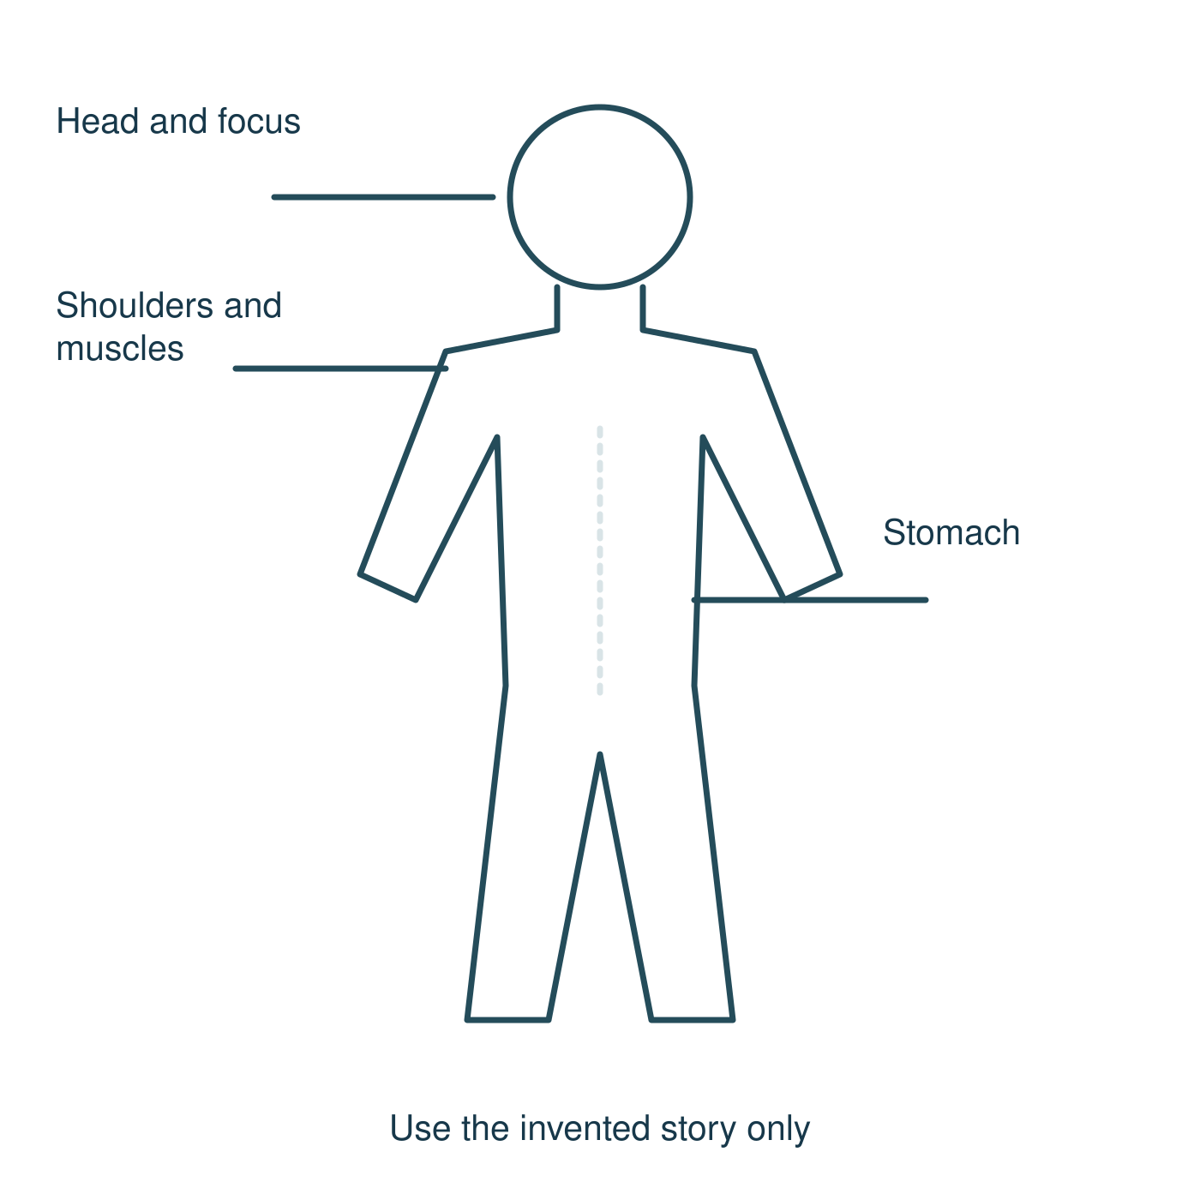
Story clues: hard to focus · tense shoulders · fluttery stomach.
These are possible clues, not proof of stress or a diagnosis. People can show different signs or none that others can see. The map is a learning diagram, not a test.

Three safe strategy trials
Each is offered in a calm lesson. You can adapt, observe or pass. No one needs to become stressed or explain a personal feeling.

Gentle breathing
Sit or stand in your usual supported position. Let an easy breath come in and out at your own pace. Keep breathing comfortable. No hold, forced deep breath, set rate or count. Try briefly, then return to usual breathing. Eyes can stay open. Stop and tell staff if uncomfortable or dizzy. You may observe, use normal breathing or pass.

Reframing
Use the invented thought: “I will get every part wrong.” What is known? The order changed, but the tasks are familiar. Try: “I know some parts. I can ask for the first step.” Say, point to, type or write the fairer thought. A fairer thought need not be cheerful. It must fit the facts. Do not reframe harm as acceptable or dismiss a real problem. Asking for a clearer plan is valid.

Accessible movement
With staff agreement, try one small, familiar move that suits your access plan: a gentle hand move, a seated stretch or a few steps in the agreed clear space. Stay in a comfortable range. No touch, exertion, balance challenge or performance target. Use a familiar alternative or observe/pass. Stop if painful or uncomfortable; follow usual health and access plans.
Choose a possible option for the invented learner. Staff can also make the plan clearer. A strategy may help; no single strategy works for everyone.

My possible plan
Choose one possible strategy for a mild change, privately, or plan for the invented learner. Include practical support. No personal worry, symptom, health or family detail is needed. Keep the card. Blank or pass is valid.

A mild change or cue, with no private detail
________________________________________________

One strategy I might choose
________________________________________________

How to keep it safe and suited to me
________________________________________________

Support by role that could help
________________________________________________

If it does not help or I need more support
________________________________________________

Fictional model
For the invented learner: when a familiar task order changes, check a fairer thought and ask school staff for the first step. If that is not useful, ask for another explanation or the agreed supervised pause.
Keep your own card. Do not add names, a private worry, symptom or health/family detail. You never have to show it. No promise to feel calm. Ask for help with the cause of pressure too.

Safe help and task aids

Pause card
I would like to use my agreed pause.
Show the card or usual signal. Staff support the agreed supervised route, without a public explanation. Keep adult support; do not go off alone. Return with support or catch up privately.

Help in private
Ask a trusted adult or school staff for a private talk. A family doctor or suitable helpline may help too. Staff can help find an age-appropriate route. If the first adult is unavailable or unhelpful, ask another. Get school staff straight away for an immediate concern.

Starter
Words: pressure, change, body, thoughts
Start: Stress can affect…
Model: It may affect focus.

Story and meanings
Words: stress, sign, different, clue
Start: In the story, one clue is…
Model: The learner has tense shoulders.

Private hinge
Words: possible, cause, proof, ask
Start: The clue may mean…
Model: It may be stress, but it is not proof.

Aids for practice and review

Story body map
Words: focus, shoulders, stomach
Start: I link… to…
Model: I link tense shoulders to the shoulder area.

Three safe trials
Words: breath, fairer, move, adapt
Start: A safe choice could be…
Model: Use a gentle move within the usual access plan.

Plan and self check
Words: cue, choice, support, alternative
Start: For the story learner…
Model: Ask staff to show the first step.

Review and help
Words: reason, next step, trusted adult
Start: My story answer now shows…
Model: A fairer thought fits what is known.
Use invented class examples only. A private plan stays with you. You may pass, use a list or point, type, draw or use your usual aid. A scribe can read back your exact chosen words.

