Invented privacy choices
All examples in this pack are made up. They are plain text, not copies of real posts or settings. No live account or online task is needed.

A learner shares a craft photo
A learner plans to share a photo of a model they made. They do not need to show their face, school badge or location. They can choose a smaller audience, keep location off and check tag and contact controls with trusted adult support. They ask before sharing anyone else’s work or image.
Setting in the invented example | Choice to consider
Audience | Only approved contacts, rather than anyone.
Location | Off unless a trusted adult helps check a clear need.
Tags and contact | Review who can add a tag or send a message.

A smaller audience can help. Another person may still copy or share a post. Deleting a post does not ensure every copy disappears.

Your book task
Which choice could reduce sharing? What can that choice fail to prevent? Use the invented learner only.

Invented media examples

A cropped notice
ACTIVITY CANCELLED TODAY The crop shows only the words Activity cancelled. No date or sender is shown. Full source: Full invented notice dated 14 January 2027: Activity cancelled on 14 January 2027. The next activity on 21 January 2027 will run as usual.

Worked model
Misleading context. The words are real within the invented notice, but the crop hides the old date and next-session line. Check the current full notice with staff.

An edited room picture
EMPTY ROOM PROVES THE ACTIVITY IS OFF A simple drawing has had the activity materials removed. The post gives no current notice. Full source: The original invented drawing shows materials in the room.

Your check
What changed or what evidence can you check? Does this prove the claim? What safe check could come next?

A checkable update
The next activity is on. Check the current notice with staff. The message is dated 21 January 2027 and points to the full notice available from staff. Full source: Full invented notice dated 21 January 2027: The activity on 21 January 2027 is on as planned. Ask trusted school staff if you need the first step explained.

Your check
What changed or what evidence can you check? Does this prove the claim? What safe check could come next?
A changed image or missing context can mislead. A clue calls for a check. It does not prove that every detail is false. Ask trusted staff to help check the full source and date.

An invented image edit
The left drawing is the invented source. The right drawing removes the activity materials. This is an edit made for the lesson.
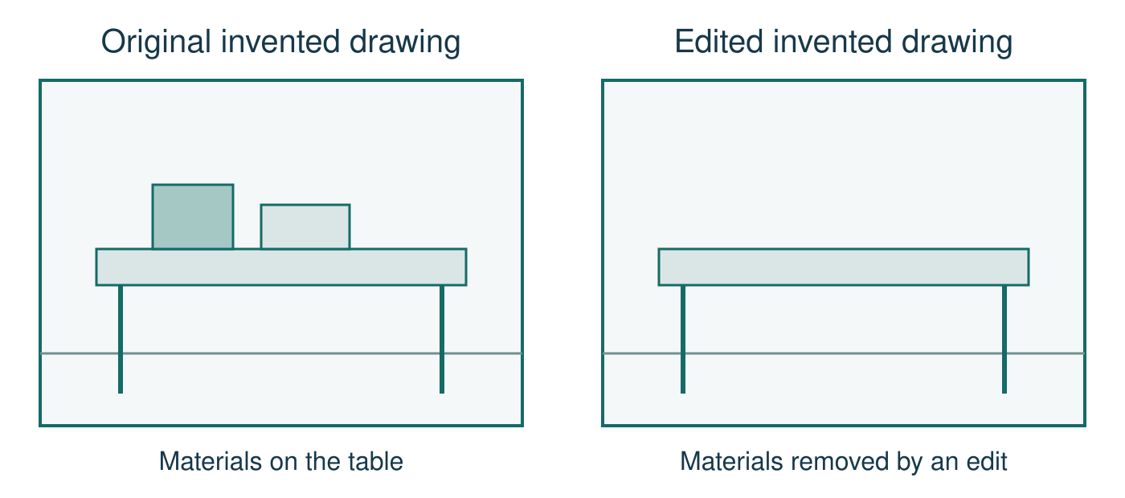
Image labels: Original invented drawing. Edited invented drawing. Materials on the table. Materials removed by an edit.
What changed? Can either drawing prove the next activity is cancelled? What else would need to be checked? Use the full invented notice on page 2.

My online safety checklist
Keep this card privately. Tick a step to remember or leave it blank. Use the invented learner instead or pass. This is a reminder, not a check of your accounts.
[ ] I pause before I post or share.
[ ] I check who could see it and leave private details out.
[ ] I ask before I share another person’s information or image.
[ ] I can ask a trusted adult to help check privacy, location and contact settings.
[ ] I check the source, date, full context and evidence before I trust a claim.
[ ] If something goes wrong, I stop engaging and ask trusted school staff for help.
No names, usernames, passwords, account details, screenshots, private incidents or device checks. Keep the card with you. It is not collected, photographed, displayed or compared.
One action I might use, or one for the invented learner:
________________________________________________
Support by role, if needed: __________________________
No account details or personal incidents. This card stays with you. A fictional example, blank or pass is valid.

Help and a discreet pause

A safe response
Support may come from a trusted adult, school staff, a family doctor or a suitable helpline. Ask trusted school staff privately to help find an age-appropriate route and use reporting tools safely. If the first adult is unavailable or unhelpful, try another trusted adult through the agreed route. For immediate concern, get school staff straight away and use the school urgent procedure. No named service, number, website or live online task is needed.

Pause card
I would like to use my agreed pause.
Show this card or your usual signal. You do not need a public explanation. Staff support the agreed supervised route. Keep adult support and do not go off alone. Return with support, use a neutral task or catch up privately.

A private opener
Can I talk to you privately about something online? I need help with what to do next. Use this for the invented learner. You never need to tell a personal story in class.

Staff note
Any disclosure goes to the safeguarding lead through school procedure. Listen calmly, reassure, do not probe or promise secrecy. Support a pupil who cannot identify a trusted adult; do not press. Keep real concerns separate from learning records.

Aids for the first tasks

Starter claim
Words: likes, claim, proof, check
Start: Many likes do not prove ___ because ___.
Model: Many shares do not prove the activity is cancelled.

Privacy model
Words: audience, location, contact, copy
Start: A setting can limit ___ but ___.
Model: A setting can limit who sees a post, but a viewer may copy it.

Private hinge
Words: crop, date, context, source
Start: Before sharing, the learner could ___.
Model: They could ask staff to check the full current notice.

Post check
Words: claim, source, date, edit, evidence
Start: The post claims ___. It leaves out ___.
Model: The crop claims the activity is off today. It leaves out the old date.

Aids for response and review

Safe response
Words: pause, stop, tell, report, support
Start: The learner could stop ___ and ask ___.
Model: They could stop replying and ask trusted school staff for help.

Learning self check
Words: explain, reason, prompt, help
Start: I can explain ___ using the invented ___.
Model: I can explain the missing context using the invented notice.

Feedback and exit
Words: next step, response, private, adult
Start: A safer next step in the story is ___.
Model: A safer next step is asking staff before sharing the post.

