Humanities · GROW · Autumn 2 · Week 4 · HUM-GROW-A2-W04

Knowledge organiser
Investigate festivals of light around the world with a Geography link.
No. Communities mark it in several countries. Use a credited account and quote or paraphrase one relevant detail.
Tier | Word | Meaning
Tier 3 | festival | A special period of celebration or remembrance
Tier 2 | belief | Something a person accepts as true
Tier 2 | tradition | A practice passed on
Tier 2 | respect | Care for people and what matters to them
I locate the example at ____. Card ____ describes ____. It can mean ____.

Humanities · GROW · Autumn 2 · Week 4 · HUM-GROW-A2-W04

World locator with neutral labels
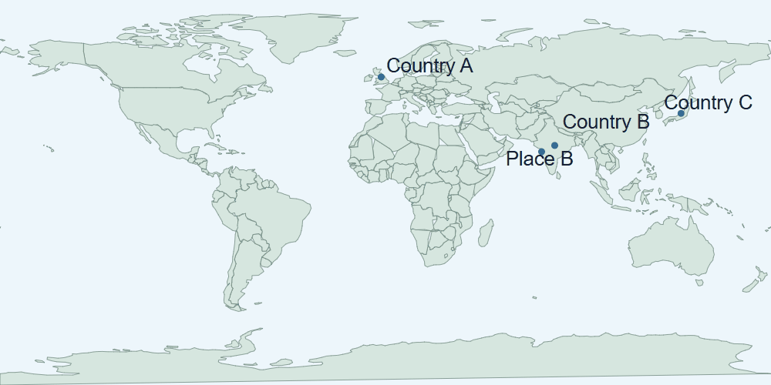
World map with approximate markers for Country A, Country B, Country C and Place B. The drawing gives a world view and does not show street details.
Use the neutral markers for location. Read card D or H to explain a practice or meaning.

Humanities · GROW · Autumn 2 · Week 4 · HUM-GROW-A2-W04

Evidence cards D and H

D · Diwali
Many Hindus mark Diwali with lamps, worship and gatherings. Light can express good overcoming evil and knowledge overcoming ignorance. Practices and stories vary.
This Hindu explanation does not cover every Hindu practice or other religions’ observances.

H · Hanukkah
Hanukkah is a Jewish festival lasting eight nights. Lights recall the Temple’s rededication and the traditional account of oil lasting eight days. A hanukkiah has eight festival lights and a helper light.
This explains one Jewish religious perspective; not all Jewish households observe identically.

Humanities · GROW · Autumn 2 · Week 4 · HUM-GROW-A2-W04

Evidence cards O and S

O · Objects and meanings
A diya is a small lamp associated with Diwali. A hanukkiah is used at Hanukkah. Ask before touching borrowed objects; use an unlit replica or a drawing.
This example does not describe every person or place.

S · One family’s celebration plan
Fictional Diwali plan: prepare a welcoming space; arrange unlit lamps with an adult; gather for worship; share food and greetings. This is one sequence, not a rule for every family.
This example does not describe every person or place.

Humanities · GROW · Autumn 2 · Week 4 · HUM-GROW-A2-W04

Shared investigation
Locate Country B and the Country A, then compare festival source details. Discuss why a celebration can be observed in several places. Take a turn to suggest a match, then check the evidence.
1. Which source describes Diwali?
2. Which source describes the Hanukkah lights?
3. What can a map add to the comparison?
Evidence or step | Check
Which source describes Diwali? | Add your answer or card clue.
Which source describes the Hanukkah lights? | Add your answer or card clue.
What can a map add to the comparison? | Add your answer or card clue.
Our explanation
____________________________________________________________

Optional · respond to feedback together
Optional: show one map marker and source clue to an adult. Hear one piece of feedback. Reply with a change, a reason to keep it or a request for help.
My response or improvement
____________________________________________________________

Humanities · GROW · Autumn 2 · Week 4 · HUM-GROW-A2-W04

We do decision checkpoint
A map has one marker beside a festival example. Which claim is supported?
1. The example has a location
2. Everyone in that country celebrates it
3. It is only celebrated in that country
My claim and clue
____________________________________________________________

Humanities · GROW · Autumn 2 · Week 4 · HUM-GROW-A2-W04

Worked model

Ask the question
No. Communities mark it in several countries. Use card D. Card D describes lamps, worship and gatherings at Diwali. Light can express good overcoming evil or knowledge overcoming ignorance.

Find the evidence
Card D describes lamps, worship and gatherings at Diwali. Light can express good overcoming evil or knowledge overcoming ignorance. A map can locate an example. A credited account helps explain what the practice means to people.

Explain the link
Use a map marker for the location and a source label for the practice and its meaning. I locate the example at ____. Card ____ describes ____. It can mean ____.

Check what we know
Use a credited account and quote or paraphrase one relevant detail. A map marker cannot establish everyone’s religion or how they celebrate.

Humanities · GROW · Autumn 2 · Week 4 · HUM-GROW-A2-W04

Arrival Supported
 | Ready to learn?  ● Green · Ready  ● Amber · Help  ● Red · Pause  You may point, choose or pass.
  1. Point to the picture that matches the top one.    __________________  __________________ | 2. Which meaning fits festival?  __________________  __________________
  3. Does Diwali belong to only one country?  __________________  __________________ | 4. What supports an explanation of a festival’s meaning?  __________________  __________________
Point, speak, sign, draw, write or choose. You may pass. An adult may note your own words or choice.

Humanities · GROW · Autumn 2 · Week 4 · HUM-GROW-A2-W04

You do Supported
Staff mark I · S · C beside the task.
1. Start in your book. Locate one festival example on a map.
2. Explain an accurate feature, its meaning and a connection between places.
3. Record a short reflection using careful language.
Word bank: festival · belief · tradition · respect.
My example and card detail
____________________________________________________________
My reason and check
____________________________________________________________
Point, speak, sign, draw, write or choose. You may pass. An adult may note your own words or choice.

Humanities · GROW · Autumn 2 · Week 4 · HUM-GROW-A2-W04

Review and exit Supported
Edit in the same colour, on the same page.
Does Diwali belong to only one country?
____________________________________________________________
What supports an explanation of a festival’s meaning?
____________________________________________________________
Point, speak, sign, draw, write or choose. You may pass. An adult may note your own words or choice.

Humanities · GROW · Autumn 2 · Week 4 · HUM-GROW-A2-W04

Arrival Independent
 | Ready to learn?  ● Green · Ready  ● Amber · Help  ● Red · Pause  You may point, choose or pass.
  1. Point to the picture that matches the top one.  __________________  __________________ | 2. Which meaning fits festival?  __________________  __________________
  3. Does Diwali belong to only one country?  __________________  __________________ | 4. What supports an explanation of a festival’s meaning?  __________________  __________________
Point, speak, sign, draw, write or choose. You may pass. An adult may note your own words or choice.

Humanities · GROW · Autumn 2 · Week 4 · HUM-GROW-A2-W04

You do Independent
Staff mark I · S · C beside the task.
1. Start in your book. Locate one festival example on a map.
2. Explain an accurate feature, its meaning and a connection between places.
3. Record a short reflection using careful language.
Word bank: festival · belief · tradition · respect.
My example and card detail
____________________________________________________________
My reason and check
____________________________________________________________
Point, speak, sign, draw, write or choose. You may pass. An adult may note your own words or choice.

Humanities · GROW · Autumn 2 · Week 4 · HUM-GROW-A2-W04

Review and exit Independent
Edit in the same colour, on the same page.
Does Diwali belong to only one country?
____________________________________________________________
What supports an explanation of a festival’s meaning?
____________________________________________________________
Point, speak, sign, draw, write or choose. You may pass. An adult may note your own words or choice.

Humanities · GROW · Autumn 2 · Week 4 · HUM-GROW-A2-W04

Arrival Aspire
 | Ready to learn?  ● Green · Ready  ● Amber · Help  ● Red · Pause  You may point, choose or pass.
  1. Point to the picture that matches the top one.  __________________  __________________ | 2. Use festival in an accurate example.  __________________  __________________
  3. Does Diwali belong to only one country? Which detail supports your answer?  __________________  __________________ | 4. What supports an explanation of a festival’s meaning?  __________________  __________________
Point, speak, sign, draw, write or choose. You may pass. An adult may note your own words or choice.

Humanities · GROW · Autumn 2 · Week 4 · HUM-GROW-A2-W04

You do Aspire
Staff mark I · S · C beside the task.
1. Start in your book. Locate one festival example on a map.
2. Explain an accurate feature, its meaning and a connection between places.
3. Record a short reflection using careful language.
4. Explain why a national location does not tell us an individual’s religion.
Word bank: festival · belief · tradition · respect.
My example and card detail
____________________________________________________________
My reason and check
____________________________________________________________
Point, speak, sign, draw, write or choose. You may pass. An adult may note your own words or choice.

Humanities · GROW · Autumn 2 · Week 4 · HUM-GROW-A2-W04

Review and exit Aspire
Edit in the same colour, on the same page.
Does Diwali belong to only one country? Use one clue.
____________________________________________________________
What supports an explanation of a festival’s meaning?
____________________________________________________________
Point, speak, sign, draw, write or choose. You may pass. An adult may note your own words or choice.

Humanities · GROW · Autumn 2 · Week 4 · HUM-GROW-A2-W04

You do Choice
Staff mark I · S · C beside the task.
1. Choose to point, speak, sign, draw or write. Keep your response in your book.
2. Explain an accurate feature, its meaning and a connection between places.
3. Record a short reflection using careful language.
Word bank: festival · belief · tradition · respect.
My example and card detail
____________________________________________________________
My reason and check
____________________________________________________________
Point, speak, sign, draw, write or choose. You may pass. An adult may note your own words or choice.

Humanities · GROW · Autumn 2 · Week 4 · HUM-GROW-A2-W04

Review and exit Choice
Point, draw, sign or tell an adult. Does Diwali belong to only one country?
____________________________________________________________
What supports an explanation of a festival’s meaning?
____________________________________________________________
Point, speak, sign, draw, write or choose. You may pass. An adult may note your own words or choice.

Humanities · GROW · Autumn 2 · Week 4 · HUM-GROW-A2-W04

Route card
Choose one: □ Supported · □ Independent · □ Aspire · □ Choice.
Start in your book and keep your evidence and check together.

Staff feedback boxes and pupil responses

□ VF
My response
____________________________________________________________

□ WS
My response
____________________________________________________________

□ I
My response
____________________________________________________________

□ NS + …
My response
____________________________________________________________

□ E
My response
____________________________________________________________

□ R
My response
____________________________________________________________

□ //
My response
____________________________________________________________

□ ?
My response
____________________________________________________________

Humanities · GROW · Autumn 2 · Week 4 · HUM-GROW-A2-W04

Catch-up absence or access only
For absence or access only.
Use card D with an adult. Card D describes lamps, worship and gatherings at Diwali. Light can express good overcoming evil or knowledge overcoming ignorance. Join the task with one clue.

Humanities · GROW · Autumn 2 · Week 4 · HUM-GROW-A2-W04

Word page
World map with approximate markers for Country A, Country B, Country C and Place B. The drawing gives a world view and does not show street details.
Tier | Word | Meaning
Tier 3 | festival | A special period of celebration or remembrance
Tier 2 | belief | Something a person accepts as true
Tier 2 | tradition | A practice passed on
Tier 2 | respect | Care for people and what matters to them

Humanities · GROW · Autumn 2 · Week 4 · HUM-GROW-A2-W04

Book strips
Humanities · GROW · Autumn 2 · Week 4 · HUM-GROW-A2-W04
Festivals of light around the world

Today I can
I can find a clue in the source. · I can explain one idea in my own words. · I can check my work with the source.
Humanities · GROW · Autumn 2 · Week 4 · HUM-GROW-A2-W04
Festivals of light around the world

Today I can
I can find a clue in the source. · I can explain one idea in my own words. · I can check my work with the source.
Humanities · GROW · Autumn 2 · Week 4 · HUM-GROW-A2-W04
Festivals of light around the world

Today I can
I can find a clue in the source. · I can explain one idea in my own words. · I can check my work with the source.
Humanities · GROW · Autumn 2 · Week 4 · HUM-GROW-A2-W04
Festivals of light around the world

Today I can
I can find a clue in the source. · I can explain one idea in my own words. · I can check my work with the source.

