Choices for the young person
First sort the acts. Then choose a safe next step.
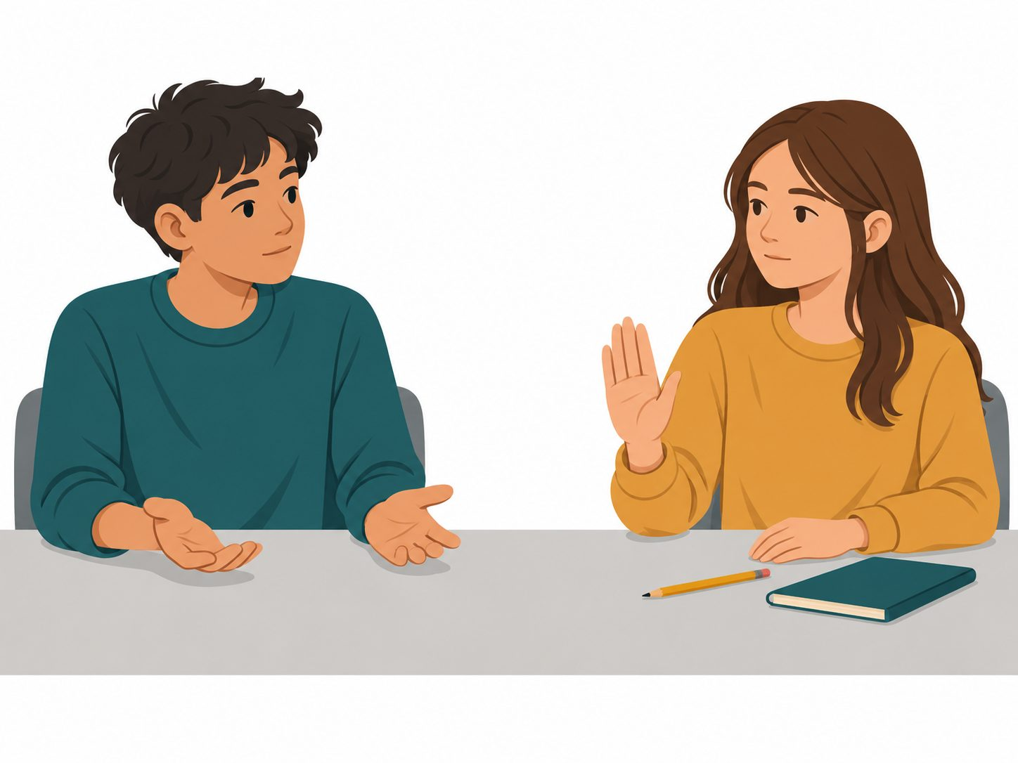
A peer says no to lending a pencil. The teen leaves the pencil alone.
Which act shows care in this story?
A helpful choice | Another choice
The teen can respect no and find another pencil. | The teen can keep asking until the peer gives in.

Cards for the fictional case
Sort each act.
Story card | Story card
A. A teen asks to use a pencil. The peer says no. The teen leaves it alone. | B. A peer laughs at a young person’s wrong answer.
C. A young person says no to a game. A peer keeps asking them to join. | D. A peer waits while a young person uses an aid to give a reply.
E. A peer says a young person must give up a snack or cannot join the group. | F. A peer says a young person’s work is rubbish.
Point, say, draw or write. An adult can read. + care ! harm ? help

A response for the young person
Action choice | Action choice
Move away if it is safe. | Ask a trusted adult for help.
Say stop if it is safe. | Give in to keep the peace.
Act | Next step
Caring | Respect the choice
Unkind | Get help if needed
Pressure | Get help; no need to give in
One next step for the young person
________________________________________________
Choices and reasons
Record | Story card | Next step
Choice | ________ | ________
Act chosen
Reason from the story
Every answer is about the made-up young person.

