A route to help
First choose a helper. Then show the request and next step.
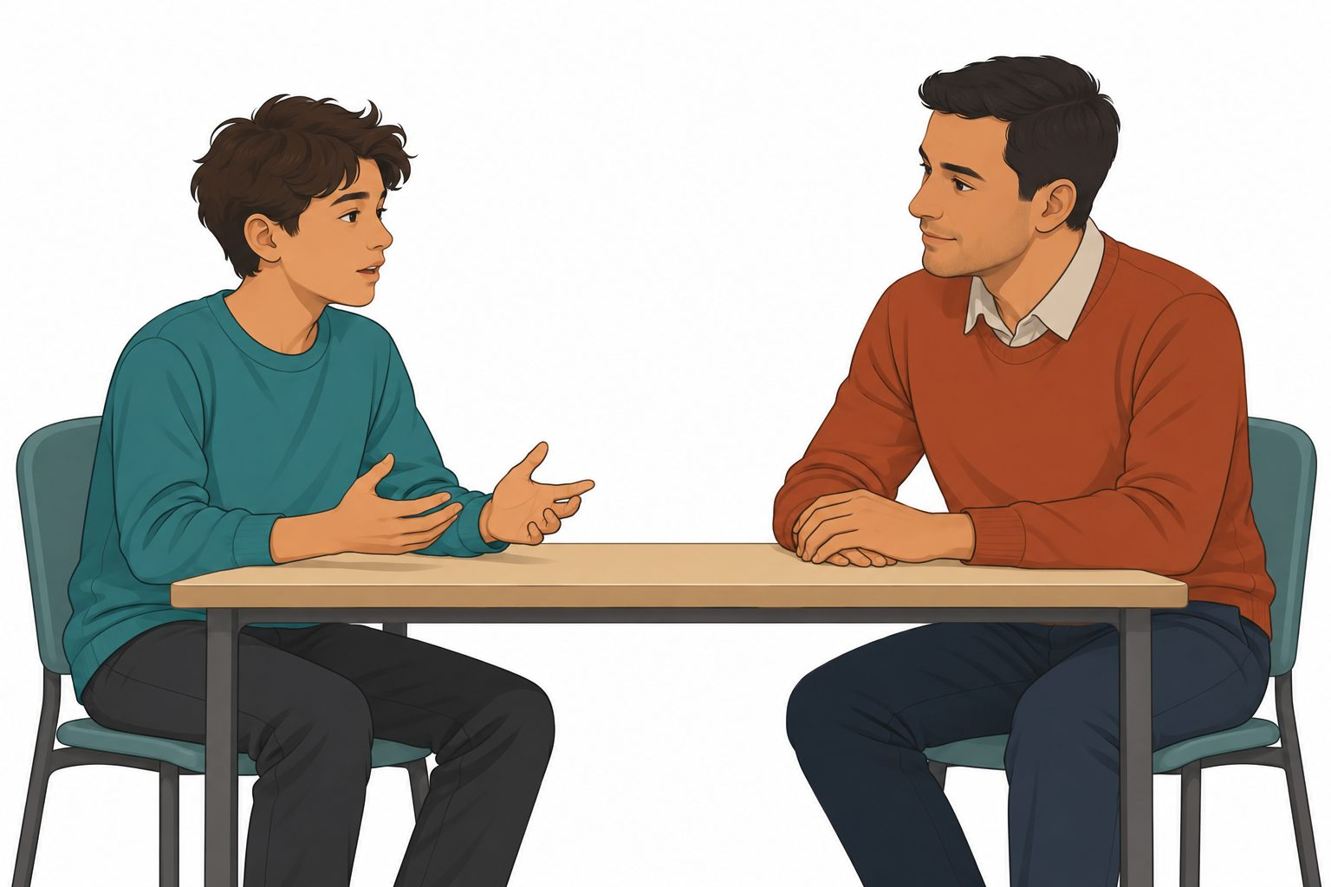
A young person has a worry in the story. They ask an adult they trust for help.
What could the adult do to help?
A helpful choice | Another choice
The adult could listen and help with the worry. | The adult could ignore the worry.

Cards for the fictional case
Choose a next step for each story.
Story card | Story card
A. A peer keeps hiding a young person’s work. The young person wants help. | B. The young person goes to the tutor for help. The tutor is away.
C. The tutor has heard the worry. The work is still being hidden and the teen needs help. | D. A young person wants help but finds speaking hard.
E. A peer asks the young person to keep a worrying act secret. | F. A young person fears they may be hurt now.
Point, say, draw or write. An adult can read. ? ask ! help now

A help route for the young person
Adult role | Adult role
Tutor in the story | Duty adult in the story
Another trusted adult | An adult who can find the duty adult
When | Next step
First route | Tell the tutor
Tutor away or help not received | Tell the duty adult
Harm may happen now | Get urgent help now

Request choices for card A
The teen needs help. A peer hides their work. Could the adult help?
The teen wants a new game.
A help request about the hidden work
________________________________________________
The route and follow-up
Record | First adult | Next adult
Role | ________ | ________
Help request
If help has not come
Every answer is about the made-up young person.

