Fair turn support
25 February 2027 | P3
White paper | Point, tell, write or ask an adult to write.

Ready starter
Two pupils want one pen. Choose the fair plan.
A One keeps the pen all the time.
B Both have a turn.

Words
fair, turn, wait, help, both, grip

Start
I choose __. It is fair because __.

Model
I choose B. Both have a turn.
Point, tell or ask an adult to write. You can rest or ask for help. Finish: show your choice in a quiet way.
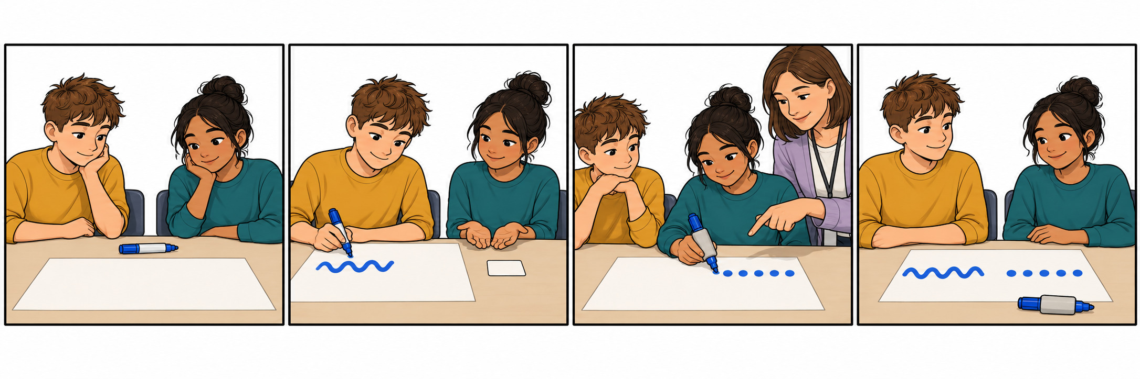

Fair turn support continued
25 February 2027 | P3
White paper | Point, tell, write or ask an adult to write.

Talk frame
It is fair because __.
Both can __.
The grip helps __.

Words
fair, turn, wait, help, both, grip, draw

Model
It is fair. Both have a turn.
The grip helps the next pupil draw.

My own line
In your book: give one line. You can point to words, tell an adult or write. An adult can write your words and read them back.

Keep or change
Listen to your line. Say or point to keep or change. Show one change after one next step.
You can pass or rest. Plan in any language. Use your usual aid.

