Fair turn words
25 February 2027 | P3
Pink paper | Point, tell, write or ask an adult to write.
Word | Meaning in the story
fair | Both get a turn and the help they need.
turn | A time when you can use the pen.
wait | Let the other pupil have a turn.
help | Make a task easier to do.
both | The two pupils.
grip | A thick part that helps you hold the pen.

Start and model
Start: It is fair because __.
Model: It is fair. Both have a turn.
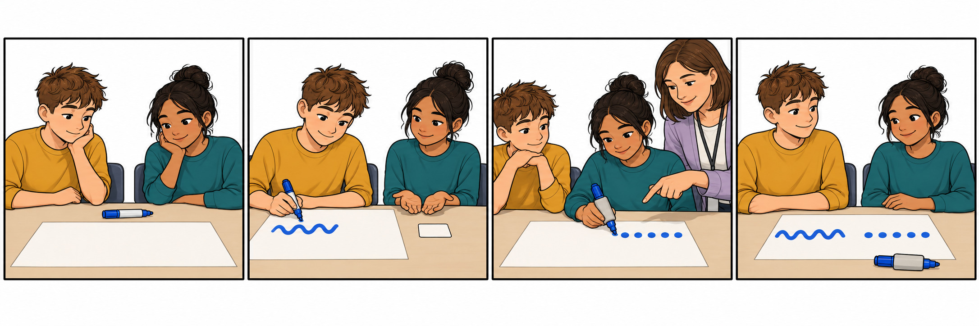
Point, tell or ask an adult to read. Use these words with the story and your book line.

