My care plan record
11 March 2027 | P3
White paper | Point, tell, write or ask an adult to write.
My code ____ Date ____
Identify ways to care for others (links PSHE).
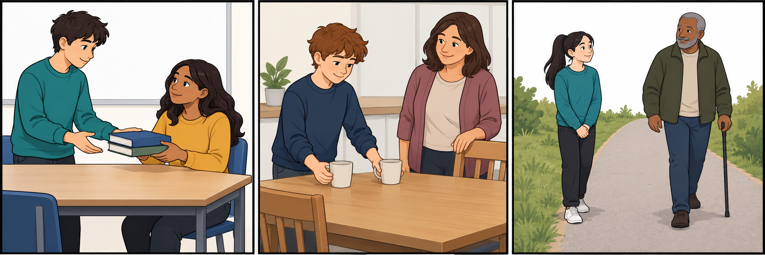
School: ask before helping with books.
Home: share a small task with an adult.
Shared path: leave room to pass.

Our one class plan
In your book: keep our plan for Week 5.
What could we do? __
Who could help? __
What kit would we need? __
Which adult should we ask? __

Words start and model
care, ask, help, share, space, plan
Start: We could __. We would need __.
Model only: We could make a book tray. It could help the class.
Point, tell or ask an adult to write. Keep or change. Plan only: we do not do it today.

My care plan record continued
11 March 2027 | P3
White paper | Point, tell, write or ask an adult to write.

Adult record
Record actual choices and help only. This lesson plans a future action; no completion or future banking is prefilled.
Record | Actual evidence
Code/date | ________________
Caring choices school/home/community | ________________
Sort or reason | ________________
One agreed class proposal or open choice | ________________
Pupil’s contribution | ________________
What/who/kit/adult check | ________________
Actual response and reading mode | ________________
Actual prompts/adult content | ________________
Read-back keep/change | ________________
Voice and audience reply | ________________
One NS and pupil response | ________________
R after reply and response | ________________
Review and actual banking E | ________________
Offer authentic work to the Communication portfolio. Do not mark the Week 5 action as delivered.

