Care choices and plan
11 March 2027 | P3
Pink paper | Point, tell, write or ask an adult to write.

Ready starter
A pupil has books to carry. Choose a caring action.
A Ask, Can I help?
B Grab the books.

Words
care, ask, help, share, space, plan

Start
I choose __. This cares because __.

Model
I choose A. They ask first.
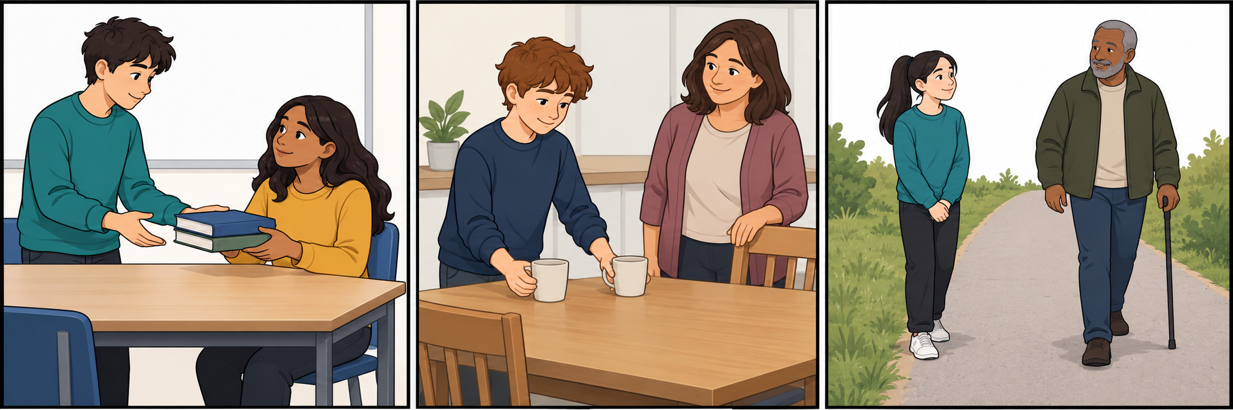
Point, tell or ask an adult to write. Show your choice in a quiet way. You can rest or ask for help.

Care choices and plan continued
11 March 2027 | P3
Pink paper | Point, tell, write or ask an adult to write.

One class plan for later
Choose ONE with the class:
A Set up a tidy book tray.
B Make a class help card.
Ask an adult to check the plan.

Words
care, ask, help, share, space, plan, tray, books, card, adult

Start
We could __ in Week 5.
__ could help.
We would need __.
We should ask __.

Model only
We could set up a tidy book tray.
Pupils and an adult could help.
We would need a tray, books and labels.
We should ask the class adult.
This is a made-up model. Keep our chosen plan in the book. We plan today. We do the action only later, if agreed. You can pass or choose a seated role.

