Our action and closing record
25 March 2027 | P3
White paper | Point, tell, write or ask an adult to write.
My code ____ Date ____
“Take part in a class 'caring' action.”
“Reflect on fairness; evidence skills (the unit award).”
In your book: tell your real part and what helped.
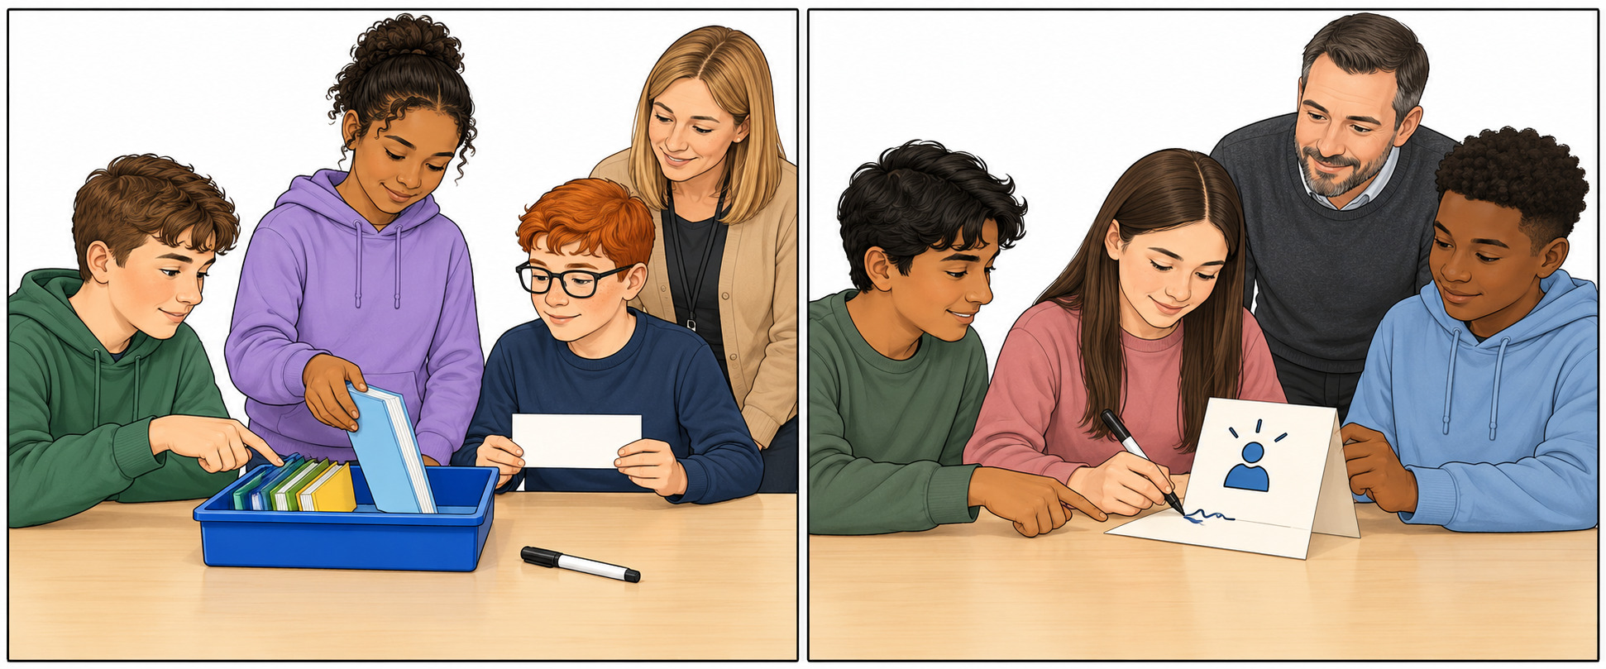
Two options shown. We do ONE agreed action.

Words start and model
care, ask, help, share, role, check
I helped by __.
It was fair because __.
We still need __.
Model only: I helped put books in the tray.
Use your own part. Point, tell, write or ask an adult to write. Keep or change your line.

Our action and closing record continued
25 March 2027 | P3
White paper | Point, tell, write or ask an adult to write.

Our task record
Fill in after the task. Leave blank until seen.
Record | What was seen
Code/date | __________________
Week 3 plan or gap | __________________
Our one job today | __________________
Kit/place check | __________________
Own role or choice | __________________
Task status | ( ) Took part ( ) Declined  ( ) Incomplete ( ) Absent
What helped or needs more work | __________________
Own words or choice | __________________
Read/listened/how shown | __________________
Help and words given | __________________
Read back keep/change | __________________
Voice and what the adult said | __________________
One NS and own change | __________________
File/book place/date/E | __________________
Check each pupil’s own part. Keep a line if the task was not done. R needs Voice and a reply from the adult. Set one NS. Keep the pupil’s own change before R.

Our action and closing record continued
25 March 2027 | P3
White paper | Point, tell, write or ask an adult to write.

Six outcome tick and comment grid
My code ____ Review date ____
Check real work from Weeks 1–5. Tick only after a check. Write actual help, a work ref and a short comment. Keep gaps open for a next check.
Quoted source outcome | Tick after check | Actual help comment or work ref
46 “Read an easy-read story that teaches fairness.” | ( ) Seen  ( ) More work  ( ) No record | Help/ref: ______  Comment: ______
47 “Talk about what is fair and unfair.” | ( ) Seen  ( ) More work  ( ) No record | Help/ref: ______  Comment: ______
48 “Identify ways to care for others (links PSHE).” | ( ) Seen  ( ) More work  ( ) No record | Help/ref: ______  Comment: ______
49 “Recognise people who stood up for fairness (Int'l Women's Day).” | ( ) Seen  ( ) More work  ( ) No record | Help/ref: ______  Comment: ______
50 “Take part in a class 'caring' action.” | ( ) Seen  ( ) More work  ( ) No record | Help/ref: ______  Comment: ______
51 “Reflect on fairness; evidence skills (the unit award).” | ( ) Seen  ( ) More work  ( ) No record | Help/ref: ______  Comment: ______
Actual next check/date ______
Staff check the unit award criteria separately. This grid does not claim the unit award is complete.

Our action and closing record continued
25 March 2027 | P3
White paper | Point, tell, write or ask an adult to write.

Closing checklist
My code ____ Actual review date ____
Tick each item only after it happens. Keep the pupil’s own words or choice. Leave a gap if the work is missing.
Check | Tick after check | Note or ref
Our one job agreed | ( ) | ________________
Kit and place checked | ( ) | ________________
Ask first and accept no | ( ) | ________________
Own role or choice seen | ( ) | ________________
It can be used | ( ) | ________________
Own book line kept | ( ) | ________________
Six rows and gaps checked | ( ) | ________________
Voice and adult reply | ( ) | ________________
One NS and own change | ( ) | ________________
File/book kept | ( ) | ________________
Real place/date and E | ( ) | ________________
Work offer made | ( ) | ________________
Actual place/date ______
Next check for gaps ______
Staff check the unit award criteria separately on the staff record. Keep a real date and file place. The ticks must show what happened.

