Our caring action and reflection
25 March 2027 | P3
White paper | Point, tell, write or ask an adult to write.
Route: Supported | My code ____
Do our ONE agreed class action. Then keep a short reflection in your book.
1 Choose one role. Ask first. Use the adult-checked kit.
2 Do or direct your part. Point to what helped.
3 In your book: choose words about your real part.

Words
care, ask, help, share, role, check

Start
I helped by __.
It was fair because __.
We still need __.

Model
Model only: I helped put books in the tray.
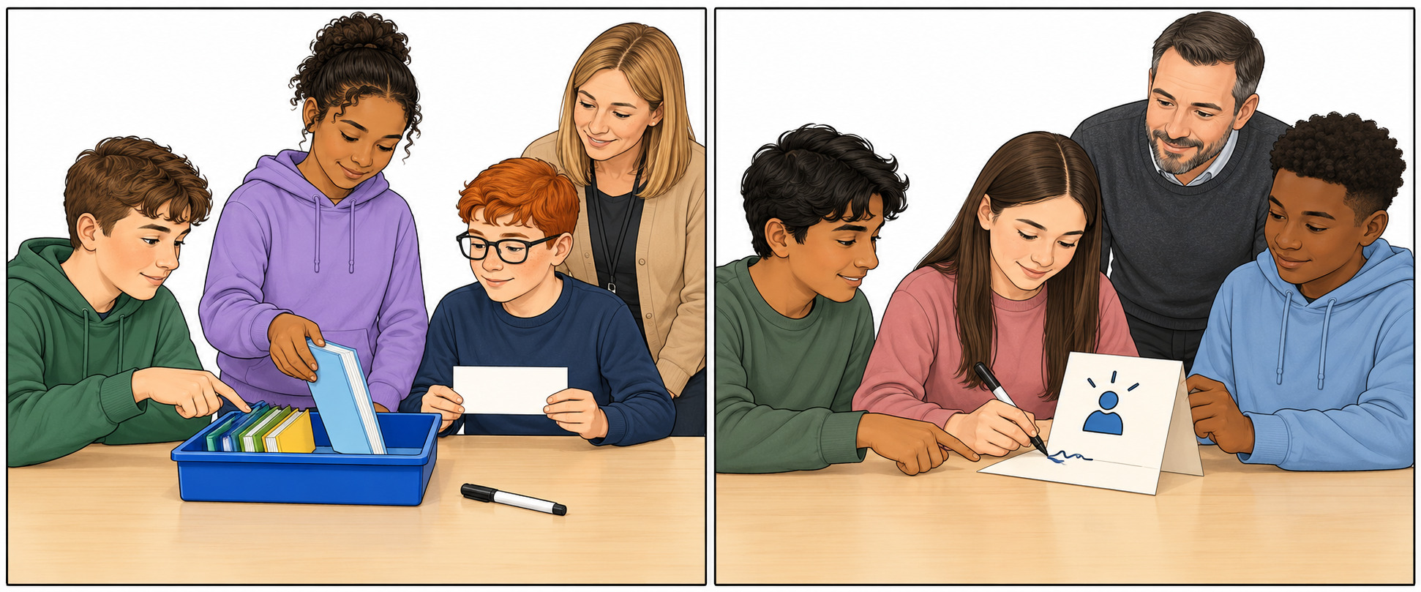
Two options shown. We do one: book tray OR help card.

Finish
Show your actual part and the benefit. Reflect on fair jobs. Keep or change your words. You can pass or rest.

Our caring action and reflection continued
25 March 2027 | P3
White paper | Point, tell, write or ask an adult to write.
Route: Independent | My code ____
Do our ONE agreed class action. Then keep a short reflection in your book.
1 Use our one agreed plan. Ask first and share the jobs.
2 Do your part. Check the real result with an adult.
3 In your book: say what you did and how it was fair.

Words
care, ask, help, share, role, check

Start
I helped by __.
It was fair because __.
We still need __.

Model
Model only: I helped put books in the tray.
Two options shown. We do one: book tray OR help card.

Finish
Show your actual part and the benefit. Reflect on fair jobs. Keep or change your words. You can pass or rest.

Our caring action and reflection continued
25 March 2027 | P3
White paper | Point, tell, write or ask an adult to write.
Route: Aspire | My code ____
Do our ONE agreed class action. Then keep a short reflection in your book.
1 Do your part in the one agreed class action.
2 Check the benefit. Make one useful change if needed.
3 In your book: say what helped and how jobs were fair.

Words
care, ask, help, share, role, check

Start
I helped by __.
It was fair because __.
We still need __.

Model
Model only: I helped put books in the tray.
Two options shown. We do one: book tray OR help card.

Finish
Show your actual part and the benefit. Reflect on fair jobs. Keep or change your words. You can pass or rest.

