Our class action steps
25 March 2027 | P3
Pink paper | Point, tell, write or ask an adult to write.

Use one agreed action
Use our real Week 3 plan if we have it. If not, agree ONE option now. Ask the class adult to check the kit and useful place.
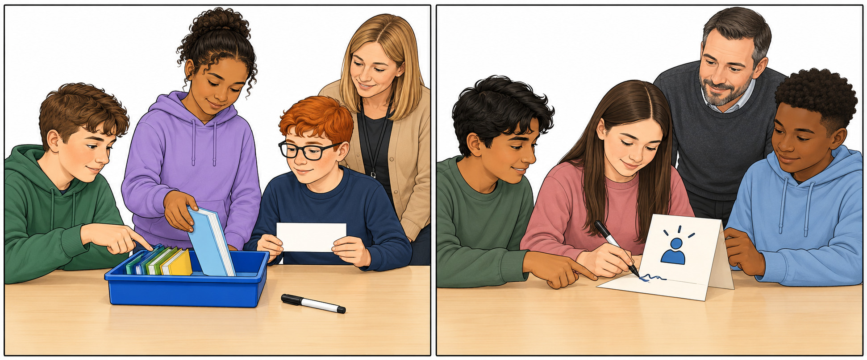
A Tidy book tray: shared light books, tray, label and pen.
B Class help card: one card, pen and a safe place to stand it.
Ask before you help. Wait for yes or no. Respect no. Use only adult-checked shared kit.

Words start and model
care, ask, help, share, role, check
Start: Can I help with __?
Model: Can I put these shared books in the tray?
These drawings show options. We choose and do ONE action. No Week 3 choice is filled in for us.

Our class action steps continued
25 March 2027 | P3
Pink paper | Point, tell, write or ask an adult to write.

Do check and reflect
Step | A Book tray | B Help card
1 Ask/check | Ask the adult. Use shared light books. | Ask the adult. Use one blank card.
2 Share jobs | Choose order; place books; label; check. | Choose words; make; point/read; check.
3 Do the job | Set up the tray in the agreed place. | Make one card. Put it in the agreed place.
4 Check use | Can someone find or return a book? | Can someone see where to ask for help?

Role choices
I can choose, make, place, point, read or check. An adult can write or move a part I choose. I can work seated.

Words start and model
care, ask, help, share, role, check
I helped by __.
It was fair because __.
Model only: I helped put books in the tray.
In your book: keep your own short reflection. Use We still need __ if a part is not done. Do not copy the model as your own work.

