Caring action support
25 March 2027 | P3
White paper | Point, tell, write or ask an adult to write.

Ready starter
Choose the caring way.
A Ask before you move shared books.
B Take them without asking.
If the answer is no, stop and ask the adult.

Words
care, ask, help, share, role, check

Start
I choose __ because __.

Model
I choose A because we ask first.
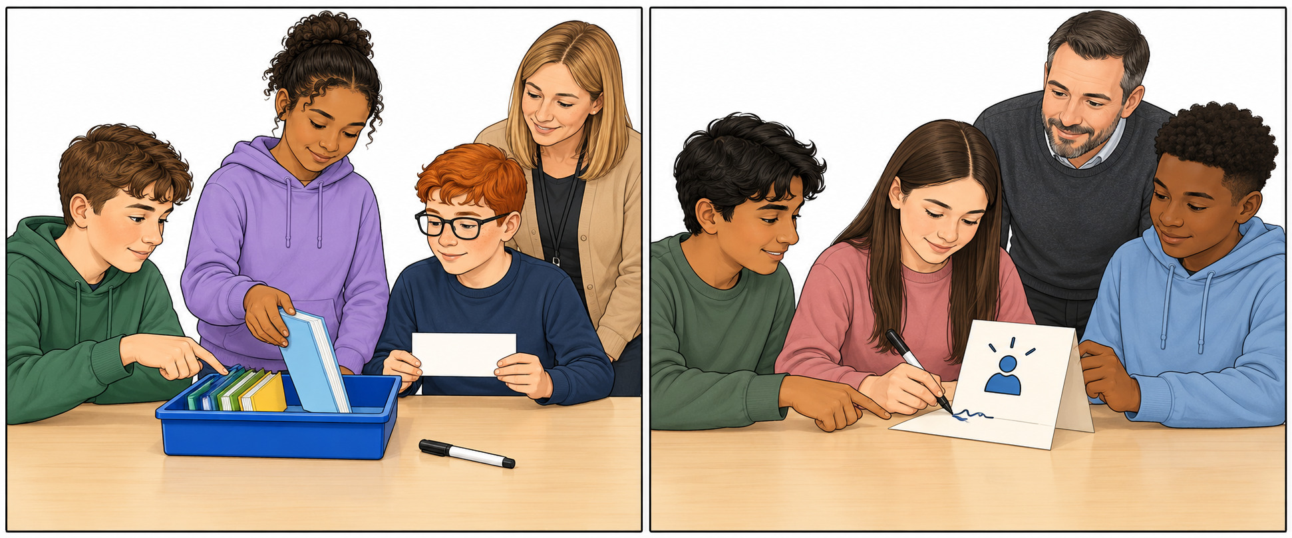
Point or tell an adult in a quiet way. You can rest or ask for help.

Caring action support continued
25 March 2027 | P3
White paper | Point, tell, write or ask an adult to write.

My role and reflection
Choose one real role: choose, place, make, point, read or check. Ask first. Listen to yes or no. Use the checked kit.

Words and starts
care, ask, help, share, role, check
I helped by __.
It was fair because __.
We still need __.

Models only
I helped put books in the tray.
It was fair because we shared the jobs.

Use your real part
Keep a short line in your book. An adult can write your exact words or chosen phrase and read it back. Keep or change it.
You can choose a seated checking role. You can pass or rest. If you pass on all roles, the adult keeps the action record open. Plan in any language. Use your usual aid.

