Caring action words
25 March 2027 | P3
Pink paper | Point, tell, write or ask an adult to write.
Word | Meaning in this lesson
care | Act in a way that helps and respects choice.
ask | Check if help is wanted.
help | Make a task easier or a shared place more useful.
share | Let each person have a fair part.
role | Your part in the task.
check | Look to see if it is safe and useful.

Start and model
I helped by __.
It was fair because __.
Model only: I helped put books in the tray.
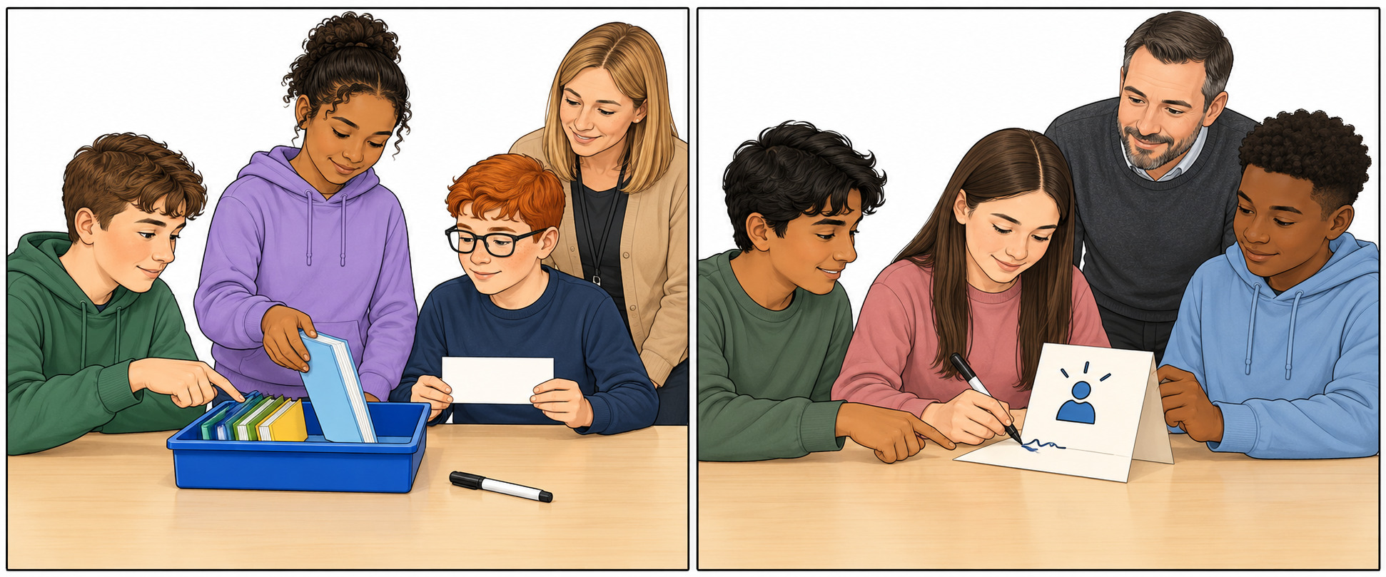
Two options shown. Do ONE agreed action. Point, tell or ask an adult to read. Use your own real part in the book reflection.

