Jobs and what workers do
White Standard sheet
Explore jobs and what people do (careers).
These workers are made up.
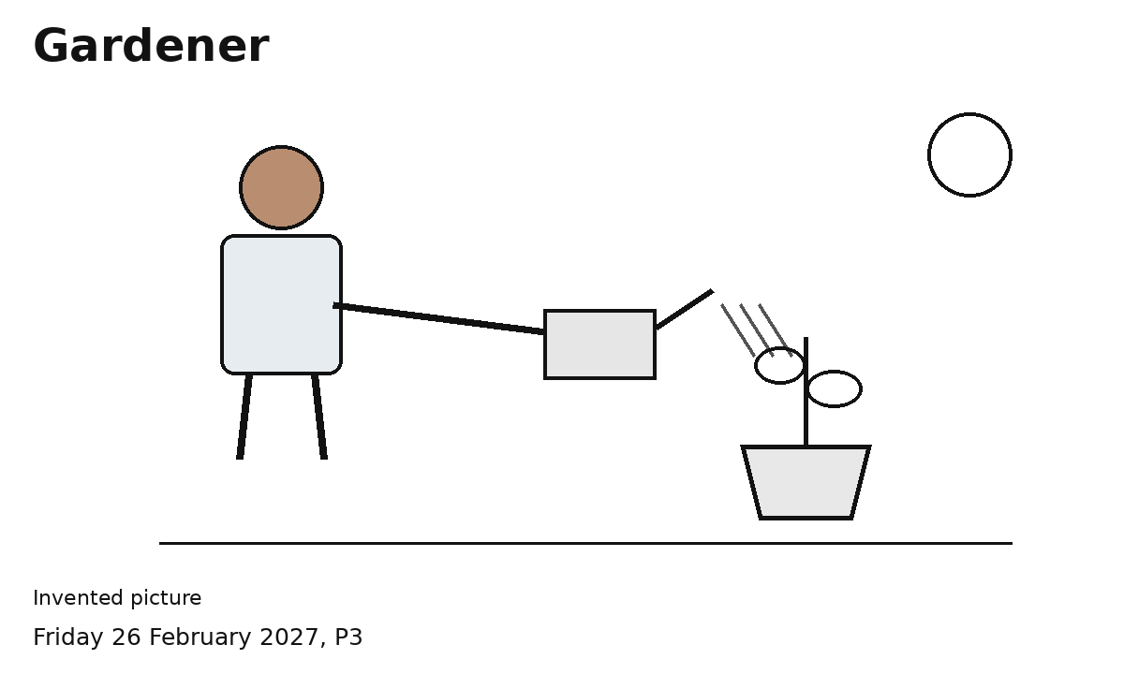
1 Pick one job picture.
2 Show or say what the worker does.
3 Try the two sort mats.
4 Pick a job to find out about.
One picture at a time is fine.
You can point, speak or ask an adult to write.

