Match items for a work task
Pink Supported sheet
Match tools/clothing to a job.
These job tasks are made up.
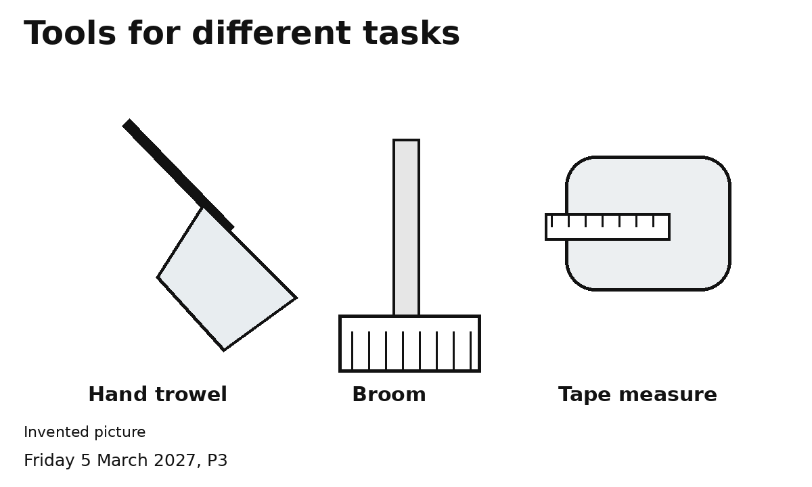
1 Pick a task. Match one tool.
2 Pick a protective item. Show why.
I can dress the picture with help.
Ask an adult to check first.
You can point, speak or ask an adult to write.

