Our real classroom work task
Pink Supported sheet
Carry out a simple work-related task.
The picture is a made up example.
Our classroom job is real.
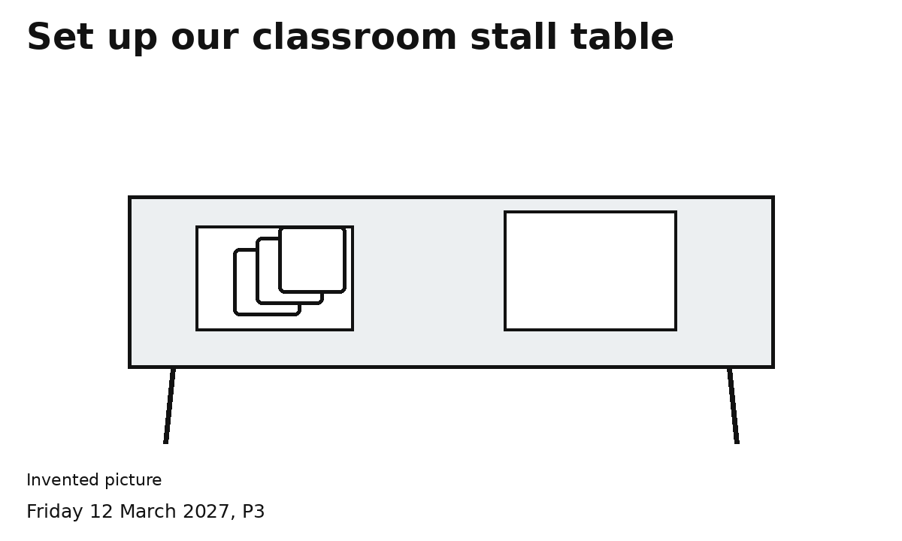
Steps 1 and 2 Clear the space. Lay the mat.
Steps 3 and 4 Set out cards and sign. Check.
Use light items. Ask for help if needed.
You can point, speak or direct an adult.

