Ask and answer at work
White Standard sheet
Practise asking and answering at 'work'.
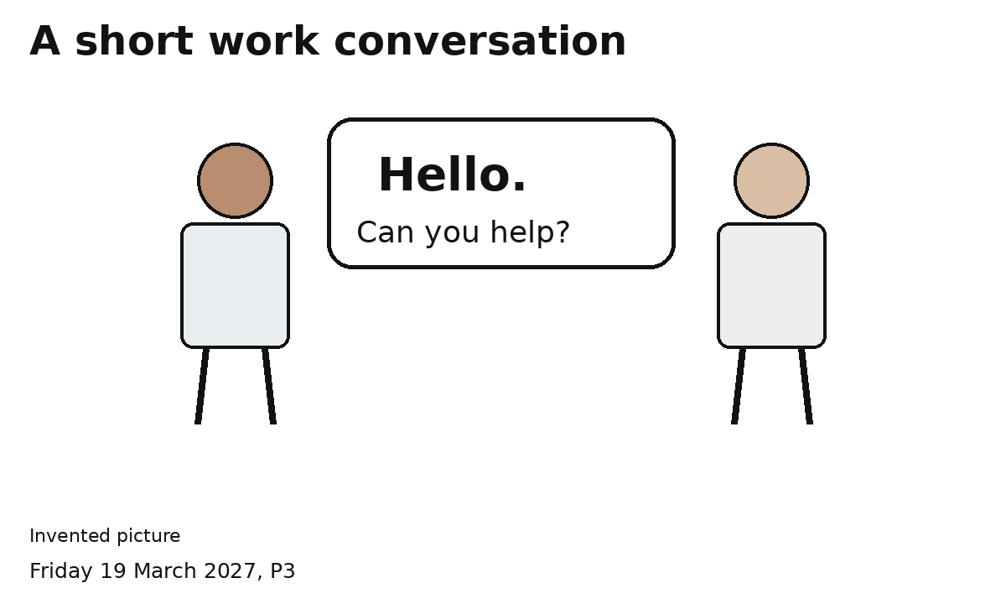
Greeting: Hello.
Partner: Hello.
Ask: Can you help with the sign?
Answer: Yes. I can help.
Swap. Both people ask and answer.
Point to words or use a gesture if you want.

Say the job is done
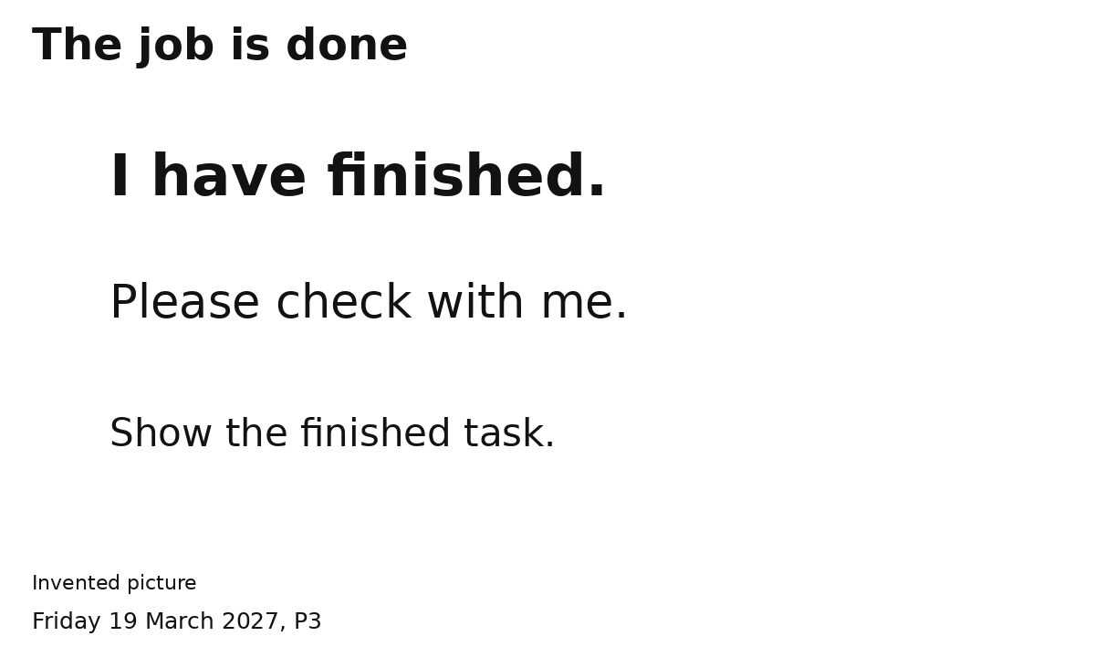
I have finished.
Please check with me.
Partner: Yes. Let us check.
Practise first. Use this after the real job.

