Prepare our classroom stall
White Standard sheet
Practise asking and answering at 'work'.
Take part in class enterprise prep.
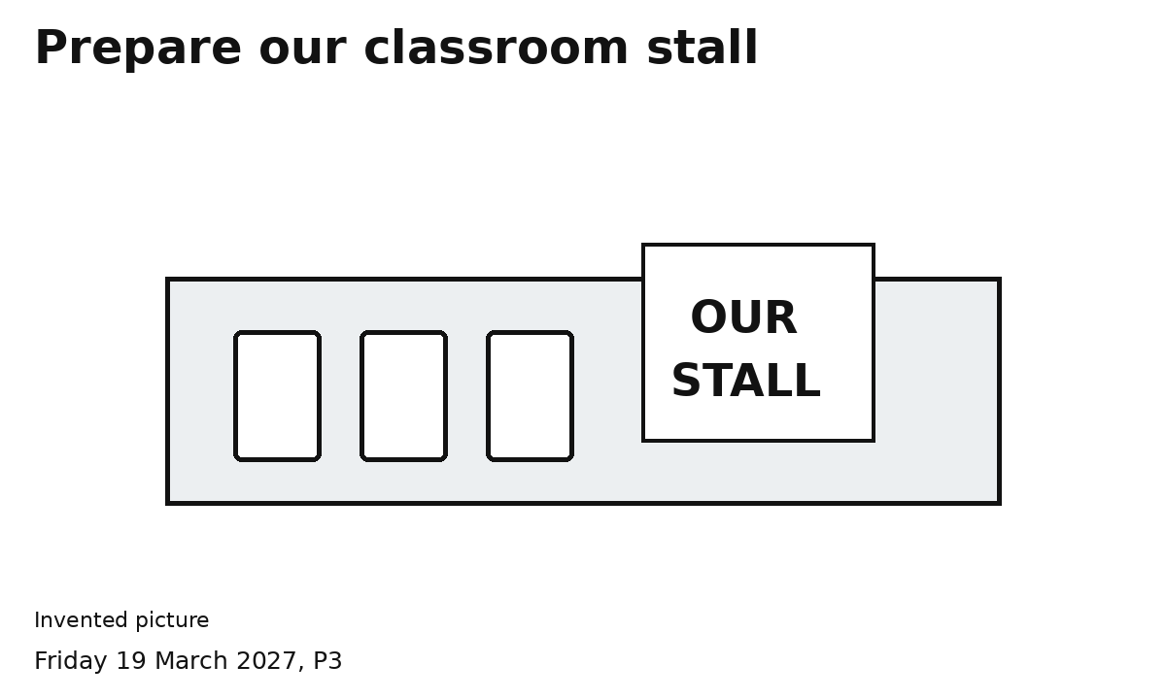
1 Choose where the three items will go.
2 Arrange three light paper items and a sign.
3 Check: stable items, clear edge and way past.
Both people make a choice and help.
Use the table space agreed with an adult.

