Our two workplace jobs
Pink Supported sheet
Practise asking and answering at 'work'.

Job 1 A short conversation
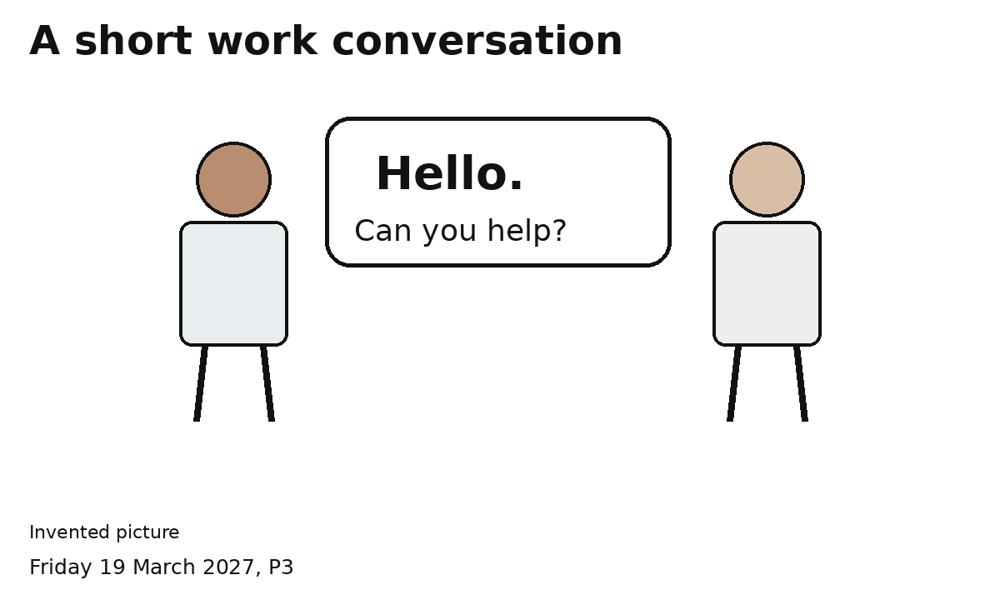
Hello.
Can you help with the sign?
Yes. I can help.
Swap. Each person asks and answers.
Speak, point or gesture.

Job 2 Prepare our classroom stall
Take part in class enterprise prep.
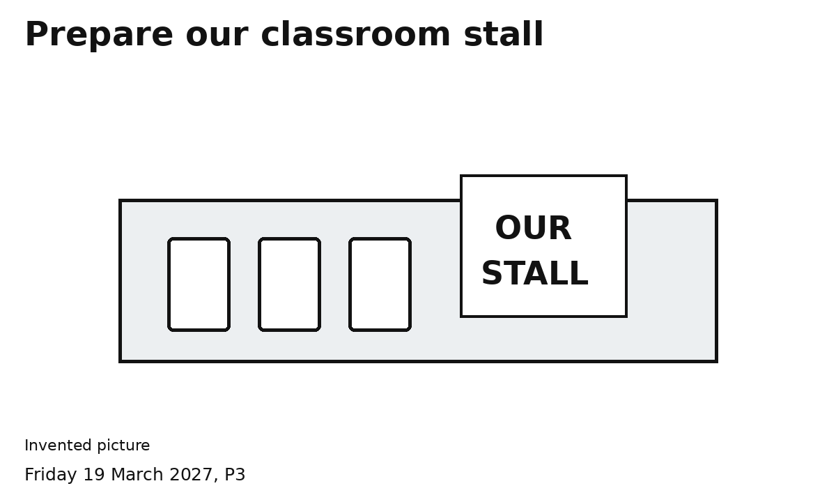
Choose a place for the items.
Arrange three light items and the sign.
Check together. Tell your partner it is done.
Both people choose and help.

