Knowledge organiser for atlas skills
Friday 26 February 2027 | P2 | 40 minutes | Year A
Humanities | GROW | Spring 2 Week 1 | HUM-GROW-S2-W01
Learning outcome: Use atlases and maps to locate climate zones and hazards.
An atlas is a book of maps. An index helps you find a place. Our atlas has one page. The grid helps you find a box. Read the letter across, then the number down.
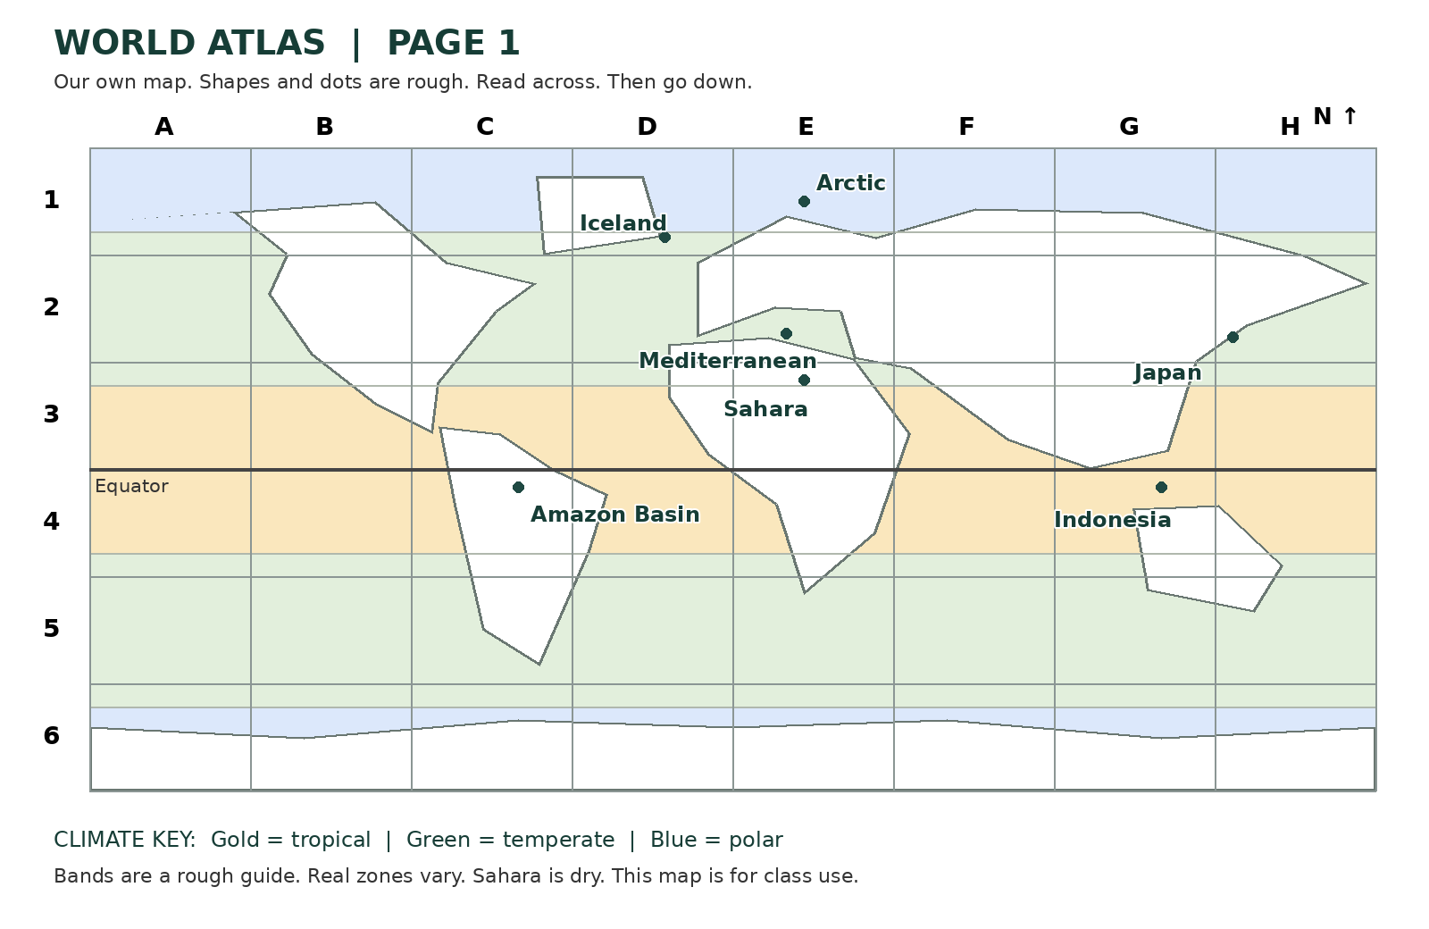
Word or mark | Meaning
Tropical | Hot through the year, near the Equator.
Temperate | Between tropical and polar areas. Seasons vary.
Polar | Very cold for much of the year, near the poles.
Dry | Very little rain. The Sahara is a dry region.
Circle | Earthquake hazard.
Triangle | Volcano hazard.
Climate is the usual weather over many years. A hazard is something that could cause harm. A hot climate does not cause an earthquake. Many earthquakes and volcanoes occur near plate edges.
Where this leads: map makers and people who plan journeys use an index, grid and key.

