Atlas page and index
Friday 26 February 2027 | P2 | 40 minutes | Year A
Humanities | GROW | Spring 2 Week 1 | HUM-GROW-S2-W01
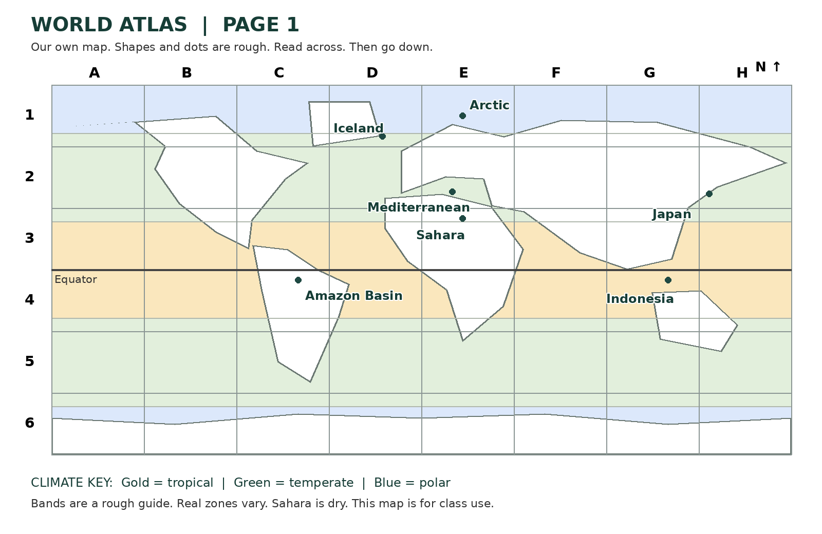
Page 1 index | Box | Climate or hazard clue
Amazon Basin | C4 | Tropical
Mediterranean | E2 | Temperate
Arctic | E1 | Polar
Japan | H2 | Earthquake
Indonesia | G4 | Volcano
Sahara | E3 | Dry
Iceland | D1 | Earthquake and volcano
This invented atlas uses approximate outlines and points. Grid references are correct for the points shown. Read letter then number. It is for classroom map practice, not navigation or local safety.

