Pupil facts and card codes
Friday 19 March 2027 | P2 | 40 minutes | Year A
Humanities | GROW | Spring 2 Week 4 | HUM-GROW-S2-W04
Today we compare groups and show map and data evidence.
You may point, write, type, speak in private or direct a scribe. You may pass. Reading aloud is your choice.
The groups are invented. All may use evidence, reason and care. Compare their stated values and actions without ranking beliefs. The UK data are real national means, not a measured local trend. The map has rough shapes and country dots. No personal faith or experience is requested.
Value Finder reads the card. Action Checker finds what the group plans to do. Swap after one card. All groups can use reason, data and care.
Card | Newly written fact
A Invented Group A | Some members draw on Christian care for creation and neighbours. They plan to use less energy at the event and offer a shaded rest space.
B Invented Group B | Some members draw on Buddhist compassion. They ask what help people need. They plan a route and entrance that people using wheels can use.
C Invented Group C | Some members draw on humanist care for wellbeing. They plan shared travel and clear event notes. They use the same maps and data as the other groups.
Use these codes or ready-cut labels in your book. The cards are not quotations.

A guide for my book
Friday 19 March 2027 | P2 | 40 minutes | Year A
Humanities | GROW | Spring 2 Week 4 | HUM-GROW-S2-W04
In your book, make one small report. Keep your own map check: locate UK and Japan, then add a key. Present the UK values for 1980 and 2025 with years and C units. Give one careful data statement. Compare Groups A and B: one shared aim, one different action and a link to a stated value.
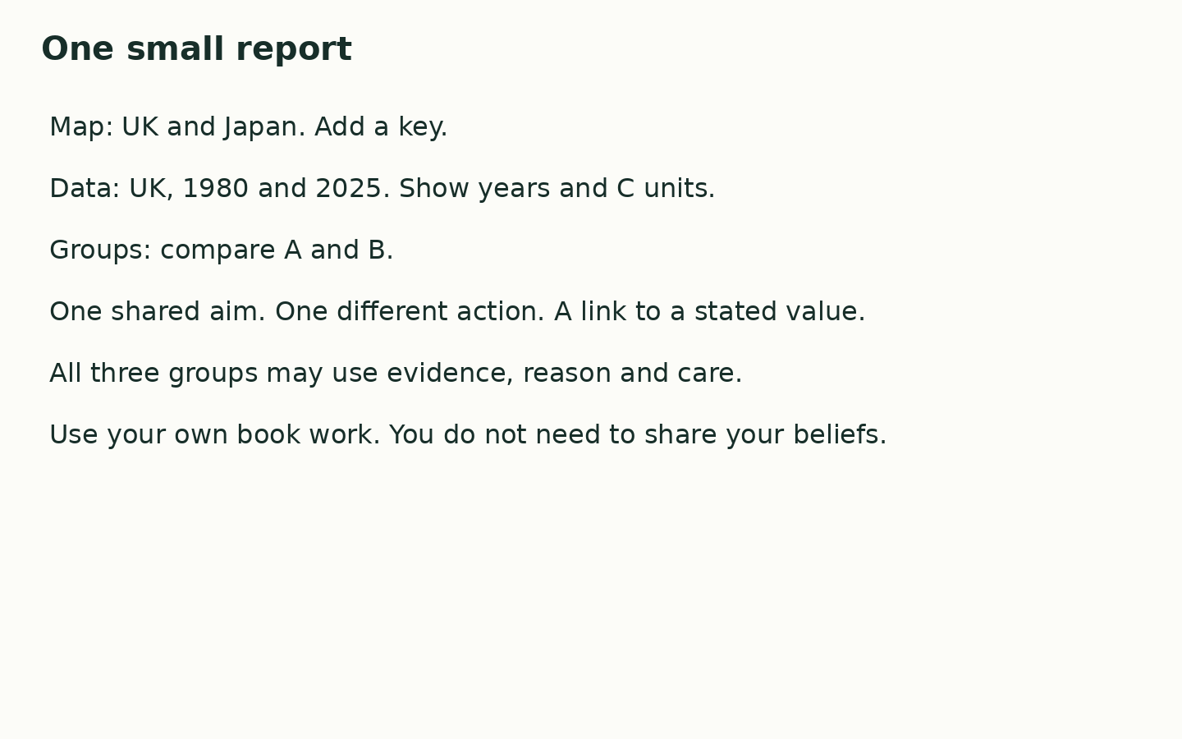
My map shows ____. The UK mean was ____ C in ____ and ____ C in ____. Both groups ____. Group A ____, while Group B ____. One reason is ____.

My check
I used the facts. I made my own choices. I gave a reason. I can show the help I used.
Use the agreed quiet signal for a pause. Stay with the adult in the usual place. Rejoin with one card check. A neutral shape task is ready.

