Adult model of a folded stand
Design and Technology LAUNCH Spring 2 Week 1 Thursday 25 February 2027 P1 Year A
One adult model to explain a possible idea. It is not a pupil design or a cutting template. Written measurements govern a later approved build.
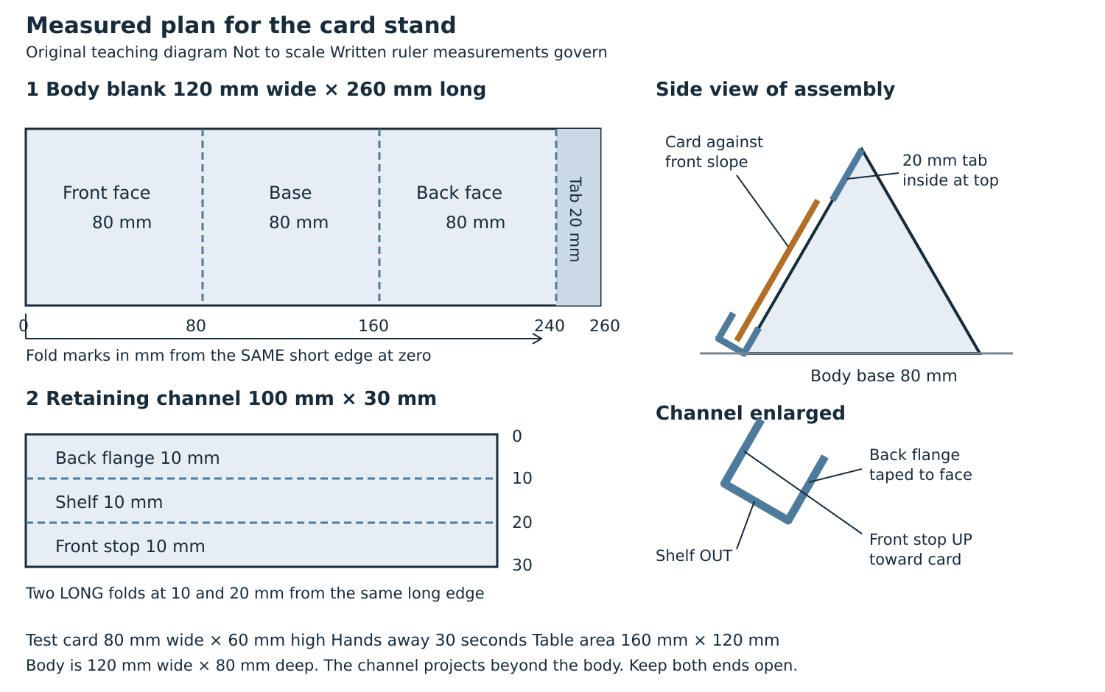

Think about its features
The broad base may help stability. The sloping face supports the card. The U channel catches the lower card edge. These are design predictions. The actual card and made stand need testing later.

Keep your own choice
Compare this with two different ideas. You can adapt the model or choose another feasible shape, but record your own labels, reasons and any adult-approved revision. No cutting or joining is required today.

