Card stand planning knowledge organiser
Design and Technology LAUNCH Spring 2 Week 2 Thursday 4 March 2027 P1 Year A
Weekly outcome verbatim: CONSTRUCTION: select materials and plan the build.
I can choose a material and safe join, plan the parts and steps, and check a card mock-up.

Today I can
[ ] I can link a material property to the stand purpose.
[ ] I can record sizes, tools and a safety step in my plan.
[ ] I can make a card mock-up and use it to improve the plan.

The useful problem
Invented client Sam needs one landscape paper prompt card to stay upright on a clear desk. The card is 80 mm wide and 60 mm high. The default body base is 120 mm by 80 mm. The whole stand, including the channel, should fit a clear table area 160 mm wide by 120 mm deep. Design a small tabletop stand that supports it for 30 seconds without a hand, is easy to move, and has no loose sharp parts. Do not use a phone, cable or personal item for the test.

Default material and join
Adult model: thin card for the Week 2 mock-up and paper tape for the cold join. Thin card is easy to fold. The triangular shape may hold the card upright. Test the actual mock-up. A final material change needs a revised plan and adult check before Week 3.

Remember the parts
Body 120 by 260 mm, crosswise folds 80, 160 and 240 mm from the same short edge. U channel 100 by 30 mm, long folds 10 and 20 mm from the same long edge. Test card 80 by 60 mm.

Resilience and change
A mock-up can show a useful change before the main build. Record the real result and keep your revised plan. A model description or imagined test is not practical evidence.
Book first. Plan in any language. Point, speak, sign or confirm a scribe’s words.

Material properties for the stand
Design and Technology LAUNCH Spring 2 Week 2 Thursday 4 March 2027 P1 Year A
Choose using a real sample result or model information. Link the property to the job. The default mock-up uses thin card and paper tape.
Material | Model property | Possible use or limit
Card | Usually light and easy to fold. Thin card may bend or sag. | Useful for a small mock-up. Test the actual card.
Corrugated board | A fluted middle often adds stiffness for its mass. Edges can crush. | Possible stand material. Compare the actual piece and flute direction.
Dowel | A round rod, often wood. Its diameter affects its size and fit. | Would need a different approved design and safe prepared lengths.
Soft wood | Wood from certain kinds of tree. It is not always soft to touch or easy to cut. | May be stiff but needs a suitable revised plan and adult-approved hand tools.

A choice with a reason
I choose ___ because its ___ helps the stand ___. My source is an actual sample result / model information ___. One limit or question ___.
These are model descriptions. The actual material, thickness, direction and adhesive label matter. A picture or model description is not a test of a pupil sample. Hand tools only. No powered or heated tool is used in this block.

Joining choices and material trials
Design and Technology LAUNCH Spring 2 Week 2 Thursday 4 March 2027 P1 Year A
Join | Model property | Control or limit
PVA adhesive | A water-based glue that can suit some porous materials. Suitability varies. | Use only after adult label and material checks. Hold the join as directed and wait for full cure.
Hot glue | A heated adhesive join can bond some materials. Hot parts and glue can cause burns. | Compare only in this block. No hot-glue tool or heated adhesive is used.
Paper tape | A cold join that can hold light card folds together. | Default for tab and channel. Test the actual tape and card; no tape around skin.

Actual sample trial or not tested
With adult approval, bend a small sample gently, release it, and look at the fold and edge. Compare stiffness and ease of folding. No sawing, drilling, blade scoring or heated tool is needed.
Sample ___. Thickness or direction if known ___. Actual action and result ___. Adult help ___. Not tested or still needed ___. A model description alone is not a trial.

Keep the final choice
For a different material or join, revise sizes, tools and controls with the adult before making. For PVA, follow the actual label and full cure before testing. Hot glue is comparison only and is not used.

Measured parts and fold marks
Design and Technology LAUNCH Spring 2 Week 2 Thursday 4 March 2027 P1 Year A
Use the pupil’s approved Week 1 design. This is the default adult model. Any revision needs matching new sizes and adult approval.
Part | Qty | Written size
Body blank | 1 | 120 mm wide by 260 mm long
U channel strip | 1 | 100 mm long by 30 mm wide
Landscape test card | 1 | 80 mm wide by 60 mm high

Measure before cutting
Use ruler zero. Mark the body folds 80, 160 and 240 mm from the SAME short edge. The last tab is 20 mm. Mark two LONG folds on the channel at 10 and 20 mm from the SAME long edge.

Check for accuracy
Aim within 2 mm of each planned cut size and fold position. This guides improvement; it is not a grade. Recheck before cutting or folding. Do not measure a printed diagram.

Record actual sizes
Body actual width ___ length ___. Body fold marks ___. Channel actual length ___ width ___. Channel fold marks ___. One difference and action ___. Adult-prepared parts or help ___.

Flat parts diagram
Design and Technology LAUNCH Spring 2 Week 2 Thursday 4 March 2027 P1 Year A
Original teaching diagram. Not to scale. Written ruler measurements govern.
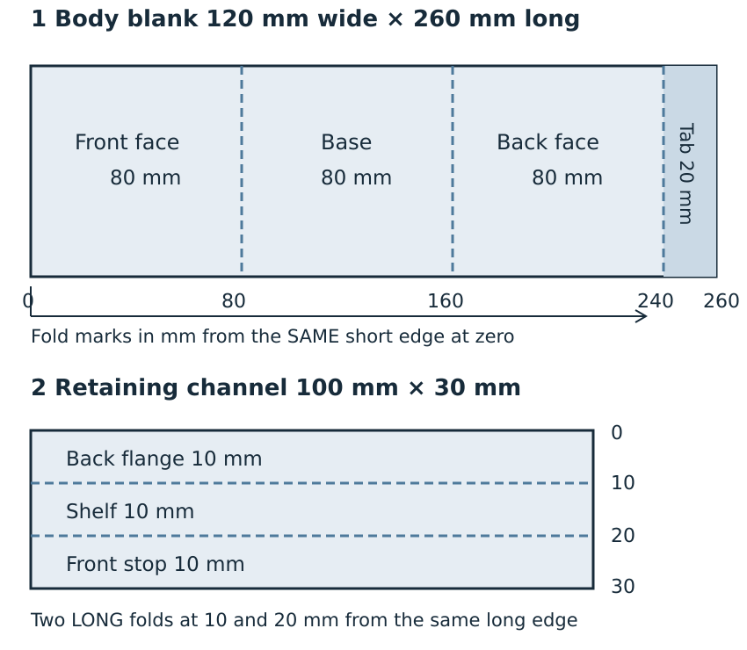
Body folds go across the width. Channel folds run along its length. Three body panels are each 80 mm; the tab is 20 mm.

My build plan with tools and safety
Design and Technology LAUNCH Spring 2 Week 2 Thursday 4 March 2027 P1 Year A
Copy or adapt this model in your book. Keep your own choices. Pause before cuts, folds, joins and testing. Stop and ask the adult if a check is unclear.
Step | Action | Tool or material | Safety and check
1 | Check the actual Week 1 design and sizes. Choose card and paper tape, or revise with the adult. | Ruler and pencil; material sample if available | Adult checks material, tool access and safe workspace first.
2 | Measure the two stand parts and test card. Mark all fold lines from the stated edge. | Ruler and pencil | Use ruler zero; recheck before any cut.
3 | Cut parts with suitable scissors, or direct the adult using prepared parts. | Adult-approved scissors | Fingers clear; close scissors at pauses; never force thick board.
4 | Fold at 80, 160 and 240 mm. Bring the last 20 mm tab inside. Tape the triangle closed. | Hands and paper tape | Fold on the flat surface; no knife scoring or heated tool.
5 | Fold the channel along 10 mm and 20 mm lines into a shallow U. Tape its back flange to the lower front face. Shelf out; front stop up. | Hands and paper tape | Adult checks the shelf is out and the front stop faces upward toward the card.
6 | Check with the test card for 30 seconds. Record one change and keep the final plan. | Test card and count or timer | Use a clear level desk. Hands away for 30 seconds; remove the card by hand. Stop if it tips or slips.

The card mock-up is a trial for the Week 3 main build. Keep it to reuse, finish or refine honestly. Do not call an unfinished model complete.

Join the triangle and U channel
Design and Technology LAUNCH Spring 2 Week 2 Thursday 4 March 2027 P1 Year A
Close the triangle with the last 20 mm tab INSIDE the top seam. Keep both ends open. Form the channel as a shallow U: back flange taped to the bottom of the front face, shelf OUT, front stop UP toward the card.
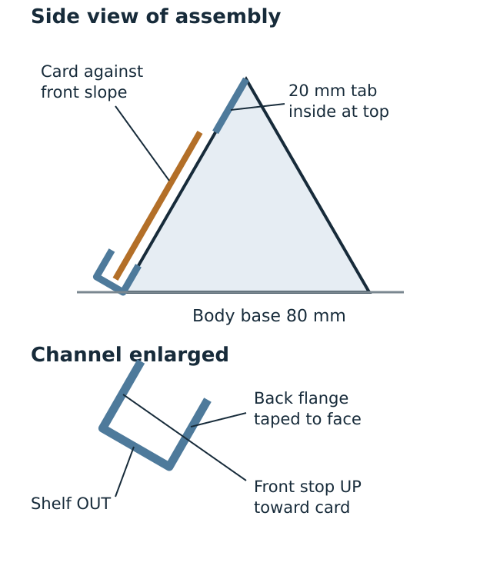
Original diagram. Not to scale. The body base is 120 mm wide by 80 mm deep. The channel projects beyond it; allow a table area 160 mm wide by 120 mm deep for the whole model.

Card mock up check record
Design and Technology LAUNCH Spring 2 Week 2 Thursday 4 March 2027 P1 Year A
Use the actual card model if safe and ready. If no model is made, write not made yet and keep the physical checks pending.
1 Measure each cut size and fold mark. Aim within 2 mm of the written size; use a difference to improve, not to grade.
2 Check the tab is inside the triangle and the U channel has its back flange taped to the lower front face, a shelf projecting out and an upward front stop.
3 Use one landscape 80 mm by 60 mm card. On a clear level desk, support it in the U channel for 30 seconds without a hand. Stop if the stand tips or the card slips.
4 Record what really happened, one change and why. A planned test is not a completed test.

Own words and real evidence
My material and join ___. Real trial result / model source ___. My mock-up is made / part made / not made ___. I did ___. The adult did ___. Test attempted yes / not yet ___. What happened ___. One change or next check ___. Why it helps the purpose ___. Date and book page ___.

Test only what is ready
Hands away for 30 seconds, then remove the one landscape 80 by 60 mm card by hand. No shaking, pushing, dropping, extra load or personal item. Stop if the stand tips or the card slips. For an approved PVA route, full cure must be complete before testing.

No materials
With no card, tools, paper or printer, hear the model material descriptions and written sizes. Point, speak or sign a material choice and reason. Rehearse the steps with empty hands. An adult records exact confirmed words when a recording method is available. Mark transcription pending until it exists. A card mock-up and material tests stay pending; rehearsal is not practical evidence.

Construction planning safety brief
Design and Technology LAUNCH Spring 2 Week 2 Thursday 4 March 2027 P1 Year A
An adult approves actual materials, hand tools and support before any practical. A plan or quiz does not authorise tool use.
1 Wait for the adult to approve the actual material, hand tool and work area. No power tools or heated tools.
2 The adult checks scissors are suitable for the actual card or board. If cutting is difficult, stop; use adult-prepared parts. Do not force the blades.
3 Cut seated or in the agreed stable position, on a clear surface. Keep fingers clear. Close scissors for pauses and carry them only as the adult has shown.
4 Use the agreed cold join. For PVA, the adult checks the actual label and materials. Follow the stated handling and full cure instructions. Do not guess a cure time.
5 Hot glue is a comparison only. Do not plug in or use a hot-glue tool. Dowel or wood cutting is not part of the default card route.
6 For any concern, stop, put tools down and tell the adult. Restart only when the adult has checked and cleared the concern.

Stop and check
Tools down. Compare with the written plan and measure. Ask the adult if unsure. Adjust one approved feature and recheck. Resume only when the adult clears the concern. Return tools and clear offcuts as directed.
No craft knives, blade scoring, saws or drills in the taught card method. Practical work not done stays pending.

