Facts for tectonic explanations
Tuesday 23 February 2027 | P2 | 40 minutes | Year A
Humanities | LAUNCH | Spring 2 Week 1 | HUM-LAUNCH-S2-W01
Pink paper version. Read quietly, point, write, type, speak privately or direct a scribe who reads your words back. You may pass. No public answer or reading aloud is required.
Original learning summaries based on checked science. These cards are not quoted source extracts. Codes C1–C5 name the cards. G codes link to research titles in SOURCE_MANIFEST.json. Use C1–C4 first. C5 adds a challenge.

C1 Plates moving apart
Use D1. Earth’s stiff outer layer is split into plates. They move slowly. At a divergent boundary, plates pull apart. Rock can crack or slip, causing shallow earthquakes. Hot mantle rock rises. As pressure falls, some rock melts. The magma can rise and erupt. Many such boundaries lie under the sea.
Think: How does the plate motion lead to the hazard? Research basis: G1, G4.

C2 One plate sinking
Use D2. At some convergent boundaries, an ocean plate sinks beneath another plate. This is subduction. Parts of the fault can lock while the plates keep moving. Strain builds in the rock. When the fault slips, energy travels as waves. This causes an earthquake. Water from the sinking plate helps hot mantle rock melt. Magma can rise and form volcanoes above the sinking plate.
Think: How does the plate motion lead to the hazard? Research basis: G1, G2.

Facts for tectonic explanations
Tuesday 23 February 2027 | P2 | 40 minutes | Year A
Humanities | LAUNCH | Spring 2 Week 1 | HUM-LAUNCH-S2-W01
Pink paper version. Read quietly, point, write, type, speak privately or direct a scribe who reads your words back. You may pass. No public answer or reading aloud is required.

C3 Plates sliding past
Use D3. At a transform boundary, plates slide past one another. Friction can hold parts of the fault still. Strain builds. A sudden slip sends out earthquake waves. Volcanoes are not usual at this type of boundary. The movement does not pull a gap open or push a plate deep into the mantle.
Think: How does the plate motion lead to the hazard? Research basis: G1.

C4 Japan earthquake example
Tohoku region, Japan. 11 March 2011. The Pacific plate sinks beneath northern Japan. Parts of this boundary had locked. The plates kept moving, so strain built up. A large part of the fault then slipped. Energy spread as waves and caused strong shaking. This explains why the earthquake occurred near a subduction boundary. The earthquake had a magnitude of 9.1 in the current event record. It was not caused by hot weather or an eruption.
Think: How does the plate motion lead to the hazard? Research basis: G3.

Facts for tectonic explanations
Tuesday 23 February 2027 | P2 | 40 minutes | Year A
Humanities | LAUNCH | Spring 2 Week 1 | HUM-LAUNCH-S2-W01
Pink paper version. Read quietly, point, write, type, speak privately or direct a scribe who reads your words back. You may pass. No public answer or reading aloud is required.

C5 Pattern and limits
Many earthquakes and volcanoes occur near plate boundaries. The pattern has a cause: plates meet and move there. Earthquakes can also occur inside plates. Some volcanoes form above hot spots away from boundaries. Where two continents collide, earthquakes can occur without a chain of volcanoes. A boundary map shows a broad pattern. It cannot tell the exact time of the next earthquake.
Think: How does the plate motion lead to the hazard? Research basis: G1, G4, G5.

Cause sorting strips
Earthquake: plate keeps moving / fault is locked / strain builds / fault slips / waves cause shaking. Put these in order.
Subduction volcano: ocean plate sinks / water helps mantle rock melt / magma rises / magma reaches the surface. Put these in order.
Keep these processes separate. The earthquake and volcano can share a boundary without one causing the other. A private pause is available.

D1 Plates moving apart
Tuesday 23 February 2027 | P2 | 40 minutes | Year A
Humanities | LAUNCH | Spring 2 Week 1 | HUM-LAUNCH-S2-W01
Pink paper version. Read quietly, point, write, type, speak privately or direct a scribe who reads your words back. You may pass. No public answer or reading aloud is required.
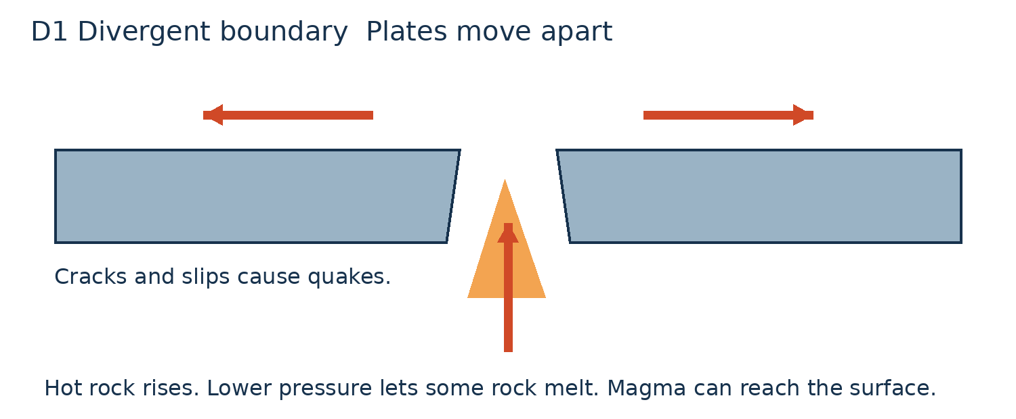
Point to where hot rock rises. Why can some rock melt?
This is a schematic diagram, not to scale. Arrows show relative motion. Use the matching fact card to explain the cause.

D2 One plate sinking
Tuesday 23 February 2027 | P2 | 40 minutes | Year A
Humanities | LAUNCH | Spring 2 Week 1 | HUM-LAUNCH-S2-W01
Pink paper version. Read quietly, point, write, type, speak privately or direct a scribe who reads your words back. You may pass. No public answer or reading aloud is required.
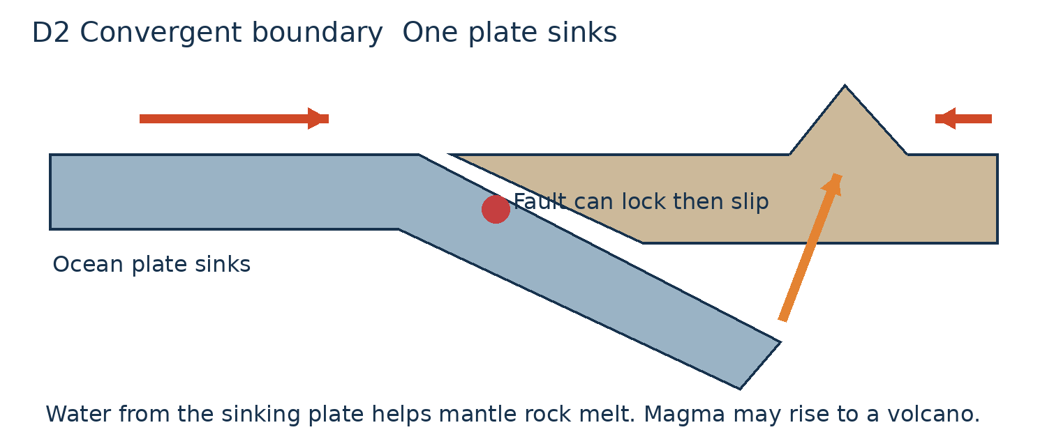
Point to the locked fault. Explain shaking. Then trace the magma path.
This is a schematic diagram, not to scale. Arrows show relative motion. Use the matching fact card to explain the cause.

D3 Plates sliding past
Tuesday 23 February 2027 | P2 | 40 minutes | Year A
Humanities | LAUNCH | Spring 2 Week 1 | HUM-LAUNCH-S2-W01
Pink paper version. Read quietly, point, write, type, speak privately or direct a scribe who reads your words back. You may pass. No public answer or reading aloud is required.
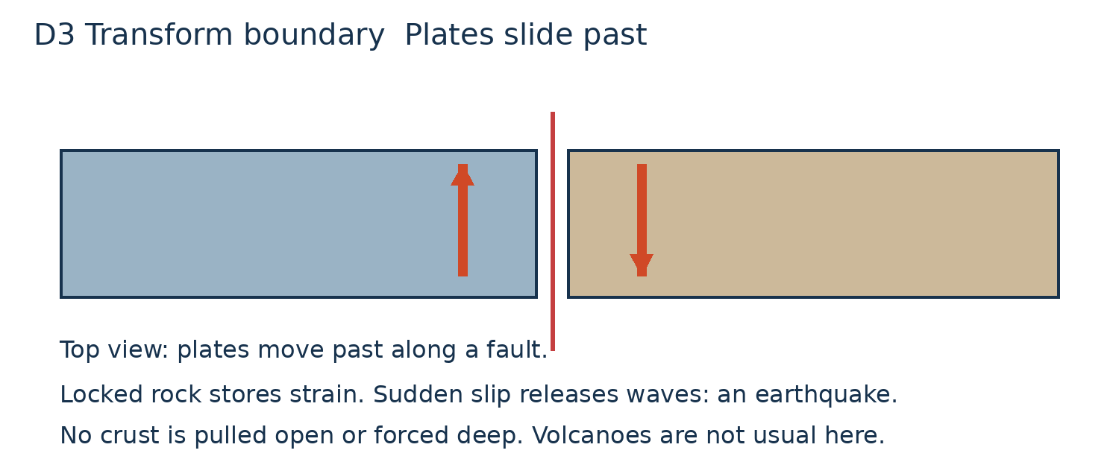
Follow both arrows. Explain why a fault might slip after a time.
This is a schematic diagram, not to scale. Arrows show relative motion. Use the matching fact card to explain the cause.

