Japan case facts and management cards
Tuesday 9 March 2027 | P2 | 40 minutes | Year A
Humanities | LAUNCH | Spring 2 Week 3 | HUM-LAUNCH-S2-W03
White paper version. Read quietly, point, write, type, speak privately or direct a scribe who reads your words back. You may pass. No public answer or reading aloud is required.
Original learning summaries based on checked facts. No source extract, map or picture is reproduced. C codes identify the cards. G codes link to research titles and records in SOURCE_MANIFEST.json.

C1 The same case and a direct effect
Tohoku region, Japan. 11 March 2011. Use the same USGS record as Week 1: magnitude 9.1 and depth 29 km. Strong ground shaking affected buildings and transport in northeastern Japan. Damage caused directly by shaking is a primary effect. A cause explains why the event happened. An effect explains what happened as a result. Research basis: U1, R1.

C2 A secondary chain and effects that overlap
The earthquake moved the sea floor. This displaced water and caused a tsunami, which flooded coastal areas. This is a secondary effect chain. The earthquake and tsunami damaged roads, railway lines and airports in the Tohoku region. Homes lost water, gas or electricity. Some damage had more than one process. Explain the evidence rather than forcing every service into one label. Research basis: J1, U1, R1.

Japan case facts and management cards
Tuesday 9 March 2027 | P2 | 40 minutes | Year A
Humanities | LAUNCH | Spring 2 Week 3 | HUM-LAUNCH-S2-W03
White paper version. Read quietly, point, write, type, speak privately or direct a scribe who reads your words back. You may pass. No public answer or reading aloud is required.

C3 Protection and preparation
Protection changes structures or physical exposure. Earthquake-resistant buildings and retrofits can reduce shaking damage. Coastal barriers can reduce some tsunami impacts, but in 2011 some were overtopped or damaged. Preparation builds readiness: practised evacuation plans, clear routes, education and emergency supplies help people respond. Japan reviewed education and evacuation practice after 2011. These approaches can work together. No measure guarantees safety. Research basis: U3, M1, R4.

C4 Warning is not exact prediction
Scientists cannot reliably predict an earthquake’s exact time, place and magnitude. Early warning uses sensors to detect an event that has already started. Japan issued an earthquake early warning 8.6 seconds after the first P-wave was detected at the nearest station. This was after detection, not 8.6 seconds after the earthquake origin time. Warnings can support prepared action, but time may be very short. Research basis: U2, J1.

Japan case facts and management cards
Tuesday 9 March 2027 | P2 | 40 minutes | Year A
Humanities | LAUNCH | Spring 2 Week 3 | HUM-LAUNCH-S2-W03
White paper version. Read quietly, point, write, type, speak privately or direct a scribe who reads your words back. You may pass. No public answer or reading aloud is required.

C5 Warning estimates and recovery
The earthquake began at 05:46:24 UTC. Japan issued the first tsunami warning at 05:49 UTC, about three minutes later. Initial estimates were too low and were updated. A warning has limits. Many people left unsafe or damaged homes and needed shelter or temporary housing. Rebuilding homes and transport links continued over years. In this lesson short term means first days or weeks; long term means months or years. Some effects span both. Research basis: J1, J2, R1, R2, R3.

Reasoning strips
Primary chain: ground shaking / building damage. Secondary chain: sea floor movement / water displaced / tsunami / coastal flooding. Management link: practised routes / people know a planned response / warnings can support action. Explain the steps with because and so. These are original learning summaries, not personal accounts.

D1 Two effect chains
Tuesday 9 March 2027 | P2 | 40 minutes | Year A
Humanities | LAUNCH | Spring 2 Week 3 | HUM-LAUNCH-S2-W03
White paper version. Read quietly, point, write, type, speak privately or direct a scribe who reads your words back. You may pass. No public answer or reading aloud is required.
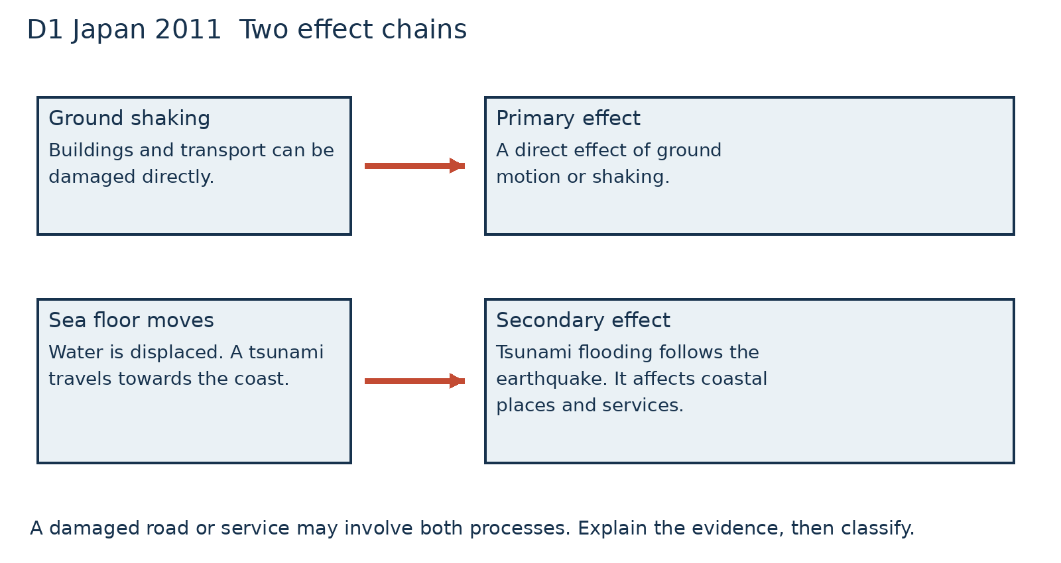
Trace one primary and one secondary chain. Then explain why a road or service may be affected by more than one process.
Original process diagram for the Japan 2011 case. The arrows show causal links, not a map or an exact time scale.

D2 Management and limits
Tuesday 9 March 2027 | P2 | 40 minutes | Year A
Humanities | LAUNCH | Spring 2 Week 3 | HUM-LAUNCH-S2-W03
White paper version. Read quietly, point, write, type, speak privately or direct a scribe who reads your words back. You may pass. No public answer or reading aloud is required.
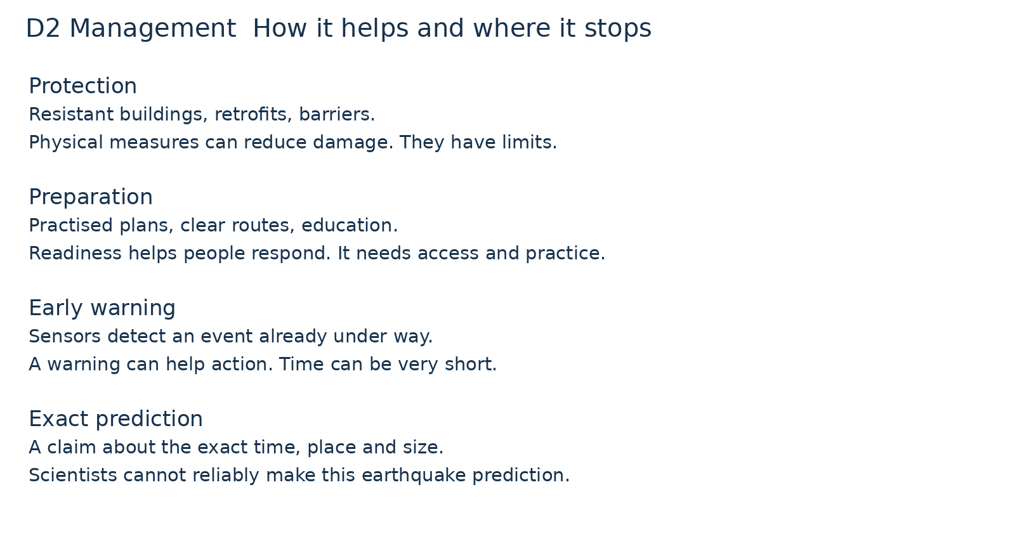
Choose one protection and one preparation measure. Link each to a case risk. State what the measure cannot guarantee.
Protection and preparation can combine with warnings. Early warning detects an event already under way; exact prediction is a different claim.

D3 Detection warning and recovery
Tuesday 9 March 2027 | P2 | 40 minutes | Year A
Humanities | LAUNCH | Spring 2 Week 3 | HUM-LAUNCH-S2-W03
White paper version. Read quietly, point, write, type, speak privately or direct a scribe who reads your words back. You may pass. No public answer or reading aloud is required.
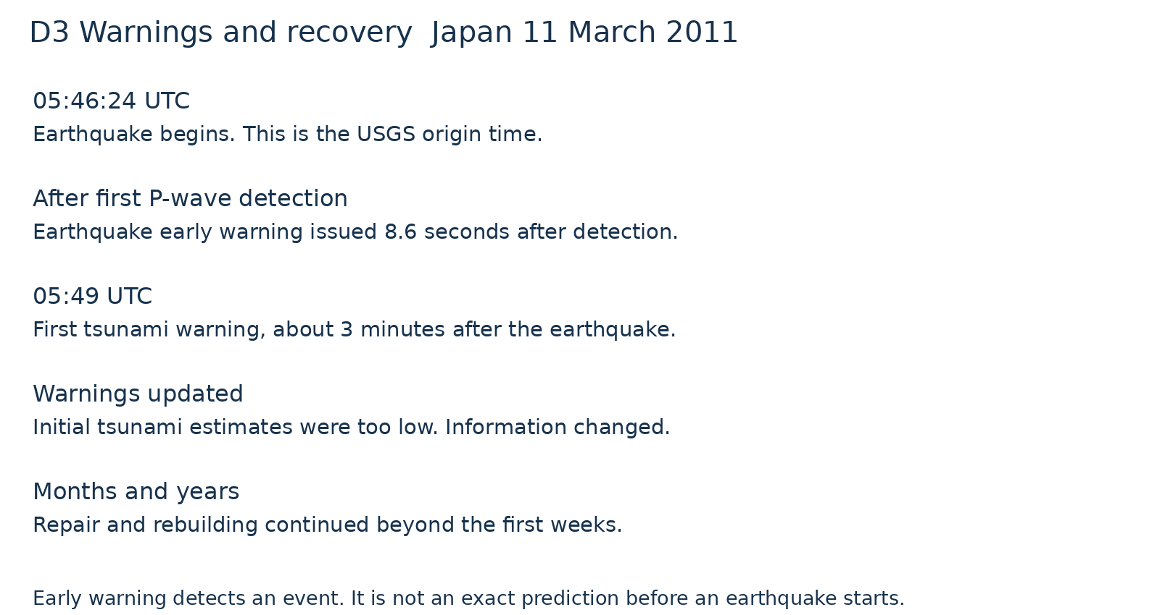
What was already happening before the earthquake early warning? Why did the tsunami warning need updating?
The 8.6-second figure is measured after first P-wave detection at the nearest station. It is not measured from the earthquake origin time. Times use UTC.

