Book strip
Creative Arts · GROW · Autumn 2 · Week 7 · ART-GROW-A2-W07-P2
I can refine my arts account using a genuine reply and verified links.
□ I can show how actual work supports my account.
□ I can use a genuine listener response to clarify one detail.
□ I can distinguish verified records from open actions.
Made by Matt

Reference sheets

Match a claim to real work
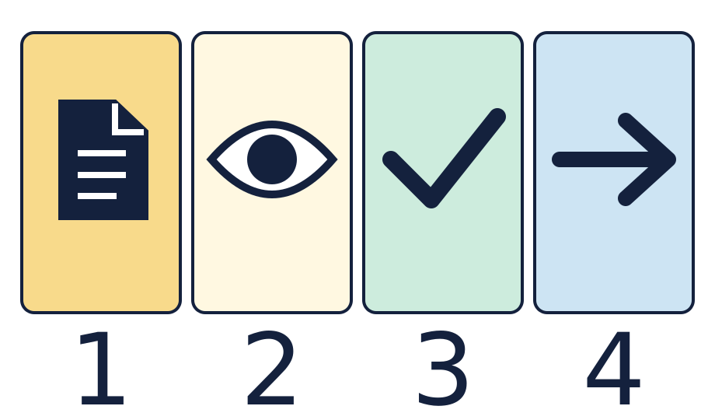
The page is a real record. The eye means look at the record. The tick means the link was checked. The arrow means a link or next action.

Keep an honest log
Open the right page, match the detail to your words, then keep the real link. Leave a gap open when the work or reply is missing.

Worked model

Ask the question
Watch the model: share a specific achievement using the verified record.

Find the evidence
Ask what the listener understood and preserve the genuine response.

Explain the link
Use that response to refine one detail, then share that part again.

Check what we know
Verify the locators, count actual files and retain explicit open actions.

Shared investigation
Bring back a checked item from Lesson 1.
Give a short share and point to its detail.
Ask what the agreed listener understood. Keep the real reply.
Use one next step, then check the link or keep a gap.

Decision checkpoint
Which reply can we keep in the log?
A · What the listener really said, signed or showed.
B · What we hope the listener would say.

Catch up for absence or access
Watch the model: share a specific achievement using the verified record.
Try the first step with the group or point through it quietly.

Arrival · Supported
Start with the picture. Point or make a mark in your book.
1. How many pages can you see?
2. Point to the first box.
3. Point to the last box.
4. Which word fits: ready, help or pause?
Green · Ready, Amber · Help, Red · Pause. Choose in private or pass.

You do · Supported
Start in your book.

Share one part with a cue
In your book
Point, speak, sign, draw, write or choose. You may pass.
Use your Lesson 1 work and page note.
Show what you liked and learnt to an agreed listener.
Ask what they understood. Keep the real reply or a gap.
Try one part again with help if needed.
In your book, keep the reply and check the page with an adult.
I learnt ___. The listener showed ___.
In your book, keep the real link, your own words and any gap to check.
You may point to real work, draw a clue, or tell an adult what to record. A quiet share has the same value. You may pass.
Staff mark I · S · C beside the task.

Review and improve
Show your first account and the real reply.
Use one next step to make a part clear.
Try that part again or explain what you kept.
Optional: show or tell an adult what you changed after feedback. You may use your usual response mode or pass.

Exit ticket
What did the listener really understand, or what gap is still open?
What did you make clear, and where can you find the work?

Pupil voice
What helped you most today, or what would you change next time?
Point, speak, sign, draw, write or choose. You may pass.

Feedback and response
In your book or usual mode
VF · WS · I · NS + … · E · R · // · ?
NS + ____________________
Edit in the same colour, on the same page or usual mode.
Mark R only after the pupil has responded to the next step and an adult has received and reflected the response.
My response
________________________
Adult ticks the improved work.

Arrival · Independent
Start with the picture. Point or make a mark in your book.
1. How many pages can you see?
2. Point to the first box.
3. What comes just after the page?
4. Which word fits: ready, help or pause?
Green · Ready, Amber · Help, Red · Pause. Choose in private or pass.

You do · Independent
Start in your book.

Refine and file a checked account
In your book
Point, speak, sign, draw, write or choose. You may pass.
Use the actual Lesson 1 record to explain a learnt skill or choice.
Share privately or with an agreed listener and retain the genuine reply.
Use the response to refine one detail, then share that part again.
Verify each locator against its actual item. Count actual submitted files.
Keep the response, checked links and one action for each gap in your log.
The reply led me to clarify ___. The verified record shows ___.
In your book, keep the real link, your own words and any gap to check.
You may point to real work, draw a clue, or tell an adult what to record. A quiet share has the same value. You may pass.
Staff mark I · S · C beside the task.

Review and improve
Show your first account and the real reply.
Use one next step to make a part clear.
Try that part again or explain what you kept.
Optional: show or tell an adult what you changed after feedback. You may use your usual response mode or pass.

Exit ticket
What did the listener really understand, or what gap is still open?
What did you make clear, and where can you find the work?

Pupil voice
What helped you most today, or what would you change next time?
Point, speak, sign, draw, write or choose. You may pass.

Feedback and response
In your book or usual mode
VF · WS · I · NS + … · E · R · // · ?
NS + ____________________
Edit in the same colour, on the same page or usual mode.
Mark R only after the pupil has responded to the next step and an adult has received and reflected the response.
My response
________________________
Adult ticks the improved work.

Arrival · Aspire
Start with the picture. Point or make a mark in your book.
1. How many pages can you see?
2. Point to the first box.
3. Point to the shape just before the arrow.
4. Which word fits: ready, help or pause?
Green · Ready, Amber · Help, Red · Pause. Choose in private or pass.

You do · Aspire
Start in your book.

Compare and justify a refinement
In your book
Point, speak, sign, draw, write or choose. You may pass.
Explain two choices using actual records and checked locators.
Compare what the listener understood with what you intended to explain.
Refine a specific detail and justify the change or a decision to retain it.
Share the refined account and compare the genuine responses.
Identify the limits of the records and prioritise one action for any gap.
Compare both accounts. Explain why your refinement improves the link to real work.
The refinement helps because ___. The remaining uncertainty is ___.
In your book, keep the real link, your own words and any gap to check.
You may point to real work, draw a clue, or tell an adult what to record. A quiet share has the same value. You may pass.
Staff mark I · S · C beside the task.

Review and improve
Show your first account and the real reply.
Use one next step to make a part clear.
Try that part again or explain what you kept.
Optional: show or tell an adult what you changed after feedback. You may use your usual response mode or pass.

Exit ticket
What did the listener really understand, or what gap is still open?
What did you make clear, and where can you find the work?

Pupil voice
What helped you most today, or what would you change next time?
Point, speak, sign, draw, write or choose. You may pass.

Feedback and response
In your book or usual mode
VF · WS · I · NS + … · E · R · // · ?
NS + ____________________
Edit in the same colour, on the same page or usual mode.
Mark R only after the pupil has responded to the next step and an adult has received and reflected the response.
My response
________________________
Adult ticks the improved work.

Arrival · Choice
Start with the picture. Point or make a mark in your book.
1. How many pages can you see?
2. Point to the first box.
3. Do any two boxes have the same shape?
4. Which word fits: ready, help or pause?
Green · Ready, Amber · Help, Red · Pause. Choose in private or pass.

You do · Choice
Start in your book.

Choose how to share and check
In your book
Point, speak, sign, draw, write or choose. You may pass.
Show your Lesson 1 work in private or direct an adult.
Point, draw or show what you liked and learnt.
Ask for a reply in your usual way, or pass.
Use one next step to make a part clear.
Keep the real reply or a gap in your book. Check the page.
I shared ___. My next action is ___.
In your book, keep the real link, your own words and any gap to check.
You may point to real work, draw a clue, or tell an adult what to record. A quiet share has the same value. You may pass.
Staff mark I · S · C beside the task.

Review and improve
Show your first account and the real reply.
Use one next step to make a part clear.
Try that part again or explain what you kept.
Optional: show or tell an adult what you changed after feedback. You may use your usual response mode or pass.

Exit ticket
What did the listener really understand, or what gap is still open?
What did you make clear, and where can you find the work?

Pupil voice
What helped you most today, or what would you change next time?
Point, speak, sign, draw, write or choose. You may pass.

Feedback and response
In your book or usual mode
VF · WS · I · NS + … · E · R · // · ?
NS + ____________________
Edit in the same colour, on the same page or usual mode.
Mark R only after the pupil has responded to the next step and an adult has received and reflected the response.
My response
________________________
Adult ticks the improved work.

