Visual step cards
Year A | Autumn 2 · Week 1 | 3 November 2026
I can create two named score variables in my maze project and set both to zero on start.
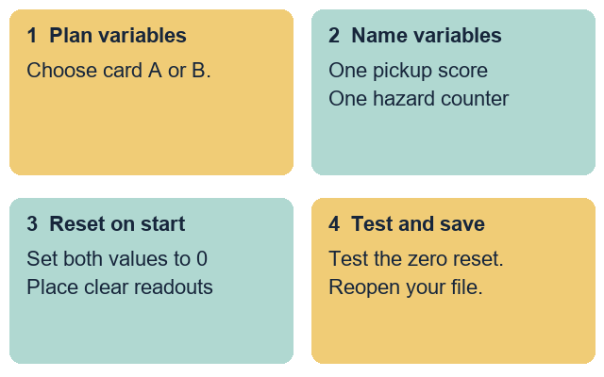
Plan the variables: Choose card A or B. Read the two variable names.
Create the variables: Make one pickup variable and one hazard variable.
Reset on start: Attach two set-to-zero blocks under the start event.
Test and save: Test the reset to zero. Save and reopen your file.
Use only the made-up project cards. Keep real personal details out.

Words for score variables
Year A | Autumn 2 · Week 1 | 3 November 2026

variable
A named store for a value that can change.

initialise
Set a starting value when the project begins.

reset
Return a value to zero for a fresh start.

readout
The box on stage that shows a variable value.

event
A trigger that starts a script running.

test
Run the project to check that a rule works.
Use one word to explain your start script.
________________________________________________________________

Knowledge organiser
Year A | Autumn 2 · Week 1 | 3 November 2026
I can create two named score variables in my maze project and set both to zero on start.
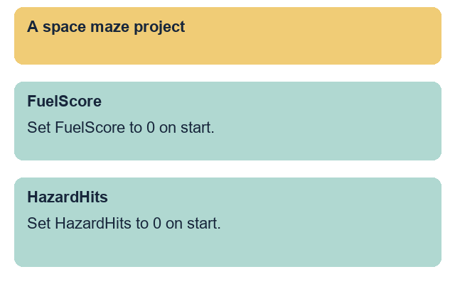
I created two named score variables.
I set both score variables to zero on start.
I placed both readouts clear of the maze path.
I tested the start reset from a non-zero value.
I reopened my saved file and checked the script.
Give each score variable a clear name that matches its role. Attach two set-to-zero blocks directly under the start event. Keep both stage readouts away from the maze walls and test the reset before saving.

Fictional project cards
Year A | Autumn 2 · Week 1 | 3 November 2026
Choose one made-up maze card. Add and reset two score variables for your maze project. Use the rules below. Do not invent personal names, places or external accounts.

Source A A space maze project
Variable names: Pickup variable FuelScore. Hazard variable HazardHits.
Start reset rules: Set FuelScore to 0 on start. Set HazardHits to 0 on start.
Extra rules: Keep both readouts at the top of the stage. Stretch variable: set RoundCount to 1 on start.

Source B A deep-sea maze project
Variable names: Pickup variable PearlScore. Hazard variable ReefHits.
Start reset rules: Set PearlScore to 0 on start. Set ReefHits to 0 on start.
Extra rules: Keep both readouts at the top of the stage. Stretch variable: set DiveCount to 1 on start.

Plan before you build
Choose card A or card B. Match the two variable names to their set-to-zero blocks under the start event. Keep the stretch rule for the Aspire route.
This reset block helps the player by ...
________________________________________________________________

Supported route
Year A | Autumn 2 · Week 1 | 3 November 2026
I can create two named score variables in my maze project and set both to zero on start.
1. Choose made-up project card A or card B.
2. Use the variable names and reset frame.
3. Create both score variables in your maze project.
4. Attach two set-to-zero blocks to start with help.
5. Ask a partner to test that both scores reset to 0.
6. Save, close and reopen the file. Check the script.

Planning frame
Card: Space maze A OR Deep-sea maze B
Pickup variable: Set ... to 0 on start
Hazard variable: Set ... to 0 on start

Check my work
[ ] I created two named score variables.
[ ] I set both score variables to zero on start.
[ ] I placed both readouts clear of the maze path.
[ ] I tested the start reset from a non-zero value.
[ ] I reopened my saved file and checked the script.
One choice that makes the start fair
________________________________________________________________
You may point, speak, build or ask for exact scribing. Each person keeps their own project file and check.

Independent route
Year A | Autumn 2 · Week 1 | 3 November 2026
I can create two named score variables in my maze project and set both to zero on start.
1. Choose card A or B and plan your two variables.
2. Create one pickup variable and one hazard variable.
3. Attach two set-to-zero blocks under the start event.
4. Place both stage readouts clear of the maze walls.
5. Test the start reset from a non-zero number with a partner.
6. Save, close and reopen the file. Check the script.

Check my work
[ ] I created two named score variables.
[ ] I set both score variables to zero on start.
[ ] I placed both readouts clear of the maze path.
[ ] I tested the start reset from a non-zero value.
[ ] I reopened my saved file and checked the script.
One choice that makes the start fair
________________________________________________________________
You may point, speak, build or ask for exact scribing. Each person keeps their own project file and check.

Aspire route
Year A | Autumn 2 · Week 1 | 3 November 2026
I can create two named score variables in my maze project and set both to zero on start.
1. Complete the Independent task first.
2. Use the extra rule to add the round counter variable.
3. Set the round counter to 1 under the start event.
4. Ask your partner to test all three variables on start.
5. Use the feedback to improve one readout position.
6. Save a new v2 copy. Keep v1 and explain the change.

Check my work
[ ] I created two named score variables.
[ ] I set both score variables to zero on start.
[ ] I placed both readouts clear of the maze path.
[ ] I tested the start reset from a non-zero value.
[ ] I reopened my saved file and checked the script.
One choice that makes the start fair
________________________________________________________________
You may point, speak, build or ask for exact scribing. Each person keeps their own project file and check.

My evidence record
Year A | Autumn 2 · Week 1 | 3 November 2026
Use the project card letter. Keep this record with your own maze file.
Project card A or B:
________________________________________________________________
My file name and folder:
________________________________________________________________
My pickup variable is ...
________________________________________________________________
My hazard variable is ...
________________________________________________________________
I changed ... because ...
________________________________________________________________
My saved file opens and resets both scores to 0: yes / not yet.
________________________________________________________________
My response to the next-step prompt:
________________________________________________________________

Staff observation
Date: __________ Support actually used: _____________________
Observed: two named variables / two set-to-zero blocks / clear readouts / reset tested / reopened file. Record each as seen, supported or not yet seen.
Next-step prompt given: _________________________________
Pupil response heard or read back: ________________________

