Humanities · GROW · Autumn 2 · Week 3 · HUM-GROW-A2-W03

Knowledge organiser
Describe how communities are connected across the world.
Yes, through messages or shared online activity. No. Card C describes two groups. Other people may have different links or beliefs.
Tier | Word | Meaning
Tier 3 | continent | A large land region
Tier 3 | ocean | A large body of salt water
Tier 2 | location | Where something is
Tier 2 | connection | A link between places or people
Place ____ connects with place ____ through ____. The card shows ____.

Humanities · GROW · Autumn 2 · Week 3 · HUM-GROW-A2-W03

World locator with neutral labels
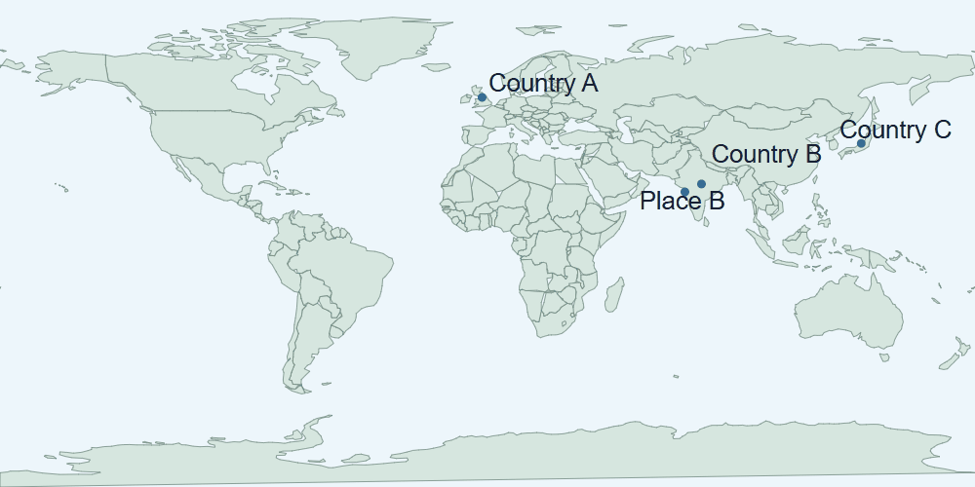
World map with approximate markers for Country A, Country B, Country C and Place B. The drawing gives a world view and does not show street details.
Place A is in Country A. Place B is the city marker in Country B. Draw or trace the link between the two groups in your book.

Humanities · GROW · Autumn 2 · Week 3 · HUM-GROW-A2-W03

Evidence cards A and B

A · Country A
Country A is in Continent 1 beside Ocean X. Place A is a local centre in the north-east of Country A. A map can show a neighbourhood or the whole world.
The world map cannot show a safe street route.

B · Countries B and C
Countries B and C are in Continent 2. Country B borders Ocean Y. Country C is an island country beside Ocean Z.
A country has many people, groups and beliefs.

Humanities · GROW · Autumn 2 · Week 3 · HUM-GROW-A2-W03

Evidence cards C and D

C · A community link
Fictional case: a Place A community group shares festival greetings with a partner group in Place B. The link can involve people and communication without a physical journey.
This example does not describe every person or place.

D · Celebrations across places
Diwali and Hanukkah are observed by communities in different countries. Locate examples using the map; a festival is not confined to one country.
Do not assign a religion to everyone living in a country.

Humanities · GROW · Autumn 2 · Week 3 · HUM-GROW-A2-W03

Shared investigation
Build a connection from Place A to Place B. Distinguish movement of people, goods and messages. Take a turn to suggest a match, then check the evidence.
1. Which two places are in the fictional link?
2. What is the link in card C?
3. Is that a movement of people, goods or messages?
Evidence or step | Check
Which two places are in the fictional link? | Add your answer or card clue.
What is the link in card C? | Add your answer or card clue.
Is that a movement of people, goods or messages? | Add your answer or card clue.
Our explanation
____________________________________________________________

Optional · respond to feedback together
Optional: show one connection and card clue to an adult. Hear one piece of feedback. Reply with a change, a reason to keep it or a request for help.
My response or improvement
____________________________________________________________

Humanities · GROW · Autumn 2 · Week 3 · HUM-GROW-A2-W03

We do decision checkpoint
Two groups send festival greetings. What does this show?
1. A message connects the groups
2. Everyone in both places shares one belief
3. People had to travel
My claim and clue
____________________________________________________________

Humanities · GROW · Autumn 2 · Week 3 · HUM-GROW-A2-W03

Worked model

Ask the question
Yes, through messages or shared online activity. Use card C. Card C describes a group in Place A sharing festival greetings with a group in Place B.

Find the evidence
Card C describes a group in Place A sharing festival greetings with a group in Place B. A greeting is a message. It can travel between places without a person making the journey.

Explain the link
The groups can send messages or take part in a shared activity from their own places. Place ____ connects with place ____ through ____. The card shows ____.

Check what we know
No. Card C describes two groups. Other people may have different links or beliefs. Card C is a fictional example of two groups. It does not show how all people in either place live or believe.

Humanities · GROW · Autumn 2 · Week 3 · HUM-GROW-A2-W03

Arrival Supported
 | Ready to learn?  ● Green · Ready  ● Amber · Help  ● Red · Pause  You may point, choose or pass.
  1. Point to the picture that matches the top one.    __________________  __________________ | 2. Which meaning fits continent?  __________________  __________________
  3. Can communities connect without people travelling?  __________________  __________________ | 4. Does one example describe everyone in either place?  __________________  __________________
Point, speak, sign, draw, write or choose. You may pass. An adult may note your own words or choice.

Humanities · GROW · Autumn 2 · Week 3 · HUM-GROW-A2-W03

You do Supported
Staff mark I · S · C beside the task.
1. Start in your book. Create a connection map for the fictional partner groups.
2. Label both places and explain one link using the account.
3. State that the example does not describe every community.
Word bank: continent · ocean · location · connection.
My example and card detail
____________________________________________________________
My reason and check
____________________________________________________________
Point, speak, sign, draw, write or choose. You may pass. An adult may note your own words or choice.

Humanities · GROW · Autumn 2 · Week 3 · HUM-GROW-A2-W03

Review and exit Supported
Edit in the same colour, on the same page.
Can communities connect without people travelling?
____________________________________________________________
Does one link describe everyone in either place?
____________________________________________________________
Point, speak, sign, draw, write or choose. You may pass. An adult may note your own words or choice.

Humanities · GROW · Autumn 2 · Week 3 · HUM-GROW-A2-W03

Arrival Independent
 | Ready to learn?  ● Green · Ready  ● Amber · Help  ● Red · Pause  You may point, choose or pass.
  1. Point to the picture that matches the top one.  __________________  __________________ | 2. Which meaning fits continent?  __________________  __________________
  3. Can communities connect without people travelling?  __________________  __________________ | 4. Does one example describe everyone in either place?  __________________  __________________
Point, speak, sign, draw, write or choose. You may pass. An adult may note your own words or choice.

Humanities · GROW · Autumn 2 · Week 3 · HUM-GROW-A2-W03

You do Independent
Staff mark I · S · C beside the task.
1. Start in your book. Create a connection map for the fictional partner groups.
2. Label both places and explain one link using the account.
3. State that the example does not describe every community.
Word bank: continent · ocean · location · connection.
My example and card detail
____________________________________________________________
My reason and check
____________________________________________________________
Point, speak, sign, draw, write or choose. You may pass. An adult may note your own words or choice.

Humanities · GROW · Autumn 2 · Week 3 · HUM-GROW-A2-W03

Review and exit Independent
Edit in the same colour, on the same page.
Can communities connect without people travelling?
____________________________________________________________
Does one link describe everyone in either place?
____________________________________________________________
Point, speak, sign, draw, write or choose. You may pass. An adult may note your own words or choice.

Humanities · GROW · Autumn 2 · Week 3 · HUM-GROW-A2-W03

Arrival Aspire
 | Ready to learn?  ● Green · Ready  ● Amber · Help  ● Red · Pause  You may point, choose or pass.
  1. Point to the picture that matches the top one.  __________________  __________________ | 2. Use continent in an accurate example.  __________________  __________________
  3. Can communities connect without people travelling? Which detail supports your answer?  __________________  __________________ | 4. Does one example describe everyone in either place?  __________________  __________________
Point, speak, sign, draw, write or choose. You may pass. An adult may note your own words or choice.

Humanities · GROW · Autumn 2 · Week 3 · HUM-GROW-A2-W03

You do Aspire
Staff mark I · S · C beside the task.
1. Start in your book. Create a connection map for the fictional partner groups.
2. Label both places and explain one link using the account.
3. State that the example does not describe every community.
4. Explain how a connection might continue without a journey.
Word bank: continent · ocean · location · connection.
My example and card detail
____________________________________________________________
My reason and check
____________________________________________________________
Point, speak, sign, draw, write or choose. You may pass. An adult may note your own words or choice.

Humanities · GROW · Autumn 2 · Week 3 · HUM-GROW-A2-W03

Review and exit Aspire
Edit in the same colour, on the same page.
Can communities connect without people travelling? Use one clue.
____________________________________________________________
Does one link describe everyone in either place?
____________________________________________________________
Point, speak, sign, draw, write or choose. You may pass. An adult may note your own words or choice.

Humanities · GROW · Autumn 2 · Week 3 · HUM-GROW-A2-W03

You do Choice
Staff mark I · S · C beside the task.
1. Choose to point, speak, sign, draw or write. Keep your response in your book.
2. Label both places and explain one link using the account.
3. State that the example does not describe every community.
Word bank: continent · ocean · location · connection.
My example and card detail
____________________________________________________________
My reason and check
____________________________________________________________
Point, speak, sign, draw, write or choose. You may pass. An adult may note your own words or choice.

Humanities · GROW · Autumn 2 · Week 3 · HUM-GROW-A2-W03

Review and exit Choice
Point, draw, sign or tell an adult. Can communities connect without people travelling?
____________________________________________________________
Does one link describe everyone in either place?
____________________________________________________________
Point, speak, sign, draw, write or choose. You may pass. An adult may note your own words or choice.

Humanities · GROW · Autumn 2 · Week 3 · HUM-GROW-A2-W03

Route card
Choose one: □ Supported · □ Independent · □ Aspire · □ Choice.
Start in your book and keep your evidence and check together.

Staff feedback boxes and pupil responses

□ VF
My response
____________________________________________________________

□ WS
My response
____________________________________________________________

□ I
My response
____________________________________________________________

□ NS + …
My response
____________________________________________________________

□ E
My response
____________________________________________________________

□ R
My response
____________________________________________________________

□ //
My response
____________________________________________________________

□ ?
My response
____________________________________________________________

Humanities · GROW · Autumn 2 · Week 3 · HUM-GROW-A2-W03

Catch-up absence or access only
For absence or access only.
Use card C with an adult. Card C describes a group in Place A sharing festival greetings with a group in Place B. Join the task with one clue.

Humanities · GROW · Autumn 2 · Week 3 · HUM-GROW-A2-W03

Word page
World map with approximate markers for Country A, Country B, Country C and Place B. The drawing gives a world view and does not show street details.
Tier | Word | Meaning
Tier 3 | continent | A large land region
Tier 3 | ocean | A large body of salt water
Tier 2 | location | Where something is
Tier 2 | connection | A link between places or people

Humanities · GROW · Autumn 2 · Week 3 · HUM-GROW-A2-W03

Book strips
Humanities · GROW · Autumn 2 · Week 3 · HUM-GROW-A2-W03
Connections across the world

Today I can
I can mark two places on a map. · I can describe a link between two groups. · I can say what one example cannot tell us.
Humanities · GROW · Autumn 2 · Week 3 · HUM-GROW-A2-W03
Connections across the world

Today I can
I can mark two places on a map. · I can describe a link between two groups. · I can say what one example cannot tell us.
Humanities · GROW · Autumn 2 · Week 3 · HUM-GROW-A2-W03
Connections across the world

Today I can
I can mark two places on a map. · I can describe a link between two groups. · I can say what one example cannot tell us.
Humanities · GROW · Autumn 2 · Week 3 · HUM-GROW-A2-W03
Connections across the world

Today I can
I can mark two places on a map. · I can describe a link between two groups. · I can say what one example cannot tell us.

