Humanities · GROW · Autumn 2 · Week 7 · HUM-GROW-A2-W07

Knowledge organiser
Complete a belief and belonging task and map skills check and bank unit award evidence.
Complete a map check on your own, using the supplied locator and key. Use the actual agreed criterion, activity and support used. Staff complete the learner and observation details on the evidence record.
Tier | Word | Meaning
Tier 2 | festival | A special occasion of celebration or remembrance
Tier 3 | belief | Something a person accepts as true
Tier 2 | tradition | A practice passed on
Tier 2 | respect | Care for people and what matters to them
My map clue is ____. My source clue is ____. I checked ____.

Humanities · GROW · Autumn 2 · Week 7 · HUM-GROW-A2-W07

World locator with neutral labels
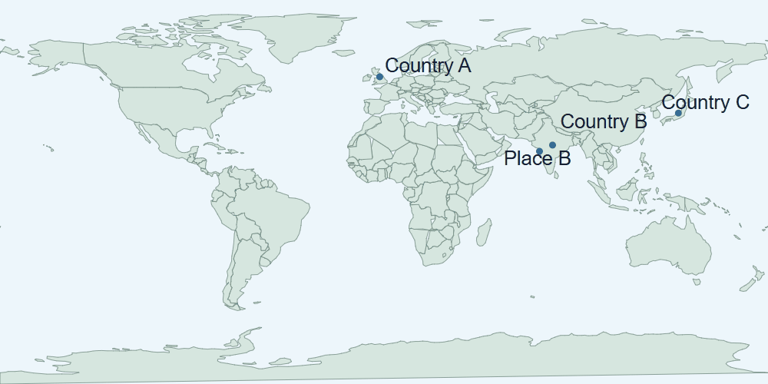
World map with approximate markers for Country A, Country B, Country C and Place B. The drawing gives a world view and does not show street details.
Use the neutral markers for the independent map check. Staff record the evidence and support on the agreed record.

Humanities · GROW · Autumn 2 · Week 7 · HUM-GROW-A2-W07

Evidence cards D and H

D · Diwali
Many Hindus mark Diwali with lamps, worship and gatherings. Light can express good overcoming evil and knowledge overcoming ignorance. Practices and stories vary.
This Hindu explanation does not cover every Hindu practice or other religions’ observances.

H · Hanukkah
Hanukkah is a Jewish festival lasting eight nights. Lights recall the Temple’s rededication and the traditional account of oil lasting eight days. A hanukkiah has eight festival lights and a helper light.
This explains one Jewish religious perspective; not all Jewish households observe identically.

Humanities · GROW · Autumn 2 · Week 7 · HUM-GROW-A2-W07

Evidence cards O and S

O · Objects and meanings
A diya is a small lamp associated with Diwali. A hanukkiah is used at Hanukkah. Ask before touching borrowed objects; use an unlit replica or a drawing.
This example does not describe every person or place.

S · One family’s celebration plan
Fictional Diwali plan: prepare a welcoming space; arrange unlit lamps with an adult; gather for worship; share food and greetings. This is one sequence, not a rule for every family.
This example does not describe every person or place.

Humanities · GROW · Autumn 2 · Week 7 · HUM-GROW-A2-W07

Shared investigation
Review what a map answer and a belief answer each need. Practise on different examples before the assessment. Take a turn to suggest a match, then check the evidence.
1. What should a map answer include?
2. What should a belief answer include?
3. Which work belongs in the evidence record?
Evidence or step | Check
What should a map answer include? | Add your answer or card clue.
What should a belief answer include? | Add your answer or card clue.
Which work belongs in the evidence record? | Add your answer or card clue.
Our explanation
____________________________________________________________

Optional · respond to feedback together
Optional: show one map or source answer to an adult. Hear one piece of feedback. Reply with a change, a reason to keep it or a request for help.
My response or improvement
____________________________________________________________

Humanities · GROW · Autumn 2 · Week 7 · HUM-GROW-A2-W07

We do decision checkpoint
Which pair gives the right evidence for the two checks?
1. Map clue for place and source clue for meaning
2. A map marker for everyone’s belief
3. A source about lights for a grid reference
My claim and clue
____________________________________________________________

Humanities · GROW · Autumn 2 · Week 7 · HUM-GROW-A2-W07

Worked model

Ask the question
Complete a map check on your own, using the supplied locator and key. Use card D. Card D explains one meaning for Diwali lights. Card H explains a different tradition. Use the neutral locator to check places.

Find the evidence
Card D explains one meaning for Diwali lights. Card H explains a different tradition. Use the neutral locator to check places. A map answer uses a map clue. A belief answer uses a relevant source detail.

Explain the link
Complete the separate map check, compare the two accounts and choose your own evidence for review. My map clue is ____. My source clue is ____. I checked ____.

Check what we know
Use the actual agreed criterion, activity and support used. Staff complete the learner and observation details on the evidence record. A map point cannot show what everyone believes. The source accounts do not speak for every household.

Humanities · GROW · Autumn 2 · Week 7 · HUM-GROW-A2-W07

Arrival Supported
 | Ready to learn?  ● Green · Ready  ● Amber · Help  ● Red · Pause  You may point, choose or pass.
  1. Point to the picture that matches the top one.    __________________  __________________ | 2. Which meaning fits festival?  __________________  __________________
  3. What separate skill check belongs in this assessment?  __________________  __________________ | 4. How should selected unit award evidence be labelled?  __________________  __________________
Point, speak, sign, draw, write or choose. You may pass. An adult may note your own words or choice.

Humanities · GROW · Autumn 2 · Week 7 · HUM-GROW-A2-W07

You do Supported
Staff mark I · S · C beside the task.
1. Start in your book. Complete an independent map task locating Country B, the Country A and an ocean.
2. Explain one festival feature and compare the two accounts.
3. Select labelled unit evidence and record the support used.
Word bank: festival · belief · tradition · respect.
My example and card detail
____________________________________________________________
My reason and check
____________________________________________________________
Point, speak, sign, draw, write or choose. You may pass. An adult may note your own words or choice.

Humanities · GROW · Autumn 2 · Week 7 · HUM-GROW-A2-W07

Review and exit Supported
Edit in the same colour, on the same page.
What separate skill check belongs in this assessment?
____________________________________________________________
How should selected unit evidence be labelled?
____________________________________________________________
Point, speak, sign, draw, write or choose. You may pass. An adult may note your own words or choice.

Humanities · GROW · Autumn 2 · Week 7 · HUM-GROW-A2-W07

Arrival Independent
 | Ready to learn?  ● Green · Ready  ● Amber · Help  ● Red · Pause  You may point, choose or pass.
  1. Point to the picture that matches the top one.  __________________  __________________ | 2. Which meaning fits festival?  __________________  __________________
  3. What separate skill check belongs in this assessment?  __________________  __________________ | 4. How should selected unit award evidence be labelled?  __________________  __________________
Point, speak, sign, draw, write or choose. You may pass. An adult may note your own words or choice.

Humanities · GROW · Autumn 2 · Week 7 · HUM-GROW-A2-W07

You do Independent
Staff mark I · S · C beside the task.
1. Start in your book. Complete an independent map task locating Country B, the Country A and an ocean.
2. Explain one festival feature and compare the two accounts.
3. Select labelled unit evidence and record the support used.
Word bank: festival · belief · tradition · respect.
My example and card detail
____________________________________________________________
My reason and check
____________________________________________________________
Point, speak, sign, draw, write or choose. You may pass. An adult may note your own words or choice.

Humanities · GROW · Autumn 2 · Week 7 · HUM-GROW-A2-W07

Review and exit Independent
Edit in the same colour, on the same page.
What separate skill check belongs in this assessment?
____________________________________________________________
How should selected unit evidence be labelled?
____________________________________________________________
Point, speak, sign, draw, write or choose. You may pass. An adult may note your own words or choice.

Humanities · GROW · Autumn 2 · Week 7 · HUM-GROW-A2-W07

Arrival Aspire
 | Ready to learn?  ● Green · Ready  ● Amber · Help  ● Red · Pause  You may point, choose or pass.
  1. Point to the picture that matches the top one.  __________________  __________________ | 2. Use festival in an accurate example.  __________________  __________________
  3. What separate skill check belongs in this assessment? Which detail supports your answer?  __________________  __________________ | 4. How should selected unit award evidence be labelled?  __________________  __________________
Point, speak, sign, draw, write or choose. You may pass. An adult may note your own words or choice.

Humanities · GROW · Autumn 2 · Week 7 · HUM-GROW-A2-W07

You do Aspire
Staff mark I · S · C beside the task.
1. Start in your book. Complete an independent map task locating Country B, the Country A and an ocean.
2. Explain one festival feature and compare the two accounts.
3. Select labelled unit evidence and record the support used.
4. Explain one limitation of using only these two accounts.
Word bank: festival · belief · tradition · respect.
My example and card detail
____________________________________________________________
My reason and check
____________________________________________________________
Point, speak, sign, draw, write or choose. You may pass. An adult may note your own words or choice.

Humanities · GROW · Autumn 2 · Week 7 · HUM-GROW-A2-W07

Review and exit Aspire
Edit in the same colour, on the same page.
What separate skill check belongs in this assessment? Use one clue.
____________________________________________________________
How should selected unit evidence be labelled?
____________________________________________________________
Point, speak, sign, draw, write or choose. You may pass. An adult may note your own words or choice.

Humanities · GROW · Autumn 2 · Week 7 · HUM-GROW-A2-W07

You do Choice
Staff mark I · S · C beside the task.
1. Choose to point, speak, sign, draw or write. Keep your response in your book.
2. Explain one festival feature and compare the two accounts.
3. Select labelled unit evidence and record the support used.
Word bank: festival · belief · tradition · respect.
My example and card detail
____________________________________________________________
My reason and check
____________________________________________________________
Point, speak, sign, draw, write or choose. You may pass. An adult may note your own words or choice.

Humanities · GROW · Autumn 2 · Week 7 · HUM-GROW-A2-W07

Review and exit Choice
Point, draw, sign or tell an adult. What separate skill check belongs in this assessment?
____________________________________________________________
How should selected unit evidence be labelled?
____________________________________________________________
Point, speak, sign, draw, write or choose. You may pass. An adult may note your own words or choice.

Humanities · GROW · Autumn 2 · Week 7 · HUM-GROW-A2-W07

Route card
Choose one: □ Supported · □ Independent · □ Aspire · □ Choice.
Start in your book and keep your evidence and check together.

Staff feedback boxes and pupil responses

□ VF
My response
____________________________________________________________

□ WS
My response
____________________________________________________________

□ I
My response
____________________________________________________________

□ NS + …
My response
____________________________________________________________

□ E
My response
____________________________________________________________

□ R
My response
____________________________________________________________

□ //
My response
____________________________________________________________

□ ?
My response
____________________________________________________________

Humanities · GROW · Autumn 2 · Week 7 · HUM-GROW-A2-W07

Catch-up absence or access only
For absence or access only.
Use card D with an adult. Card D explains one meaning for Diwali lights. Card H explains a different tradition. Use the neutral locator to check places. Join the task with one clue.

Humanities · GROW · Autumn 2 · Week 7 · HUM-GROW-A2-W07

Word page
World map with approximate markers for Country A, Country B, Country C and Place B. The drawing gives a world view and does not show street details.
Tier | Word | Meaning
Tier 2 | festival | A special occasion of celebration or remembrance
Tier 3 | belief | Something a person accepts as true
Tier 2 | tradition | A practice passed on
Tier 2 | respect | Care for people and what matters to them

Humanities · GROW · Autumn 2 · Week 7 · HUM-GROW-A2-W07

Book strips
Humanities · GROW · Autumn 2 · Week 7 · HUM-GROW-A2-W07
Belief and belonging review

Today I can
I can find a clue in the source. · I can explain one idea in my own words. · I can check my work with the source.
Humanities · GROW · Autumn 2 · Week 7 · HUM-GROW-A2-W07
Belief and belonging review

Today I can
I can find a clue in the source. · I can explain one idea in my own words. · I can check my work with the source.
Humanities · GROW · Autumn 2 · Week 7 · HUM-GROW-A2-W07
Belief and belonging review

Today I can
I can find a clue in the source. · I can explain one idea in my own words. · I can check my work with the source.
Humanities · GROW · Autumn 2 · Week 7 · HUM-GROW-A2-W07
Belief and belonging review

Today I can
I can find a clue in the source. · I can explain one idea in my own words. · I can check my work with the source.

