Humanities · LAUNCH · Autumn 2 · Week 2 · HUM-LAUNCH-A2-W02

Knowledge organiser
Use digital mapping or GIS to describe a place.
It shows one type of information on a map. No. You also need to know how many people live in the area.
Tier | Word | Meaning
Tier 2 | settlement | A place where people live
Tier 2 | urbanisation | Growth in the share of people living in urban places
Tier 2 | land use | What land is used for
Tier 2 | GIS | Mapping information in separate data layers
The source shows ____. This helps me explain ____.

Humanities · LAUNCH · Autumn 2 · Week 2 · HUM-LAUNCH-A2-W02

Local map and its layers
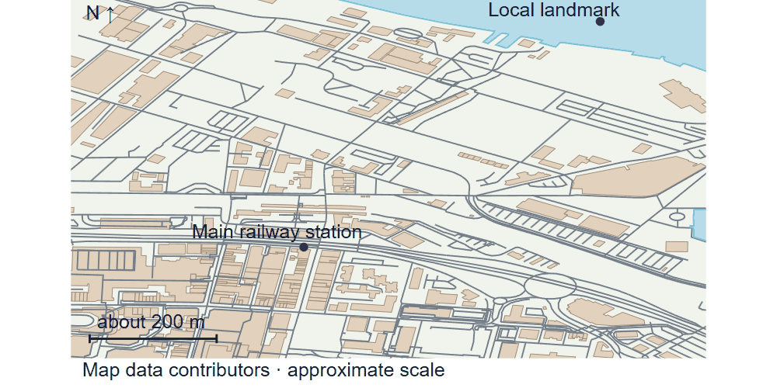
Supplied local map of railway station, well-known local landmark, roads, buildings and water; north points upwards. Approximate scale bar about 200 m.
Use the drawing alongside the evidence cards.

Humanities · LAUNCH · Autumn 2 · Week 2 · HUM-LAUNCH-A2-W02

Evidence cards A and B

A · Local reference points
The main railway station and the local bridge are reference points on our digital map. Toggle layers to examine their positions. the civic building lies beyond this map’s southern boundary.
These points alone cannot show population density or prove why development happened.

B · Reasons places grow
Work, transport and services can attract people and businesses. A growing town may need more homes and infrastructure. Population growth can also occur within existing settlements.
A reason is a hypothesis until tested against evidence for a particular place.

Humanities · LAUNCH · Autumn 2 · Week 2 · HUM-LAUNCH-A2-W02

Evidence cards C and D

C · Practice land-use sample
Fictional practice tally: shops 8, homes 12, public services 4, green spaces 6. This is training data only. Replace it with your labelled observations for the fieldwork enquiry.
This example does not describe every person or place.

D · Contrasting reference place
Compare a small centre such as the smaller centre with the larger centre at comparable map scales. Record the area, source and observation round.
One sampled street does not represent a whole settlement.

Humanities · LAUNCH · Autumn 2 · Week 2 · HUM-LAUNCH-A2-W02

Shared investigation
Toggle road, building and place layers on the supplied local map. Compare what becomes visible and what remains uncertain. Take a turn to suggest a match, then check the evidence.
1. What does a GIS layer do?
2. Which clue supports your answer?
3. Can building outlines alone establish population density?
Evidence or step | Check
What does a GIS layer do? | Add your answer or card clue.
Which clue supports your answer? | Add your answer or card clue.
Can building outlines alone establish population density? | Add your answer or card clue.
Our explanation
____________________________________________________________

Optional · respond to feedback together
Optional: show one map comparison to an adult. Hear one piece of feedback. Reply with a change, a reason to keep it or a request for help.
My response or improvement
____________________________________________________________

Humanities · LAUNCH · Autumn 2 · Week 2 · HUM-LAUNCH-A2-W02

We do decision checkpoint
Which claim can you check with the roads layer?
1. Where the roads run
2. How many people live in a square
3. Why a town first grew
My claim and clue
____________________________________________________________

Humanities · LAUNCH · Autumn 2 · Week 2 · HUM-LAUNCH-A2-W02

Worked model

Ask the question
It shows one type of information on a map. Use card A. The station and the local landmark help you find your position.

Find the evidence
The station and the local landmark help you find your position. The road layer shows routes. The building layer shows outlines.

Explain the link
Compare the same area with layers on and off. The source shows ____. This helps me explain ____.

Check what we know
No. You also need to know how many people live in the area. A layer only shows what its source records.

Humanities · LAUNCH · Autumn 2 · Week 2 · HUM-LAUNCH-A2-W02

Arrival Supported
 | Ready to learn?  ● Green · Ready  ● Amber · Help  ● Red · Pause  You may point, choose or pass.
  1. Point to the picture that matches the top one.    __________________  __________________ | 2. Which meaning fits settlement?  __________________  __________________
  3. What does a GIS layer do?  __________________  __________________ | 4. Can building outlines alone establish population density?  __________________  __________________
Point, speak, sign, draw, write or choose. You may pass. An adult may note your own words or choice.

Humanities · LAUNCH · Autumn 2 · Week 2 · HUM-LAUNCH-A2-W02

You do Supported
Staff mark I · S · C beside the task.
1. Start in your book. Capture or print an annotated map with at least two layers.
2. Locate two features and describe a spatial pattern.
3. Answer an independent question about what the map cannot establish.
Word bank: settlement · urbanisation · land use · GIS.
My example and card detail
____________________________________________________________
My reason and check
____________________________________________________________
Point, speak, sign, draw, write or choose. You may pass. An adult may note your own words or choice.

Humanities · LAUNCH · Autumn 2 · Week 2 · HUM-LAUNCH-A2-W02

Review and exit Supported
Edit in the same colour, on the same page.
What does a GIS layer do?
____________________________________________________________
Can building outlines alone establish population density?
____________________________________________________________
Point, speak, sign, draw, write or choose. You may pass. An adult may note your own words or choice.

Humanities · LAUNCH · Autumn 2 · Week 2 · HUM-LAUNCH-A2-W02

Arrival Independent
 | Ready to learn?  ● Green · Ready  ● Amber · Help  ● Red · Pause  You may point, choose or pass.
  1. Point to the picture that matches the top one.  __________________  __________________ | 2. Which meaning fits settlement?  __________________  __________________
  3. What does a GIS layer do?  __________________  __________________ | 4. Can building outlines alone establish population density?  __________________  __________________
Point, speak, sign, draw, write or choose. You may pass. An adult may note your own words or choice.

Humanities · LAUNCH · Autumn 2 · Week 2 · HUM-LAUNCH-A2-W02

You do Independent
Staff mark I · S · C beside the task.
1. Start in your book. Capture or print an annotated map with at least two layers.
2. Locate two features and describe a spatial pattern.
3. Answer an independent question about what the map cannot establish.
Word bank: settlement · urbanisation · land use · GIS.
My example and card detail
____________________________________________________________
My reason and check
____________________________________________________________
Point, speak, sign, draw, write or choose. You may pass. An adult may note your own words or choice.

Humanities · LAUNCH · Autumn 2 · Week 2 · HUM-LAUNCH-A2-W02

Review and exit Independent
Edit in the same colour, on the same page.
What does a GIS layer do?
____________________________________________________________
Can building outlines alone establish population density?
____________________________________________________________
Point, speak, sign, draw, write or choose. You may pass. An adult may note your own words or choice.

Humanities · LAUNCH · Autumn 2 · Week 2 · HUM-LAUNCH-A2-W02

Arrival Aspire
 | Ready to learn?  ● Green · Ready  ● Amber · Help  ● Red · Pause  You may point, choose or pass.
  1. Point to the picture that matches the top one.  __________________  __________________ | 2. Use settlement in an accurate example.  __________________  __________________
  3. What does a GIS layer do? Which detail supports your answer?  __________________  __________________ | 4. Can building outlines alone establish population density?  __________________  __________________
Point, speak, sign, draw, write or choose. You may pass. An adult may note your own words or choice.

Humanities · LAUNCH · Autumn 2 · Week 2 · HUM-LAUNCH-A2-W02

You do Aspire
Staff mark I · S · C beside the task.
1. Start in your book. Capture or print an annotated map with at least two layers.
2. Locate two features and describe a spatial pattern.
3. Answer an independent question about what the map cannot establish.
4. Explain how scale, incomplete data or a missing layer could change your interpretation.
Word bank: settlement · urbanisation · land use · GIS.
My example and card detail
____________________________________________________________
My reason and check
____________________________________________________________
Point, speak, sign, draw, write or choose. You may pass. An adult may note your own words or choice.

Humanities · LAUNCH · Autumn 2 · Week 2 · HUM-LAUNCH-A2-W02

Review and exit Aspire
Edit in the same colour, on the same page.
What does a GIS layer do? Use one clue.
____________________________________________________________
Can building outlines alone establish population density?
____________________________________________________________
Point, speak, sign, draw, write or choose. You may pass. An adult may note your own words or choice.

Humanities · LAUNCH · Autumn 2 · Week 2 · HUM-LAUNCH-A2-W02

You do Choice
Staff mark I · S · C beside the task.
1. Choose to point, speak, sign, draw or write. Keep your response in your book.
2. Locate two features and describe a spatial pattern.
3. Answer an independent question about what the map cannot establish.
Word bank: settlement · urbanisation · land use · GIS.
My example and card detail
____________________________________________________________
My reason and check
____________________________________________________________
Point, speak, sign, draw, write or choose. You may pass. An adult may note your own words or choice.

Humanities · LAUNCH · Autumn 2 · Week 2 · HUM-LAUNCH-A2-W02

Review and exit Choice
Point, draw, sign or tell an adult. What does a GIS layer do?
____________________________________________________________
Can building outlines alone establish population density?
____________________________________________________________
Point, speak, sign, draw, write or choose. You may pass. An adult may note your own words or choice.

Humanities · LAUNCH · Autumn 2 · Week 2 · HUM-LAUNCH-A2-W02

Route card
Choose one: □ Supported · □ Independent · □ Aspire · □ Choice.
Start in your book and keep your evidence and check together.

Staff feedback boxes and pupil responses

□ VF
My response
____________________________________________________________

□ WS
My response
____________________________________________________________

□ I
My response
____________________________________________________________

□ NS + …
My response
____________________________________________________________

□ E
My response
____________________________________________________________

□ R
My response
____________________________________________________________

□ //
My response
____________________________________________________________

□ ?
My response
____________________________________________________________

Humanities · LAUNCH · Autumn 2 · Week 2 · HUM-LAUNCH-A2-W02

Catch-up absence or access only
For absence or access only.
Use card A with an adult. The station and the local landmark help you find your position. Join the task with one clue.

Humanities · LAUNCH · Autumn 2 · Week 2 · HUM-LAUNCH-A2-W02

Word page
Supplied local map of railway station, well-known local landmark, roads, buildings and water; north points upwards. Approximate scale bar about 200 m.
Tier | Word | Meaning
Tier 2 | settlement | A place where people live
Tier 2 | urbanisation | Growth in the share of people living in urban places
Tier 2 | land use | What land is used for
Tier 2 | GIS | Mapping information in separate data layers

Humanities · LAUNCH · Autumn 2 · Week 2 · HUM-LAUNCH-A2-W02

Book strips
Humanities · LAUNCH · Autumn 2 · Week 2 · HUM-LAUNCH-A2-W02
Using digital mapping and GIS

Today I can
I can find a clue in the source. · I can explain one idea in my own words. · I can check my work with the source.
Humanities · LAUNCH · Autumn 2 · Week 2 · HUM-LAUNCH-A2-W02
Using digital mapping and GIS

Today I can
I can find a clue in the source. · I can explain one idea in my own words. · I can check my work with the source.
Humanities · LAUNCH · Autumn 2 · Week 2 · HUM-LAUNCH-A2-W02
Using digital mapping and GIS

Today I can
I can find a clue in the source. · I can explain one idea in my own words. · I can check my work with the source.
Humanities · LAUNCH · Autumn 2 · Week 2 · HUM-LAUNCH-A2-W02
Using digital mapping and GIS

Today I can
I can find a clue in the source. · I can explain one idea in my own words. · I can check my work with the source.

