Humanities · LAUNCH · Autumn 2 · Week 3 · HUM-LAUNCH-A2-W03

Knowledge organiser
Explain settlement and urbanisation.
A local settlement can grow as jobs, transport or services attract people. National urbanisation measures a rising urban population share. Compare like with like.
Tier | Word | Meaning
Tier 3 | settlement | A place where people live.
Tier 3 | urbanisation | An increase in the share of people living in urban places.
Tier 2 | land use | What land is used for.
Tier 3 | GIS | A way to map information in separate data layers.
A place may grow because ____. This can lead to ____. Urbanisation specifically means ____.

Humanities · LAUNCH · Autumn 2 · Week 3 · HUM-LAUNCH-A2-W03

Compare settlement patterns
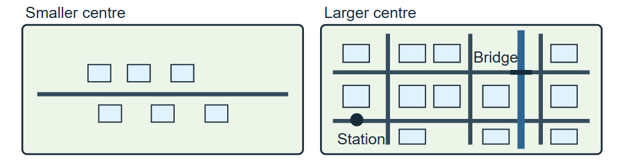
Two schematic views at the same scale. The smaller centre has a few buildings along one road and open land. The larger centre has more streets and buildings, a station and a bridge.
The drawings show two fictional centres at the same scale. Use them to compare patterns and locate reference points. Use the tally separately as practice data.

Humanities · LAUNCH · Autumn 2 · Week 3 · HUM-LAUNCH-A2-W03

Evidence cards A and B

A · Local reference points
A railway station and bridge mark two reference points in the larger centre. A civic building is outside the map to the south. Layers can separate routes, buildings and reference points.
Reference points alone give neither population density nor a cause of growth.

B · Reasons places grow
Work, transport and services can attract residents and businesses. Growing settlements may need more homes and infrastructure. Population can also rise within a settlement’s existing boundary.
Treat each explanation as a hypothesis until you have local evidence.

Humanities · LAUNCH · Autumn 2 · Week 3 · HUM-LAUNCH-A2-W03

Evidence cards C and D

C · Practice land-use tally
Fictional sample: shops 8, homes 12, public services 4, green spaces 6. Use the tally to practise interpreting what a small area contains. Use your own labelled observations for fieldwork.
The sample describes 30 recorded uses. It gives neither a population count nor a national trend.

D · Contrast at the same scale
Compare a small centre and a larger centre at the same map scale. Record the area, source and observation round for each sample.
One sampled street does not represent a whole settlement.

Humanities · LAUNCH · Autumn 2 · Week 3 · HUM-LAUNCH-A2-W03

Shared investigation
Sort each claim as a land-use observation, a possible growth explanation or urbanisation. Use card C to say what the sample actually measures.
1. Sort: a street has eight shops.
2. Sort: more jobs attract residents.
3. Sort: the share living in urban areas rises.
Practice land use | Count
Shops | 8
Homes | 12
Public services | 4
Green spaces | 6
Our explanation
____________________________________________________________

Optional · respond to feedback together
Optional: show an adult one link between a cause and a possible change. Listen to one piece of feedback. Reply by revising the link, justifying it or asking for help.
My response or improvement
____________________________________________________________

Humanities · LAUNCH · Autumn 2 · Week 3 · HUM-LAUNCH-A2-W03

We do decision checkpoint
A group counted eight shops on one street. Which claim can their tally support?
1. The sample has eight shops
2. The national urban share has risen
3. Jobs caused the settlement to grow
My claim and clue
____________________________________________________________

Humanities · LAUNCH · Autumn 2 · Week 3 · HUM-LAUNCH-A2-W03

Worked model

Identify the claim
More buildings prove national urbanisation. They show building growth in the mapped area.

Link a possible cause
Jobs may attract people and increase demand for homes. Better links or services may attract residents and businesses.

Check the measure
A rising share of people living in urban places. Yes. Population can grow in rural and urban places at the same time.

Ask for evidence
Urban and total population counts for two comparable observations. Use the same boundary and definition of urban. Compare the share, as well as the raw counts.

Humanities · LAUNCH · Autumn 2 · Week 3 · HUM-LAUNCH-A2-W03

Arrival Supported
 | Ready to learn?  ● Green · Ready  ● Amber · Help  ● Red · Pause  You may point, choose or pass.
  1. Point to the picture that matches the top one.  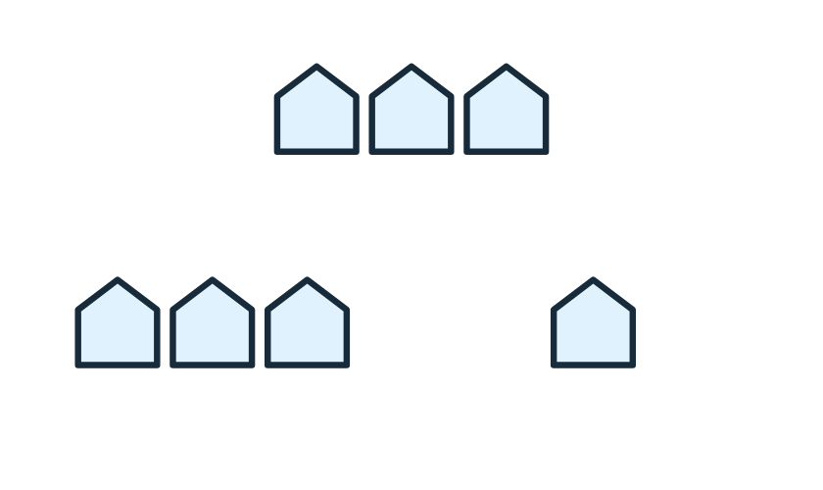  __________________  __________________ | 2. Is a settlement a place where people live or a change in urban share?  __________________  __________________
  3. Do more buildings prove national urbanisation?  __________________  __________________ | 4. What could show population change?  __________________  __________________
Point, speak, sign, draw, write or choose. You may pass. An adult may note your own words or choice.

Humanities · LAUNCH · Autumn 2 · Week 3 · HUM-LAUNCH-A2-W03

You do Supported
Staff mark I · S · C beside the task.
1. Start in your book. Use card B to show how work, transport and services can help a settlement grow.
2. Use the diagram and one number from the fictional tally. Explain what the number measures.
3. Use the frame: A place may grow because ____. Urbanisation means a rising share of people living in urban places.
Word bank: settlement · land use · infrastructure · urban population share.
My example and card detail
____________________________________________________________
My reason and check
____________________________________________________________
Point, speak, sign, draw, write or choose. You may pass. An adult may note your own words or choice.

Humanities · LAUNCH · Autumn 2 · Week 3 · HUM-LAUNCH-A2-W03

Review and exit Supported
Edit in the same colour, on the same page.
Can more buildings alone prove national urbanisation?
____________________________________________________________
What further evidence would help?
____________________________________________________________
Point, speak, sign, draw, write or choose. You may pass. An adult may note your own words or choice.

Humanities · LAUNCH · Autumn 2 · Week 3 · HUM-LAUNCH-A2-W03

Arrival Independent
 | Ready to learn?  ● Green · Ready  ● Amber · Help  ● Red · Pause  You may point, choose or pass.
  1. Point to the picture that matches the top one.  __________________  __________________ | 2. What is a settlement?  __________________  __________________
  3. Why do more buildings alone fail to prove national urbanisation?  __________________  __________________ | 4. What evidence would you compare?  __________________  __________________
Point, speak, sign, draw, write or choose. You may pass. An adult may note your own words or choice.

Humanities · LAUNCH · Autumn 2 · Week 3 · HUM-LAUNCH-A2-W03

You do Independent
Staff mark I · S · C beside the task.
1. Explain how work, transport and services can lead to settlement growth.
2. Use the diagram and the practice tally to support one part of your explanation.
3. Distinguish local growth from a rising national urban population share.
Word bank: settlement · land use · infrastructure · urban population share.
My example and card detail
____________________________________________________________
My reason and check
____________________________________________________________
Point, speak, sign, draw, write or choose. You may pass. An adult may note your own words or choice.

Humanities · LAUNCH · Autumn 2 · Week 3 · HUM-LAUNCH-A2-W03

Review and exit Independent
Edit in the same colour, on the same page.
Why is adding buildings alone insufficient?
____________________________________________________________
Which population evidence would you compare?
____________________________________________________________
Point, speak, sign, draw, write or choose. You may pass. An adult may note your own words or choice.

Humanities · LAUNCH · Autumn 2 · Week 3 · HUM-LAUNCH-A2-W03

Arrival Aspire
 | Ready to learn?  ● Green · Ready  ● Amber · Help  ● Red · Pause  You may point, choose or pass.
  1. Point to the picture that matches the top one.  __________________  __________________ | 2. Give an accurate example of a settlement.  __________________  __________________
  3. What could local building growth tell us, and what can it not establish?  __________________  __________________ | 4. What makes two observations comparable?  __________________  __________________
Point, speak, sign, draw, write or choose. You may pass. An adult may note your own words or choice.

Humanities · LAUNCH · Autumn 2 · Week 3 · HUM-LAUNCH-A2-W03

You do Aspire
Staff mark I · S · C beside the task.
1. Explain how work, transport and services can contribute to growth. Use the diagram and the practice tally.
2. Distinguish local growth from a rising national urban share.
3. Evaluate why one tally cannot establish urbanisation. Specify the population evidence you would need.
Word bank: settlement · land use · infrastructure · urban population share.
My example and card detail
____________________________________________________________
My reason and check
____________________________________________________________
Point, speak, sign, draw, write or choose. You may pass. An adult may note your own words or choice.

Humanities · LAUNCH · Autumn 2 · Week 3 · HUM-LAUNCH-A2-W03

Review and exit Aspire
Edit in the same colour, on the same page.
Explain why settlement growth and urbanisation can diverge.
____________________________________________________________
What further evidence would make a trend comparison valid?
____________________________________________________________
Point, speak, sign, draw, write or choose. You may pass. An adult may note your own words or choice.

Humanities · LAUNCH · Autumn 2 · Week 3 · HUM-LAUNCH-A2-W03

You do Choice
Staff mark I · S · C beside the task.
1. Choose a spoken, signed, written or drawn explanation. Keep your diagram or exact words in your book.
2. Show a link from work, transport or services to a possible change. Use one tally figure as a land-use clue.
3. Show how local growth differs from a rising national urban share.
Word bank: settlement · land use · infrastructure · urban population share.
My example and card detail
____________________________________________________________
My reason and check
____________________________________________________________
Point, speak, sign, draw, write or choose. You may pass. An adult may note your own words or choice.

Humanities · LAUNCH · Autumn 2 · Week 3 · HUM-LAUNCH-A2-W03

Review and exit Choice
Show one way that local growth and urbanisation differ.
____________________________________________________________
Show what you would compare to test urbanisation.
____________________________________________________________
Point, speak, sign, draw, write or choose. You may pass. An adult may note your own words or choice.

Humanities · LAUNCH · Autumn 2 · Week 3 · HUM-LAUNCH-A2-W03

Route card
Choose one: □ Supported · □ Independent · □ Aspire · □ Choice.
Start in your book and keep your evidence and check together.

Staff feedback boxes and pupil responses

□ VF
My response
____________________________________________________________

□ WS
My response
____________________________________________________________

□ I
My response
____________________________________________________________

□ NS + …
My response
____________________________________________________________

□ E
My response
____________________________________________________________

□ R
My response
____________________________________________________________

□ //
My response
____________________________________________________________

□ ?
My response
____________________________________________________________

Humanities · LAUNCH · Autumn 2 · Week 3 · HUM-LAUNCH-A2-W03

Catch-up absence or access only
For absence or access only.
Read card B and match one cause to a possible change. Read card C and identify one land-use count. Join the main task with those two clues.

Humanities · LAUNCH · Autumn 2 · Week 3 · HUM-LAUNCH-A2-W03

Word page
Two schematic views at the same scale. The smaller centre has a few buildings along one road and open land. The larger centre has more streets and buildings, a station and a bridge.
Tier | Word | Meaning
Tier 3 | settlement | A place where people live.
Tier 3 | urbanisation | An increase in the share of people living in urban places.
Tier 2 | land use | What land is used for.
Tier 3 | GIS | A way to map information in separate data layers.

Humanities · LAUNCH · Autumn 2 · Week 3 · HUM-LAUNCH-A2-W03

Book strips
Humanities · LAUNCH · Autumn 2 · Week 3 · HUM-LAUNCH-A2-W03
Settlement and urbanisation

Today I can
I can distinguish land use, settlement growth and urbanisation. · I can link work, transport or services to a possible change. · I can explain what further evidence a claim needs.
Humanities · LAUNCH · Autumn 2 · Week 3 · HUM-LAUNCH-A2-W03
Settlement and urbanisation

Today I can
I can distinguish land use, settlement growth and urbanisation. · I can link work, transport or services to a possible change. · I can explain what further evidence a claim needs.
Humanities · LAUNCH · Autumn 2 · Week 3 · HUM-LAUNCH-A2-W03
Settlement and urbanisation

Today I can
I can distinguish land use, settlement growth and urbanisation. · I can link work, transport or services to a possible change. · I can explain what further evidence a claim needs.
Humanities · LAUNCH · Autumn 2 · Week 3 · HUM-LAUNCH-A2-W03
Settlement and urbanisation

Today I can
I can distinguish land use, settlement growth and urbanisation. · I can link work, transport or services to a possible change. · I can explain what further evidence a claim needs.

