BUILD HUMANITIES / PUPIL SHEET 1

Map A: a made-up community
  - Autumn 1 · Week 3 · Places in our community
Name: __________________________ Date: ______________
Use this map throughout. It is a teaching model, not a real street or your home.
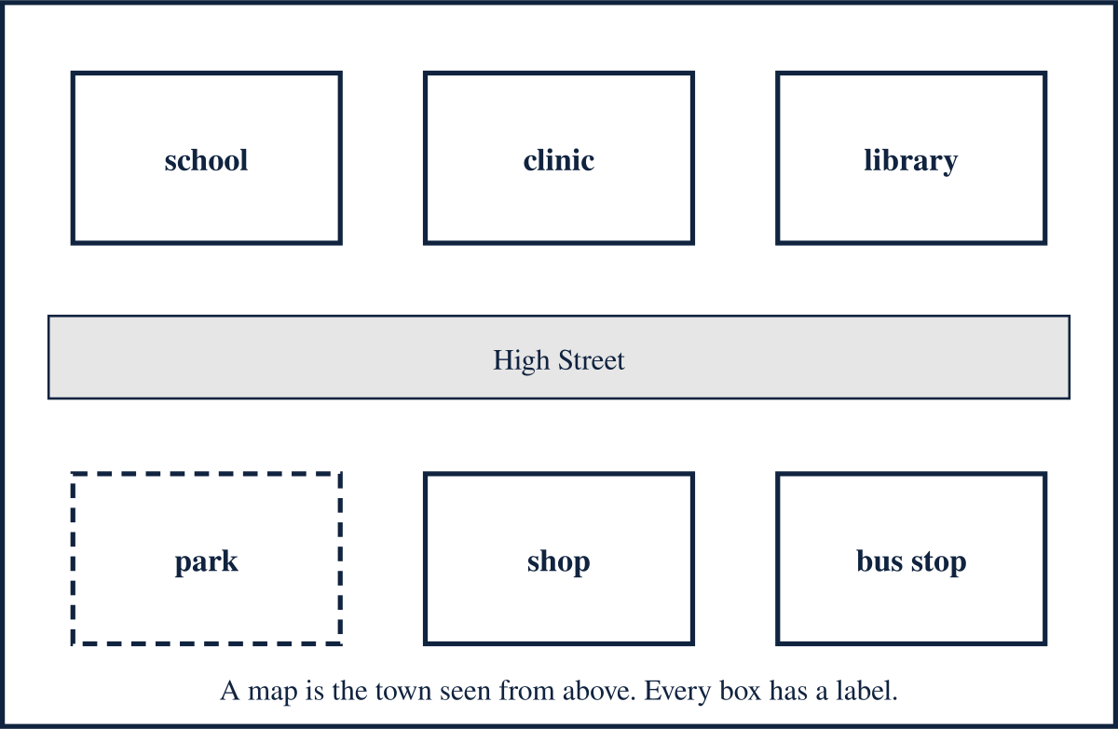
My first place is:

I think it is for:

BUILD HUMANITIES / PUPIL SHEET 2

Match the place to its use
  - Autumn 1 · Week 3 · Places in our community
Use bank: learn; buy food; borrow books; health appointment; play; wait for a bus. Choose four rows, or all six for a challenge.
Place | What happens there? | A helper
School
Shop
Library
Clinic
Park
Bus stop

BUILD HUMANITIES / PUPIL SHEET 3

Explain and improve
  - Autumn 1 · Week 3 · Places in our community
You can point, speak, draw or write. Your teacher records the support used.
The __________ is useful because __________.

A person who can help there is __________.

My listener heard:

I kept or changed this word because:

