BUILD HUMANITIES / PUPIL SHEET 1

Two real photographs
  - Autumn 1 · Week 4 · Then and now
Name: __________________________ Date: ______________
Tees Transporter Bridge, photographed from different viewpoints. Both images are in the past. Credits and licence are in the Teacher Guide.
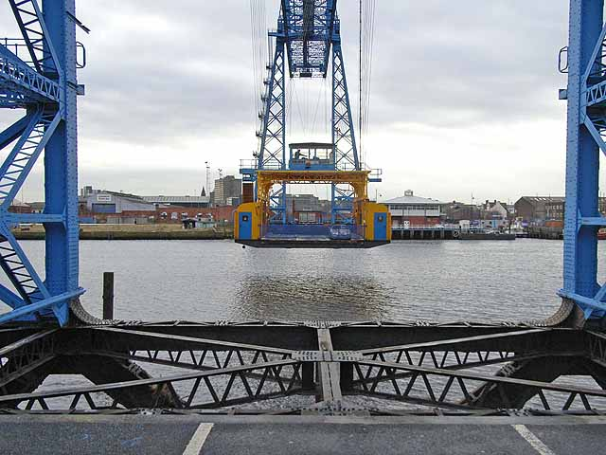  A | Oliver Dixon | 21 November 2008 | 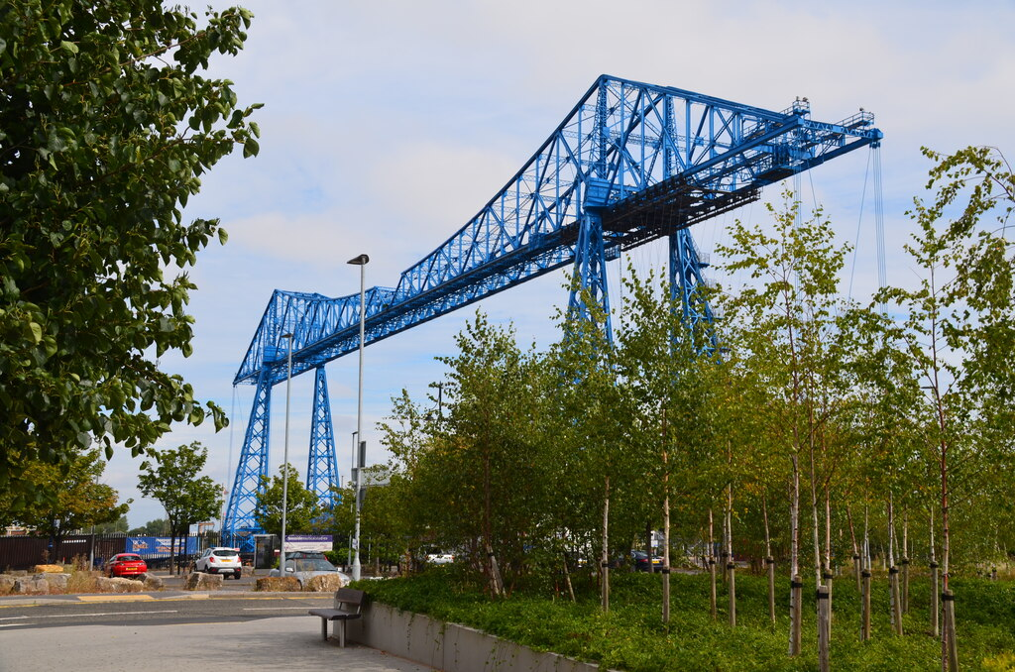  B | Rod Grealish | 4 September 2017
Earlier photo: ______ because ______.

A feature I can see in both:

BUILD HUMANITIES / PUPIL SHEET 2

Two model records
  - Autumn 1 · Week 4 · Then and now
These are fictional teaching records of the same made-up place. They are not archive evidence about Teesside.
Record | Date | Description
C | 1990 | A library and an empty grass area beside it.
D | 2026 | The same library and a play area beside it.

One thing that stayed:

One thing that changed:

A possible reason (a guess, not a proven fact):

BUILD HUMANITIES / PUPIL SHEET 3

What can the evidence support?
  - Autumn 1 · Week 4 · Then and now
Why are the dates more useful than photo colour?

Why might two photographs look different even if the place has not changed?

My best evidence sentence:

My listener heard / my improvement:

