BUILD HUMANITIES / PUPIL SHEET 1

Our shared map
  - Autumn 1 · Week 6 · Build our community map
Name: __________________________ Date: ______________
Use Map A as your shared base. No home addresses are needed.
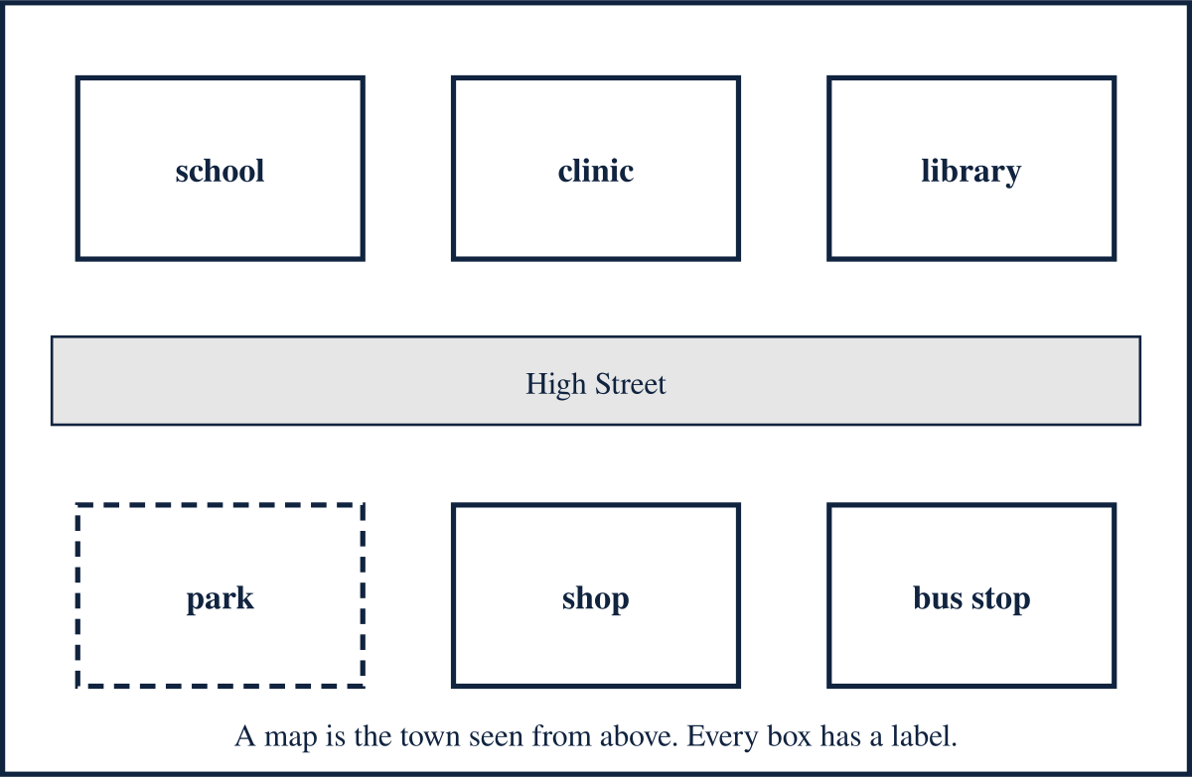
My map role:

The place I choose to add or explain:

Its label:

BUILD HUMANITIES / PUPIL SHEET 2

Place cards to cut or point to
  - Autumn 1 · Week 6 · Build our community map
Choose the place card first. Cover the other columns if you want to generate your own use note.
Place | Use | Who may help
School | Learn and practise | Teacher
Library | Borrow books | Librarian
Clinic | Attend a health appointment | Nurse or doctor
Shop | Buy food or other goods | Shop worker
Park | Play, rest or meet | Park worker
Bus stop | Wait for public transport | Bus driver on arrival

BUILD HUMANITIES / PUPIL SHEET 3

My map contribution
  - Autumn 1 · Week 6 · Build our community map
Draw or stick your place here. Your teacher can enlarge this page for the shared display.
Label:

Use note:

Who can this place help?

My reader said the note meant:

I kept / changed the note because:

Draw or stick your place here

