LAUNCH HUMANITIES / PUPIL SHEET 1

Source A: the original document
  - Autumn 1 · Week 3 · What can a source show?
Name: __________________________ Date: ______________
Passenger list for M.V. Empire Windrush, June 1948. The National Archives, BT 26/1237. This is an original-document image, not a newly invented record. Use the accessible extract on the next page if handwriting is difficult.
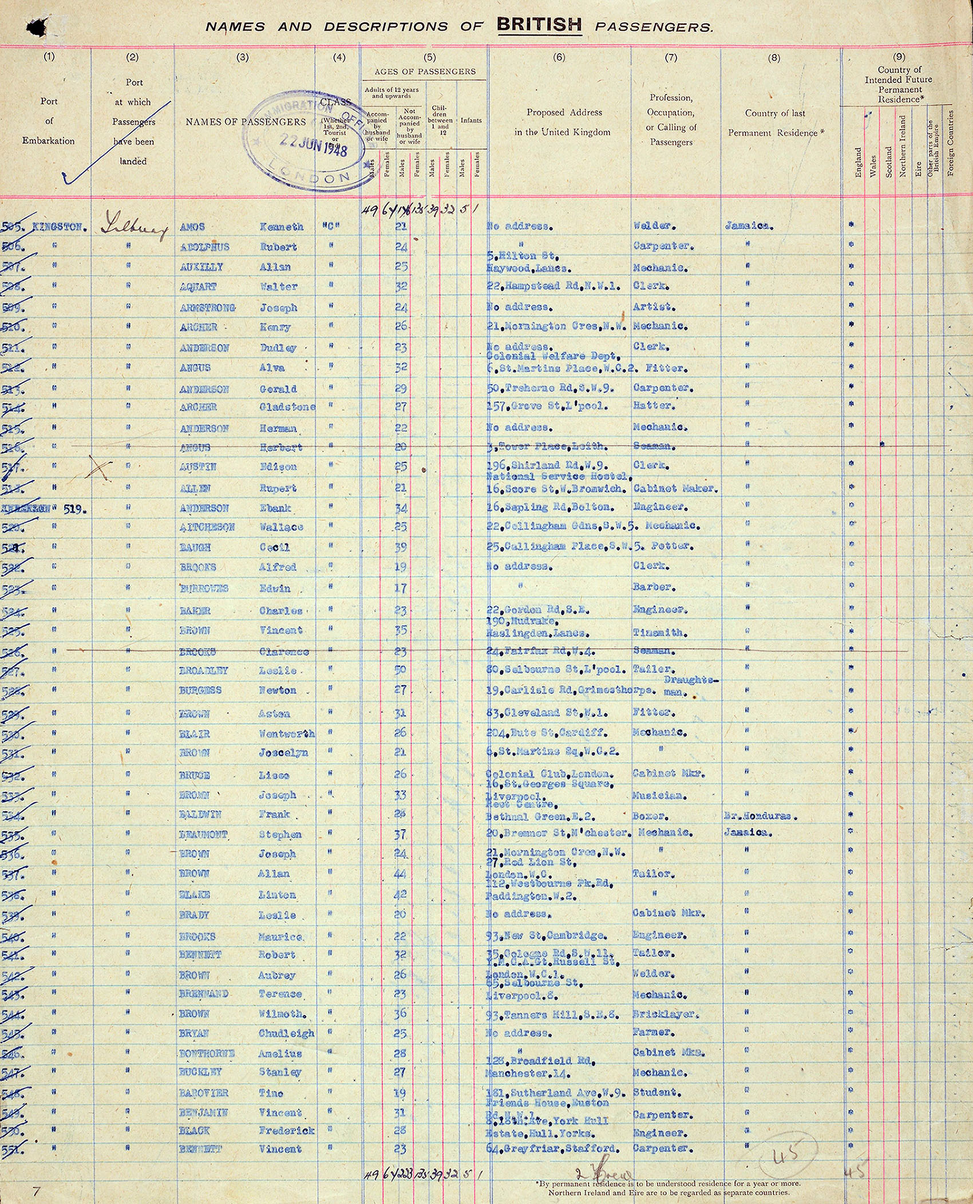

LAUNCH HUMANITIES / PUPIL SHEET 2

Source A: accessible record sheet
  - Autumn 1 · Week 3 · What can a source show?
Selected transcription of two rows: Kenneth Amos | 21 | Welder. Rubert Adolphus | 24 | Carpenter. Spellings follow the archive transcript; a historian may compare the handwriting. Source W in the notes links the original.
Field | What we can establish
Document | An inward passenger list for M.V. Empire Windrush
Date | June 1948; arrival at Tilbury on 22 June
Origin | Shipping passenger record; New Zealand Shipping Company voyage
Custodian | The National Archives
Reference | BT 26/1237
Fields on this page | Names, ages, occupations, proposed addresses, residence
Digitisation date | Not established here; not needed to date the voyage

LAUNCH HUMANITIES / PUPIL SHEET 3

Correct and evaluate
  - Autumn 1 · Week 3 · What can a source show?
Error: The National Archives created the passenger list. Correction and field:

Error: The online upload date tells us the year of the journey. Correction and field:

Error: A listed occupation proves why a person travelled. Correction and field:

Useful for __________ because __________.

Limited for __________ because __________.

Another source I would seek, and why:

