People special to me
Knowledge organiser

Learning goal
Talk about family and people special to me.

Enquiry
Who helps us belong to a community?
Word | Meaning
community | People linked by a place or activity
care | An action that meets a need
belong | Feel included in a group
service | Work that helps people

Key knowledge
Sam explained choices and showed a quiet space, helping Alex join in with support.
No. A fictional person is a complete response.

A frame to use
___ helps ___ by ___. This matters because ___.

Remember
Use a fictional person or place if preferred. The practice map is invented and is not a route to follow outside school.

Supported arrival
Begin with questions 1 and 2. Continue when ready. Choose one route; reading, pointing and exact scribing are available on every route.


1 Which picture can help someone find a book?
Help: Choose A or B. Point first; an adult can record your choice.
__________________________________________________________________
__________________________________________________________________

2 What did Sam do that could help Alex belong?
Help: Read or listen to the relevant evidence card; point first.
__________________________________________________________________
__________________________________________________________________

3 Find “care” in word help. What does it mean?
Help: Use the word and meaning cards together.
__________________________________________________________________
__________________________________________________________________

4 Must a people map use your real family?
Help: Use the source limit or map key as a clue.
__________________________________________________________________
__________________________________________________________________

Standard arrival
Begin with questions 1 and 2. Continue when ready. Choose one route; reading, pointing and exact scribing are available on every route.

1 Which picture can help someone find a book? Explain your choice.
Help: Choose A or B. Point first; an adult can record your choice.
__________________________________________________________________
__________________________________________________________________

2 What did Sam do that could help Alex belong?
Help: Use one source detail or labelled map feature.
__________________________________________________________________
__________________________________________________________________

3 Explain care using an example.
Help: Choose an example from the evidence cards.
__________________________________________________________________
__________________________________________________________________

4 Must a people map use your real family?
Help: State the reason for your answer.
__________________________________________________________________
__________________________________________________________________

Stretch arrival
Begin with questions 1 and 2. Continue when ready. Choose one route; reading, pointing and exact scribing are available on every route.

1 Which picture can help someone find a book? What can this teaching picture not tell us?
Help: Separate the illustration from historical or personal evidence.
__________________________________________________________________
__________________________________________________________________

2 What did Sam do that could help Alex belong? Give supporting evidence.
Help: Name the source or data label.
__________________________________________________________________
__________________________________________________________________

3 How does care help answer today’s enquiry?
Help: Explain the connection, not only the definition.
__________________________________________________________________
__________________________________________________________________

4 Must a people map use your real family? Explain a limit or further check.
Help: Think about what the supplied evidence leaves uncertain.
__________________________________________________________________
__________________________________________________________________

Evidence cards
Read or listen to the cards. Original historical records, authored summaries and fictional teaching cases are labelled separately.

A Alex and Sam
Fictional case: Alex is new to the youth club. Sam, a trusted club worker, explains the choices and shows Alex a quiet place.
Authored classroom case
Limit: This example does not describe every person or place.

B Library
A library lends books and can offer space to read or find information. Our practice map puts the library in square 1021.
Authored classroom case
Limit: This example does not describe every person or place.

C Health centre
The practice health centre is in square 1221. A receptionist helps people arrange appointments; trained health staff provide care.
Authored classroom case
Limit: This example does not describe every person or place.

D Park and hall
Our practice park is in 1122 and community hall in 1121. The hall hosts a drawing club with an optional quiet table.
Authored classroom case
Limit: This example does not describe every person or place.

Visual resources and data
Keep this page beside the shared and independent tasks.
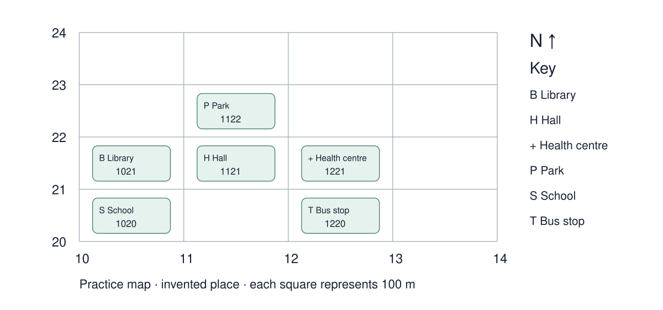

Use the resource
What did Sam do that could help Alex belong?
__________________________________________________________________
__________________________________________________________________
__________________________________________________________________
Must a people map use your real family?
__________________________________________________________________
__________________________________________________________________

Shared investigation
Make a decision, check the evidence, then explain. An individual or private response can replace speaking to the group.
1. Match a person to a caring action.
2. Discuss how the action changes Alex’s experience.
Item or draft | My decision or revision
Sam explains the choices
Sam refuses to explain
Alex chooses a quiet table

Support choices
Supported: Read two cards aloud and point to the matching action.
Standard: Match each item, then explain how it meets the need.
Stretch: Test an alternative match and explain when it could work.

Our explanation
__________________________________________________________________
__________________________________________________________________
__________________________________________________________________

Supported independent task
Complete this route only. Keep your own decisions; an adult may read, organise access or scribe your exact words.
1. Create a people map for Alex or a chosen fictional person.
2. Add a trusted person and a caring action.
3. Record one reason that person matters.

Help
Begin with one step. Read the sources with an adult, reduce the visible choice set and use: ___ helps ___ by ___. This matters because ___.
Keep all required evidence; speech, pointing, drawing and exact scribing are available.

My outcome and supporting evidence
__________________________________________________________________
__________________________________________________________________
__________________________________________________________________
__________________________________________________________________
__________________________________________________________________
__________________________________________________________________
__________________________________________________________________
__________________________________________________________________
__________________________________________________________________
__________________________________________________________________
Check: people map and one reason the person matters.

Standard independent task
Complete this route only. Keep your own decisions; an adult may read, organise access or scribe your exact words.
1. Create a people map for Alex or a chosen fictional person.
2. Add a trusted person and a caring action.
3. Record one reason that person matters.

Help
___ helps ___ by ___. This matters because ___.
Check your evidence before adding a final explanation.

My outcome and supporting evidence
__________________________________________________________________
__________________________________________________________________
__________________________________________________________________
__________________________________________________________________
__________________________________________________________________
__________________________________________________________________
__________________________________________________________________
__________________________________________________________________
__________________________________________________________________
__________________________________________________________________
Check: people map and one reason the person matters.

Stretch independent task
Complete this route only. Keep your own decisions; an adult may read, organise access or scribe your exact words.
1. Create a people map for Alex or a chosen fictional person.
2. Add a trusted person and a caring action.
3. Record one reason that person matters.

Help
Plan your answer using the source labels. Use the frame if useful.
Add a second caring relationship and explain a different need.

My outcome and supporting evidence
__________________________________________________________________
__________________________________________________________________
__________________________________________________________________
__________________________________________________________________
__________________________________________________________________
__________________________________________________________________
__________________________________________________________________
__________________________________________________________________
__________________________________________________________________
__________________________________________________________________
Check: people map and one reason the person matters.

Exit ticket choices
Choose one route. Answer both questions individually using your normal access support.

Supported
What did Sam do that could help Alex belong?
Must a people map use your real family?
Help: Use the word bank and a named evidence card.
__________________________________________________________________
__________________________________________________________________

Standard
What did Sam do that could help Alex belong?
Must a people map use your real family?
Help: Include a source detail, location or value.
__________________________________________________________________
__________________________________________________________________

Stretch
What did Sam do that could help Alex belong? Justify with evidence.
Must a people map use your real family? Evaluate a limitation.
Help: Weigh the evidence and name a limitation.
__________________________________________________________________
__________________________________________________________________

Teacher planning and alignment
Staff pages begin here. Print pupil routes selectively; keep answers separate.

Scheme of work
BUILD_A1_W01; My family my community and special people; SOW page 3
Exact outcome: Talk about family and people special to me.
Teaching and application: Model an inclusive people map. Together match people to caring actions; independently add a chosen person using symbols or a sentence. Allow a fictional example without personal disclosure.
Assessment evidence: F: people map and one reason the person matters.

Forty minute sequence
Time | Stage
0–4 | Arrival route
4–7 | Starter and visual enquiry
7–13 | Explicit model and optional captioned film
13–20 | Shared interactive activity
20–22 | Method check
22–34 | Independent application
34–37 | Review and improve
37–40 | Two exit questions

Access and assessment
Use one-step instructions, symbols and a model first. Offer talk, point, draw, type or write. Reduce the number of choices; extend by asking for a reason or a second example. Adults prompt the first response then fade support.
Routes are flexible. Check the learner can begin within two minutes. Use reading, typing, exact scribing or oral responses without lowering the Humanities thinking. Fade prompts. Record what was independent. For a summative outcome, rehearse on a practice example and keep the final response individual.

Teacher answers and scaffolding

Core and exit answers
Sam explained choices and showed a quiet space, helping Alex join in with support.
No. A fictional person is a complete response.

Shared task feedback
Sam explains the choices → Care. Alex knows what can happen next.
Sam refuses to explain → Needs changing. Alex still needs clear information.
Alex chooses a quiet table → Choice. The choice can help Alex participate.

Arrival answers
Supported: 1. A: the library books. 2. Sam explained choices and showed a quiet space, helping Alex join in with support. 3. An action that meets a need 4. No. A fictional person is a complete response.
Standard: 1. A: the library books. 2. Sam explained choices and showed a quiet space, helping Alex join in with support. 3. An action that meets a need Accept a relevant example. 4. No. A fictional person is a complete response.
Stretch: 1. A: the library books. It cannot establish a real person’s whole experience or belief. 2. Sam explained choices and showed a quiet space, helping Alex join in with support. 3. An action that meets a need Accept a supported connection. 4. No. A fictional person is a complete response.

Stage scaffolding
Starter, model and shared task: Read two cards aloud and point to the matching action. Match each item, then explain how it meets the need.
Further challenge: Test an alternative match and explain when it could work.
Review: check the exact required outcome before improving presentation. Retain first and revised responses when useful.

Sources and evidence record

Sources and resource preparation

UAS mapping before submission
The scheme provides no approved unit codes. The centre must select the exact unit and check every requirement. These resources prepare evidence; task completion does not establish an award.
Record | Complete for this learner
Learner and date
Selected unit title and code
Exact criterion and evidence page
Independent response and support used
Decision and next step

Calendar and editing
Schedule Black History Month, remembrance, Human Rights Day, Holocaust Memorial Day and International Women’s Day against the school calendar. The SOW sequence controls week numbering. Word text and tables are editable; HTML is the editable lesson source. Recheck layout and keep source details and answers aligned after changes.

