Then and now photographs
Knowledge organiser

Learning goal
Sort then and now photographs.

Enquiry
Who helps us belong to a community?
Word | Meaning
past | A time before now
present | The time we are in now
change | Something that becomes different
continuity | Something that stays the same

Key knowledge
No. Use the source and date labels.
Name a feature you can point to in both images.

A frame to use
Photo ___ is earlier. The ___ changed. Both show ___.

Remember
Use date and source labels to establish order. Image colour is not proof of age. A fictional personal timeline is always allowed.

Supported arrival
Begin with questions 1 and 2. Continue when ready. Choose one route; reading, pointing and exact scribing are available on every route.


1 Which phone has a dial that turns?
Help: Point to the dial or choose A. The diagrams are examples, not dated photographs.
__________________________________________________________________
__________________________________________________________________

2 Does a black-and-white photo have to be older?
Help: Read or listen to the relevant evidence card; point first.
__________________________________________________________________
__________________________________________________________________

3 Find “present” in word help. What does it mean?
Help: Use the word and meaning cards together.
__________________________________________________________________
__________________________________________________________________

4 How do you show a similarity?
Help: Use the source limit or map key as a clue.
__________________________________________________________________
__________________________________________________________________

Standard arrival
Begin with questions 1 and 2. Continue when ready. Choose one route; reading, pointing and exact scribing are available on every route.

1 Which phone has a dial that turns? Explain your choice.
Help: Point to the dial or choose A. The diagrams are examples, not dated photographs.
__________________________________________________________________
__________________________________________________________________

2 Does a black-and-white photo have to be older?
Help: Use one source detail or labelled map feature.
__________________________________________________________________
__________________________________________________________________

3 Explain present using an example.
Help: Choose an example from the evidence cards.
__________________________________________________________________
__________________________________________________________________

4 How do you show a similarity?
Help: State the reason for your answer.
__________________________________________________________________
__________________________________________________________________

Stretch arrival
Begin with questions 1 and 2. Continue when ready. Choose one route; reading, pointing and exact scribing are available on every route.

1 Which phone has a dial that turns? What can this teaching picture not tell us?
Help: Separate the illustration from historical or personal evidence.
__________________________________________________________________
__________________________________________________________________

2 Does a black-and-white photo have to be older? Give supporting evidence.
Help: Name the source or data label.
__________________________________________________________________
__________________________________________________________________

3 How does present help answer today’s enquiry?
Help: Explain the connection, not only the definition.
__________________________________________________________________
__________________________________________________________________

4 How do you show a similarity? Explain a limit or further check.
Help: Think about what the supplied evidence leaves uncertain.
__________________________________________________________________
__________________________________________________________________

Evidence cards
Read or listen to the cards. Original historical records, authored summaries and fictional teaching cases are labelled separately.

A A fictional week
Monday: choose a club activity. Wednesday: practise the activity. Friday: share what was made. The words Monday, Wednesday and Friday supply the order.
Authored classroom case
Limit: This example does not describe every person or place.

B Telephone comparison
A rotary telephone and a smartphone both support conversations over distance. A smartphone can also show a video call; a rotary dial selects numbers differently.
Authored comparison of familiar objects
Limit: A newer object is not automatically better for every person or purpose.

C Photo enquiry
Use the paired local photographs supplied with this unit. Read the captions and dates. Point to one feature in each image before deciding what changed.
See photograph captions and credits
Limit: A camera angle or season can make features appear different; a photograph alone may not explain why.

D Questions worth asking
Who used this object? When was this photo made? A dated catalogue entry can help with time; a user’s account can help with experience.
Authored classroom case
Limit: This example does not describe every person or place.

Visual resources and data
Keep this page beside the shared and independent tasks.
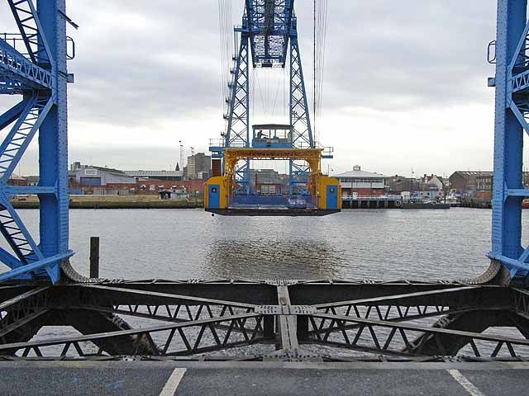
21 November 2008. Oliver Dixon. CC BY-SA 2.0.
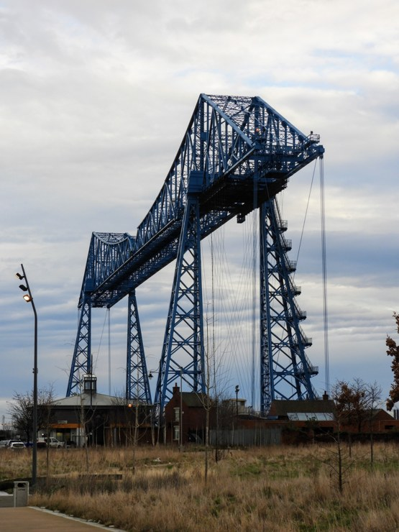
31 January 2020. Reading Tom. CC BY 2.0.
Tees Transporter Bridge. Different viewpoints: compare the gondola position and blue steel structure. Do not infer permanent rebuilding from the camera angle. These are dated views, not photographs of today.

Shared investigation
Make a decision, check the evidence, then explain. An individual or private response can replace speaking to the group.
1. Read the dates on the paired bridge photographs.
2. Point to a feature visible in both before naming a change.
Record | Our response
Feature
First example
Second example
Comparison

Support choices
Supported: Choose one feature in each example and use the same feature to compare.
Standard: Complete both sides before writing a similarity and a difference.
Stretch: Consider viewpoint, source selection and variation within groups.

Our explanation
__________________________________________________________________
__________________________________________________________________
__________________________________________________________________

Supported independent task
Complete this route only. Keep your own decisions; an adult may read, organise access or scribe your exact words.
1. Sort the two dated photographs into then and later.
2. Caption one visible change and one similarity.
3. Use the image labels as evidence.

Help
Begin with one step. Read the sources with an adult, reduce the visible choice set and use: Photo ___ is earlier. The ___ changed. Both show ___.
Keep all required evidence; speech, pointing, drawing and exact scribing are available.

My outcome and supporting evidence
__________________________________________________________________
__________________________________________________________________
__________________________________________________________________
__________________________________________________________________
__________________________________________________________________
__________________________________________________________________
__________________________________________________________________
__________________________________________________________________
__________________________________________________________________
__________________________________________________________________
Check: sorted images and a change/similarity response.

Standard independent task
Complete this route only. Keep your own decisions; an adult may read, organise access or scribe your exact words.
1. Sort the two dated photographs into then and later.
2. Caption one visible change and one similarity.
3. Use the image labels as evidence.

Help
Photo ___ is earlier. The ___ changed. Both show ___.
Check your evidence before adding a final explanation.

My outcome and supporting evidence
__________________________________________________________________
__________________________________________________________________
__________________________________________________________________
__________________________________________________________________
__________________________________________________________________
__________________________________________________________________
__________________________________________________________________
__________________________________________________________________
__________________________________________________________________
__________________________________________________________________
Check: sorted images and a change/similarity response.

Stretch independent task
Complete this route only. Keep your own decisions; an adult may read, organise access or scribe your exact words.
1. Sort the two dated photographs into then and later.
2. Caption one visible change and one similarity.
3. Use the image labels as evidence.

Help
Plan your answer using the source labels. Use the frame if useful.
Explain how angle or image quality might limit one comparison.

My outcome and supporting evidence
__________________________________________________________________
__________________________________________________________________
__________________________________________________________________
__________________________________________________________________
__________________________________________________________________
__________________________________________________________________
__________________________________________________________________
__________________________________________________________________
__________________________________________________________________
__________________________________________________________________
Check: sorted images and a change/similarity response.

Exit ticket choices
Choose one route. Answer both questions individually using your normal access support.

Supported
Does a black-and-white photo have to be older?
How do you show a similarity?
Help: Use the word bank and a named evidence card.
__________________________________________________________________
__________________________________________________________________

Standard
Does a black-and-white photo have to be older?
How do you show a similarity?
Help: Include a source detail, location or value.
__________________________________________________________________
__________________________________________________________________

Stretch
Does a black-and-white photo have to be older? Justify with evidence.
How do you show a similarity? Evaluate a limitation.
Help: Weigh the evidence and name a limitation.
__________________________________________________________________
__________________________________________________________________

Teacher planning and alignment
Staff pages begin here. Print pupil routes selectively; keep answers separate.

Scheme of work
BUILD_A1_W04; My family my community and special people; SOW page 4
Exact outcome: Sort then and now photographs.
Teaching and application: Model a paired comparison; sort 2–4 images, identify one change and one similarity, then add a caption. Pair-match before writing.
Assessment evidence: F: sorted images and a change/similarity response.

Forty minute sequence
Time | Stage
0–4 | Arrival route
4–7 | Starter and visual enquiry
7–13 | Explicit model and optional captioned film
13–20 | Shared interactive activity
20–22 | Method check
22–34 | Independent application
34–37 | Review and improve
37–40 | Two exit questions

Access and assessment
Use one-step instructions, symbols and a model first. Offer talk, point, draw, type or write. Reduce the number of choices; extend by asking for a reason or a second example. Adults prompt the first response then fade support.
Routes are flexible. Check the learner can begin within two minutes. Use reading, typing, exact scribing or oral responses without lowering the Humanities thinking. Fade prompts. Record what was independent. For a summative outcome, rehearse on a practice example and keep the final response individual.

Teacher answers and scaffolding

Core and exit answers
No. Use the source and date labels.
Name a feature you can point to in both images.

Shared task feedback
Review the pupil’s evidence against: F: sorted images and a change/similarity response. Open explanations are not automatically graded. Accept a different justified response that meets the outcome.

Arrival answers
Supported: 1. A: the rotary telephone. 2. No. Use the source and date labels. 3. The time we are in now 4. Name a feature you can point to in both images.
Standard: 1. A: the rotary telephone. 2. No. Use the source and date labels. 3. The time we are in now Accept a relevant example. 4. Name a feature you can point to in both images.
Stretch: 1. A: the rotary telephone. It cannot establish a real person’s whole experience or belief. 2. No. Use the source and date labels. 3. The time we are in now Accept a supported connection. 4. Name a feature you can point to in both images.

Stage scaffolding
Starter, model and shared task: Choose one feature in each example and use the same feature to compare. Complete both sides before writing a similarity and a difference.
Further challenge: Consider viewpoint, source selection and variation within groups.
Review: check the exact required outcome before improving presentation. Retain first and revised responses when useful.

Sources and evidence record

Sources and resource preparation
Oliver Dixon, Transporter Bridge, 21 November 2008, CC BY-SA 2.0. Reading Tom, Transporter Bridge, 31 January 2020, CC BY 2.0. Photographs resized without changing content.
https://commons.wikimedia.org/wiki/File:Middlesbrough_Transporter_Bridge_-_geograph.org.uk_-_1061873.jpg
https://commons.wikimedia.org/wiki/File:Middlesbrough_Transporter_Bridge_(49497796843).jpg

UAS mapping before submission
The scheme provides no approved unit codes. The centre must select the exact unit and check every requirement. These resources prepare evidence; task completion does not establish an award.
Record | Complete for this learner
Learner and date
Selected unit title and code
Exact criterion and evidence page
Independent response and support used
Decision and next step

Calendar and editing
Schedule Black History Month, remembrance, Human Rights Day, Holocaust Memorial Day and International Women’s Day against the school calendar. The SOW sequence controls week numbering. Word text and tables are editable; HTML is the editable lesson source. Recheck layout and keep source details and answers aligned after changes.

