A festival of light
Learning goal: Explore a festival of light and why it matters.

Words to use
Word | Meaning
festival | A special period of celebration or remembrance
belief | Something a person accepts as true
tradition | A practice passed on
respect | Care for people and what matters to them

Remember
What can light represent at Diwali? Good overcoming evil or knowledge overcoming ignorance.
Do all families celebrate in exactly the same way? No. Practices and stories vary.

How to show your learning
Make a museum label for Diwali.
Many Hindus use ___. It can represent ___.

Evidence matters
Fictional cases are teaching examples. Historical, geographical and religious claims use the named sources. A model video demonstrates a method.
You can respond by speaking, pointing, drawing, typing or writing. A fictional personal example is welcome.
Sources: Hindu American Foundation Diwali; Chabad What is Hanukkah

Arrival choices
You can begin without previous learning. Word help: festival means a special period of celebration or remembrance.

Start with 1 and 2. Try 3 and 4 when ready. Reading and exact scribing are available.

1 What does festival mean
Support: Use the reminder strip or talk it through with an adult.
My response
________________________________________________________________________

2 Which meaning fits festival
Support: Choose: A special period of celebration or remembrance OR Something a person accepts as true.
My response
________________________________________________________________________

3 What can light represent at Diwali
Support: Use the model evidence anchor D or read one relevant card together.
My response
________________________________________________________________________

4 Do all families celebrate in exactly the same way
Support: Give a reason when ready.
My response
________________________________________________________________________
Stretch: use a precise example or explain which detail supports your answer.

Evidence cards
Read, point or listen. Keep the source label with any detail you use.

D Diwali
Many Hindus mark Diwali with lamps, worship and gatherings. Light can express good overcoming evil and knowledge overcoming ignorance. Practices and stories vary.
Source: Hindu American Foundation, Diwali
Limit: This Hindu explanation does not cover every Hindu practice or other religions’ observances.

H Hanukkah
Hanukkah is a Jewish festival lasting eight nights. Lights recall the Temple’s rededication and the traditional account of oil lasting eight days. A hanukkiah has eight festival lights and a helper light.
Source: Chabad, What is Hanukkah
Limit: This explains one Jewish religious perspective; not all Jewish households observe identically.

O Objects and meanings
A diya is a small lamp associated with Diwali. A hanukkiah is used at Hanukkah. Ask before touching borrowed objects; use an unlit replica or a drawing.
Source: Authored classroom case
Limit: This example does not describe every person or place.

S One family’s celebration plan
Fictional Diwali plan: prepare a welcoming space; arrange unlit lamps with an adult; gather for worship; share food and greetings. This is one sequence, not a rule for every family.
Source: Authored classroom case
Limit: This example does not describe every person or place.

Visual resource
Use this visual with the evidence cards and enquiry questions.
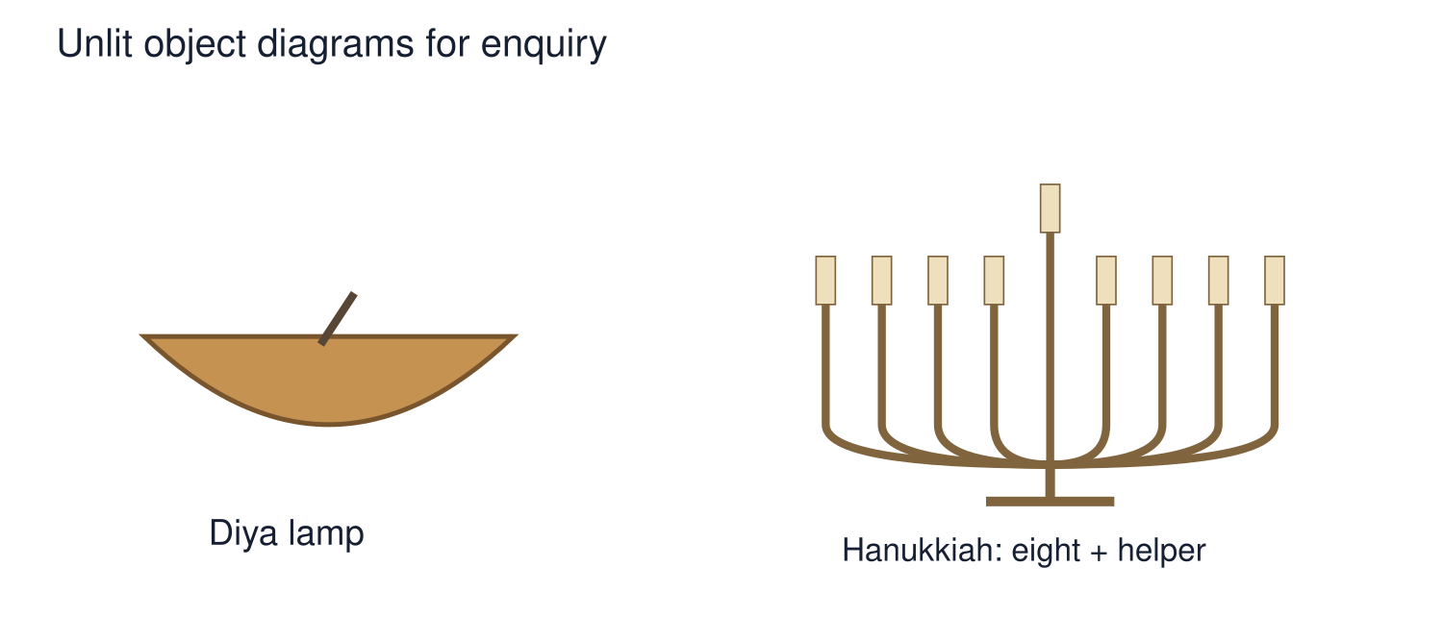
A detail I noticed and what it helps me explain
________________________________________________________________________
________________________________________________________________________
________________________________________________________________________
________________________________________________________________________

Shared investigation
1. Look closely at an unlit diya diagram.
2. Predict its use, reveal the source and revise the prediction.
Work with a partner or adult, or use your own table. One person suggests; the other checks the evidence. Swap after one turn. Passing is allowed.

Move or match the cards
Cards to use
A lamp can carry meaning
Every person in India celebrates Diwali
Diwali can include lamps

Possible labels: Not established / Supported
Our explanation
________________________________________________________________________
________________________________________________________________________
________________________________________________________________________
Support: Show two choices. Read one short instruction. Point, match or say a word, then add a reason when ready.
Further challenge: Explain why a picture alone cannot tell us everyone’s beliefs.

Supported independent task
Complete this route only. Explore a festival of light and why it matters.
1. Make a museum label for Diwali.
2. Record one accurate feature and explain its meaning for many Hindus.
3. Choose a drawing, caption or spoken label.
Support: Show two choices. Read one short instruction. Point, match or say a word, then add a reason when ready. Complete the organiser one space at a time. Many Hindus use ___. It can represent ___.
Source label and origin
________________________________________________________________________
________________________________________________________________________
A detail I can point to
________________________________________________________________________
________________________________________________________________________
What this detail helps me explain
________________________________________________________________________
________________________________________________________________________
What I still need to check
________________________________________________________________________
________________________________________________________________________
An adult may read or scribe your exact response. They should not choose the answer.

Standard independent task
Complete this route only. Explore a festival of light and why it matters.
1. Make a museum label for Diwali.
2. Record one accurate feature and explain its meaning for many Hindus.
3. Choose a drawing, caption or spoken label.
Support: Many Hindus use ___. It can represent ___.
Source label and origin
________________________________________________________________________
________________________________________________________________________
A detail I can point to
________________________________________________________________________
________________________________________________________________________
What this detail helps me explain
________________________________________________________________________
________________________________________________________________________
What I still need to check
________________________________________________________________________
________________________________________________________________________
Check the required evidence and revise one detail.

Stretch independent task
Complete this route only. Explore a festival of light and why it matters.
1. Make a museum label for Diwali.
2. Record one accurate feature and explain its meaning for many Hindus.
3. Choose a drawing, caption or spoken label.
4. Explain why a picture alone cannot tell us everyone’s beliefs.
Support: Choose the evidence independently. Use the frame only if it helps.
Source label and origin
________________________________________________________________________
________________________________________________________________________
A detail I can point to
________________________________________________________________________
________________________________________________________________________
What this detail helps me explain
________________________________________________________________________
________________________________________________________________________
What I still need to check
________________________________________________________________________
________________________________________________________________________
Explain why a picture alone cannot tell us everyone’s beliefs.

Exit ticket
Choose a response mode. You may give your answers privately to an adult.

What can light represent at Diwali
My response
________________________________________________________________________
________________________________________________________________________
________________________________________________________________________

Do all families celebrate in exactly the same way
My response
________________________________________________________________________
________________________________________________________________________
________________________________________________________________________
Support: Many Hindus use ___. It can represent ___.
Further challenge: Explain why a picture alone cannot tell us everyone’s beliefs.
One thing I changed or want to check
________________________________________________________________________
________________________________________________________________________

