Comparing celebrations
Learning goal: Compare how different communities celebrate.

Words to use
Word | Meaning
festival | A special period of celebration or remembrance
belief | Something a person accepts as true
tradition | A practice passed on
respect | Care for people and what matters to them

Remember
Name one shared feature. Both can use lights in celebration.
Name one difference supported by the sources. Hanukkah lasts eight nights; its lights recall rededication and the oil tradition.

How to show your learning
Complete a two-celebration comparison grid.
Both can ___. Diwali ___. Hanukkah ___.

Evidence matters
Fictional cases are teaching examples. Historical, geographical and religious claims use the named sources. A model video demonstrates a method.
You can respond by speaking, pointing, drawing, typing or writing. A fictional personal example is welcome.
Sources: Hindu American Foundation Diwali; Chabad What is Hanukkah

Arrival choices
Previous lesson reminder:
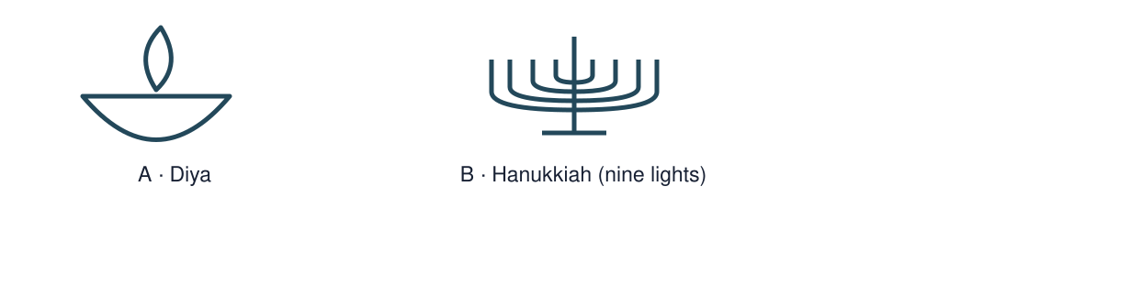
Start with 1 and 2. Try 3 and 4 when ready. Reading and exact scribing are available.

1 What can light represent at Diwali
Support: Use the reminder strip or talk it through with an adult.
My response
________________________________________________________________________

2 Which meaning fits festival
Support: Choose: A special period of celebration or remembrance OR Something a person accepts as true.
My response
________________________________________________________________________

3 Name one shared feature
Support: Use the model evidence anchor D,H or read one relevant card together.
My response
________________________________________________________________________

4 Name one difference supported by the sources
Support: Give a reason when ready.
My response
________________________________________________________________________
Stretch: use a precise example or explain which detail supports your answer.

Evidence cards
Read, point or listen. Keep the source label with any detail you use.

D Diwali
Many Hindus mark Diwali with lamps, worship and gatherings. Light can express good overcoming evil and knowledge overcoming ignorance. Practices and stories vary.
Source: Hindu American Foundation, Diwali
Limit: This Hindu explanation does not cover every Hindu practice or other religions’ observances.

H Hanukkah
Hanukkah is a Jewish festival lasting eight nights. Lights recall the Temple’s rededication and the traditional account of oil lasting eight days. A hanukkiah has eight festival lights and a helper light.
Source: Chabad, What is Hanukkah
Limit: This explains one Jewish religious perspective; not all Jewish households observe identically.

O Objects and meanings
A diya is a small lamp associated with Diwali. A hanukkiah is used at Hanukkah. Ask before touching borrowed objects; use an unlit replica or a drawing.
Source: Authored classroom case
Limit: This example does not describe every person or place.

S One family’s celebration plan
Fictional Diwali plan: prepare a welcoming space; arrange unlit lamps with an adult; gather for worship; share food and greetings. This is one sequence, not a rule for every family.
Source: Authored classroom case
Limit: This example does not describe every person or place.

Visual resource
Use this visual with the evidence cards and enquiry questions.
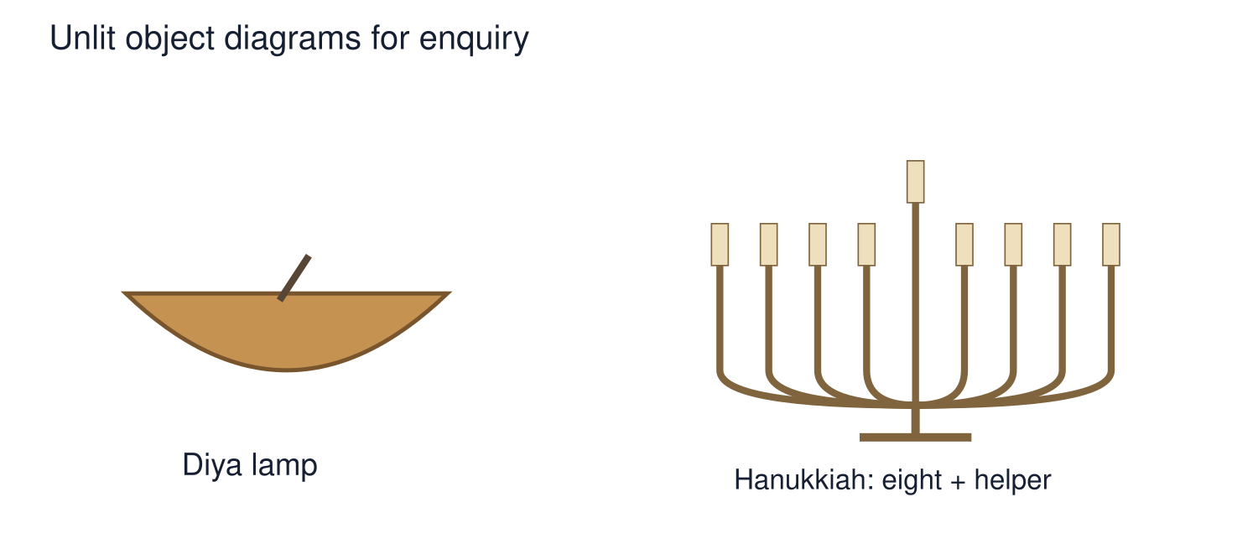
A detail I noticed and what it helps me explain
________________________________________________________________________
________________________________________________________________________
________________________________________________________________________
________________________________________________________________________

Shared investigation
1. Place features into Diwali, Hanukkah or both.
2. Explain a shared feature without calling the festivals identical.
Work with a partner or adult, or use your own table. One person suggests; the other checks the evidence. Swap after one turn. Passing is allowed.

Move or match the cards
Cards to use
Diyas
Eight nights
Lights

Possible labels: Both / Diwali / Hanukkah
Our explanation
________________________________________________________________________
________________________________________________________________________
________________________________________________________________________
Support: Show two choices. Read one short instruction. Point, match or say a word, then add a reason when ready.
Further challenge: Explain how similar objects can have different meanings.

Supported independent task
Complete this route only. Compare how different communities celebrate.
1. Complete a two-celebration comparison grid.
2. Record one similarity and one difference.
3. Explain one of your comparisons using D and H.
Support: Show two choices. Read one short instruction. Point, match or say a word, then add a reason when ready. Complete the organiser one space at a time. Both can ___. Diwali ___. Hanukkah ___.
My choice or example
________________________________________________________________________
________________________________________________________________________
A detail from the card story or object
________________________________________________________________________
________________________________________________________________________
My reason
________________________________________________________________________
________________________________________________________________________
My check or next step
________________________________________________________________________
________________________________________________________________________
An adult may read or scribe your exact response. They should not choose the answer.

Standard independent task
Complete this route only. Compare how different communities celebrate.
1. Complete a two-celebration comparison grid.
2. Record one similarity and one difference.
3. Explain one of your comparisons using D and H.
Support: Both can ___. Diwali ___. Hanukkah ___.
My choice or example
________________________________________________________________________
________________________________________________________________________
A detail from the card story or object
________________________________________________________________________
________________________________________________________________________
My reason
________________________________________________________________________
________________________________________________________________________
My check or next step
________________________________________________________________________
________________________________________________________________________
Check the required evidence and revise one detail.

Stretch independent task
Complete this route only. Compare how different communities celebrate.
1. Complete a two-celebration comparison grid.
2. Record one similarity and one difference.
3. Explain one of your comparisons using D and H.
4. Explain how similar objects can have different meanings.
Support: Choose the evidence independently. Use the frame only if it helps.
My choice or example
________________________________________________________________________
________________________________________________________________________
A detail from the card story or object
________________________________________________________________________
________________________________________________________________________
My reason
________________________________________________________________________
________________________________________________________________________
My check or next step
________________________________________________________________________
________________________________________________________________________
Explain how similar objects can have different meanings.

Exit ticket
Choose a response mode. You may give your answers privately to an adult.

Name one shared feature
My response
________________________________________________________________________
________________________________________________________________________
________________________________________________________________________

Name one difference supported by the sources
My response
________________________________________________________________________
________________________________________________________________________
________________________________________________________________________
Support: Both can ___. Diwali ___. Hanukkah ___.
Further challenge: Explain how similar objects can have different meanings.
One thing I changed or want to check
________________________________________________________________________
________________________________________________________________________

