Comparing belief and celebration
Learning goal: Compare how two communities celebrate with an RE link.

Words to use
Word | Meaning
festival | A special period of celebration or remembrance
belief | Something a person accepts as true
tradition | A practice passed on
respect | Care for people and what matters to them

Remember
What shared feature can the sources support? The use of lights.
Does the shared feature make the meanings identical? No. Each account connects light to particular traditions.

How to show your learning
Complete a comparison grid for D and H.
Both sources describe ___. Their meanings differ because ___.

Evidence matters
Fictional cases are teaching examples. Historical, geographical and religious claims use the named sources. A model video demonstrates a method.
You can respond by speaking, pointing, drawing, typing or writing. A fictional personal example is welcome.
Sources: Hindu American Foundation Diwali; Chabad What is Hanukkah

Arrival choices
Previous lesson reminder:
Start with 1 and 2. Try 3 and 4 when ready. Reading and exact scribing are available.

1 Does Diwali belong to only one country
Support: Use the reminder strip or talk it through with an adult.
My response
________________________________________________________________________

2 Which meaning fits festival
Support: Choose: A special period of celebration or remembrance OR Something a person accepts as true.
My response
________________________________________________________________________

3 What shared feature can the sources support
Support: Use the model evidence anchor D,H or read one relevant card together.
My response
________________________________________________________________________

4 Does the shared feature make the meanings identical
Support: Give a reason when ready.
My response
________________________________________________________________________
Stretch: use a precise example or explain which detail supports your answer.

Evidence cards
Read, point or listen. Keep the source label with any detail you use.

D Diwali
Many Hindus mark Diwali with lamps, worship and gatherings. Light can express good overcoming evil and knowledge overcoming ignorance. Practices and stories vary.
Source: Hindu American Foundation, Diwali
Limit: This Hindu explanation does not cover every Hindu practice or other religions’ observances.

H Hanukkah
Hanukkah is a Jewish festival lasting eight nights. Lights recall the Temple’s rededication and the traditional account of oil lasting eight days. A hanukkiah has eight festival lights and a helper light.
Source: Chabad, What is Hanukkah
Limit: This explains one Jewish religious perspective; not all Jewish households observe identically.

O Objects and meanings
A diya is a small lamp associated with Diwali. A hanukkiah is used at Hanukkah. Ask before touching borrowed objects; use an unlit replica or a drawing.
Source: Authored classroom case
Limit: This example does not describe every person or place.

S One family’s celebration plan
Fictional Diwali plan: prepare a welcoming space; arrange unlit lamps with an adult; gather for worship; share food and greetings. This is one sequence, not a rule for every family.
Source: Authored classroom case
Limit: This example does not describe every person or place.

Visual resource
Use this visual with the evidence cards and enquiry questions.
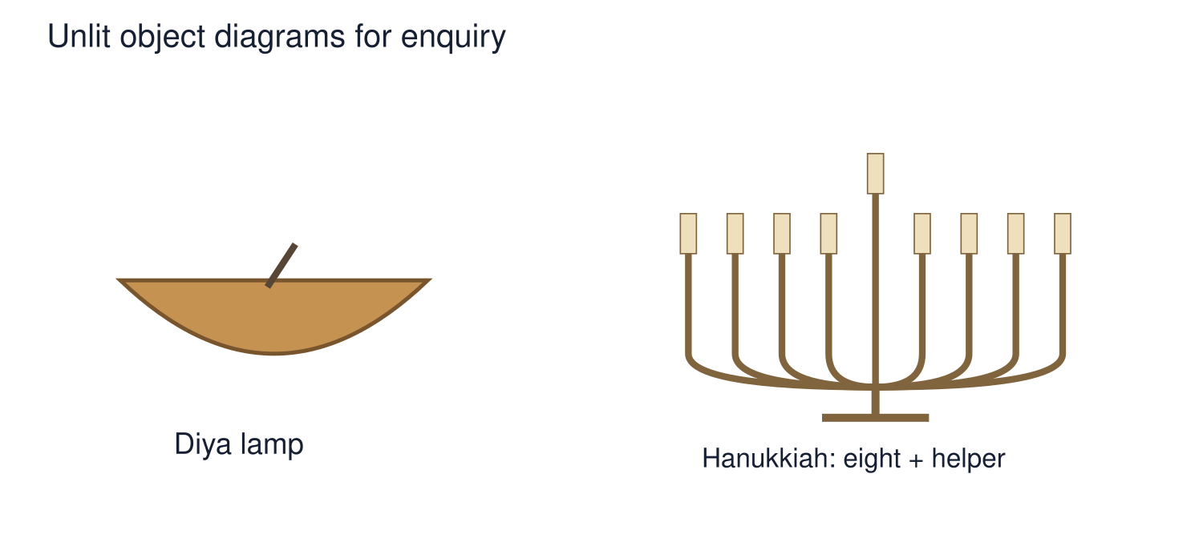
A detail I noticed and what it helps me explain
________________________________________________________________________
________________________________________________________________________
________________________________________________________________________
________________________________________________________________________

Shared investigation
1. Sort source features into Diwali, Hanukkah or both.
2. Test a claim that all celebrations involving light have the same meaning.
Work with a partner or adult, or use your own table. One person suggests; the other checks the evidence. Swap after one turn. Passing is allowed.

Move or match the cards
Cards to use
Knowledge overcoming ignorance
Temple rededication
Use of lights

Possible labels: Both / Diwali / Hanukkah
Our explanation
________________________________________________________________________
________________________________________________________________________
________________________________________________________________________
Support: Read one evidence card together. Highlight a useful detail. Rehearse with: Both sources describe ___. Their meanings differ because ___.
Further challenge: Evaluate what these two sources leave out about variation.

Supported independent task
Complete this route only. Compare how two communities celebrate with an RE link.
1. Complete a comparison grid for D and H.
2. Explain one similarity and one difference.
3. Recognise variation within each community.
Support: Read one evidence card together. Highlight a useful detail. Rehearse with: Both sources describe ___. Their meanings differ because ___. Complete the organiser one space at a time. Both sources describe ___. Their meanings differ because ___.
My choice or example
________________________________________________________________________
________________________________________________________________________
A detail from the card story or object
________________________________________________________________________
________________________________________________________________________
My reason
________________________________________________________________________
________________________________________________________________________
My check or next step
________________________________________________________________________
________________________________________________________________________
An adult may read or scribe your exact response. They should not choose the answer.

Standard independent task
Complete this route only. Compare how two communities celebrate with an RE link.
1. Complete a comparison grid for D and H.
2. Explain one similarity and one difference.
3. Recognise variation within each community.
Support: Both sources describe ___. Their meanings differ because ___.
My choice or example
________________________________________________________________________
________________________________________________________________________
A detail from the card story or object
________________________________________________________________________
________________________________________________________________________
My reason
________________________________________________________________________
________________________________________________________________________
My check or next step
________________________________________________________________________
________________________________________________________________________
Check the required evidence and revise one detail.

Stretch independent task
Complete this route only. Compare how two communities celebrate with an RE link.
1. Complete a comparison grid for D and H.
2. Explain one similarity and one difference.
3. Recognise variation within each community.
4. Evaluate what these two sources leave out about variation.
Support: Choose the evidence independently. Use the frame only if it helps.
My choice or example
________________________________________________________________________
________________________________________________________________________
A detail from the card story or object
________________________________________________________________________
________________________________________________________________________
My reason
________________________________________________________________________
________________________________________________________________________
My check or next step
________________________________________________________________________
________________________________________________________________________
Evaluate what these two sources leave out about variation.

Exit ticket
Choose a response mode. You may give your answers privately to an adult.

What shared feature can the sources support
My response
________________________________________________________________________
________________________________________________________________________
________________________________________________________________________

Does the shared feature make the meanings identical
My response
________________________________________________________________________
________________________________________________________________________
________________________________________________________________________
Support: Both sources describe ___. Their meanings differ because ___.
Further challenge: Evaluate what these two sources leave out about variation.
One thing I changed or want to check
________________________________________________________________________
________________________________________________________________________

