Belief and belonging review
Learning goal: Complete a belief and belonging task and map skills check and bank UAS evidence.

Words to use
Word | Meaning
festival | A special period of celebration or remembrance
belief | Something a person accepts as true
tradition | A practice passed on
respect | Care for people and what matters to them

Remember
What separate skill check belongs in this assessment? An independent map check.
How should selected UAS evidence be labelled? With learner, date, activity, exact selected criterion once confirmed, and support used.

How to show your learning
Complete an independent map task locating India, the UK and an ocean.
The map shows ___. The accounts are similar in ___ but differ in ___.

Evidence matters
Fictional cases are teaching examples. Historical, geographical and religious claims use the named sources. A model video demonstrates a method.
You can respond by speaking, pointing, drawing, typing or writing. A fictional personal example is welcome.
Sources: Hindu American Foundation Diwali; Chabad What is Hanukkah

Arrival choices
Previous lesson reminder:
Start with 1 and 2. Try 3 and 4 when ready. Reading and exact scribing are available.

1 Why should a presentation use evidence
Support: Use the reminder strip or talk it through with an adult.
My response
________________________________________________________________________

2 Which meaning fits festival
Support: Choose: A special period of celebration or remembrance OR Something a person accepts as true.
My response
________________________________________________________________________

3 What separate skill check belongs in this assessment
Support: Use the model evidence anchor assessment or read one relevant card together.
My response
________________________________________________________________________

4 How should selected UAS evidence be labelled
Support: Give a reason when ready.
My response
________________________________________________________________________
Stretch: use a precise example or explain which detail supports your answer.

Evidence cards
Read, point or listen. Keep the source label with any detail you use.

D Diwali
Many Hindus mark Diwali with lamps, worship and gatherings. Light can express good overcoming evil and knowledge overcoming ignorance. Practices and stories vary.
Source: Hindu American Foundation, Diwali
Limit: This Hindu explanation does not cover every Hindu practice or other religions’ observances.

H Hanukkah
Hanukkah is a Jewish festival lasting eight nights. Lights recall the Temple’s rededication and the traditional account of oil lasting eight days. A hanukkiah has eight festival lights and a helper light.
Source: Chabad, What is Hanukkah
Limit: This explains one Jewish religious perspective; not all Jewish households observe identically.

O Objects and meanings
A diya is a small lamp associated with Diwali. A hanukkiah is used at Hanukkah. Ask before touching borrowed objects; use an unlit replica or a drawing.
Source: Authored classroom case
Limit: This example does not describe every person or place.

S One family’s celebration plan
Fictional Diwali plan: prepare a welcoming space; arrange unlit lamps with an adult; gather for worship; share food and greetings. This is one sequence, not a rule for every family.
Source: Authored classroom case
Limit: This example does not describe every person or place.

Visual resource
Use this visual with the evidence cards and enquiry questions.
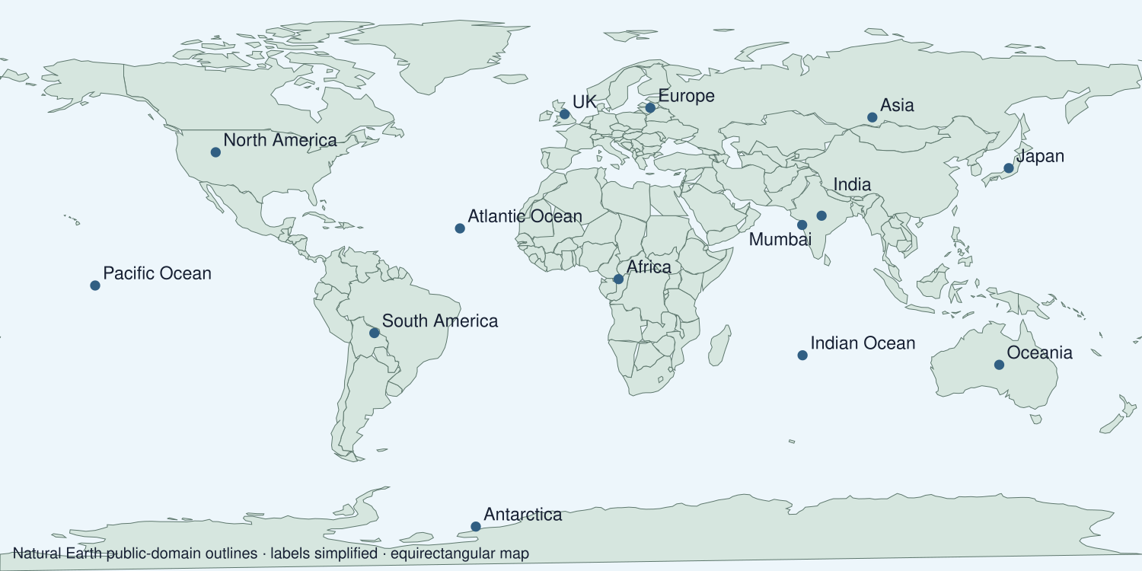
A detail I noticed and what it helps me explain
________________________________________________________________________
________________________________________________________________________
________________________________________________________________________
________________________________________________________________________

Shared investigation
1. Review what a map answer and a belief answer each need.
2. Practise on different examples before the assessment.
Work with a partner or adult, or use your own table. One person suggests; the other checks the evidence. Swap after one turn. Passing is allowed.
Use the evidence cards and any visual sheet. Follow the two shared steps above, then record one decision.
Our explanation
________________________________________________________________________
________________________________________________________________________
________________________________________________________________________
Support: Read one evidence card together. Highlight a useful detail. Rehearse with: The map shows ___. The accounts are similar in ___ but differ in ___.
Further challenge: Explain one limitation of using only these two accounts.

Supported independent task
Complete this route only. Complete a belief and belonging task and map skills check and bank UAS evidence.
1. Complete an independent map task locating India, the UK and an ocean.
2. Explain one festival feature and compare the two accounts.
3. Select labelled unit evidence and record the support used.
Support: Read one evidence card together. Highlight a useful detail. Rehearse with: The map shows ___. The accounts are similar in ___ but differ in ___. Complete the organiser one space at a time. The map shows ___. The accounts are similar in ___ but differ in ___.
My answer to the assessment enquiry
________________________________________________________________________
________________________________________________________________________
My evidence and source
________________________________________________________________________
________________________________________________________________________
My explanation or comparison
________________________________________________________________________
________________________________________________________________________
My conclusion and what the evidence does not show
________________________________________________________________________
________________________________________________________________________
An adult may read or scribe your exact response. They should not choose the answer.

Standard independent task
Complete this route only. Complete a belief and belonging task and map skills check and bank UAS evidence.
1. Complete an independent map task locating India, the UK and an ocean.
2. Explain one festival feature and compare the two accounts.
3. Select labelled unit evidence and record the support used.
Support: The map shows ___. The accounts are similar in ___ but differ in ___.
My answer to the assessment enquiry
________________________________________________________________________
________________________________________________________________________
My evidence and source
________________________________________________________________________
________________________________________________________________________
My explanation or comparison
________________________________________________________________________
________________________________________________________________________
My conclusion and what the evidence does not show
________________________________________________________________________
________________________________________________________________________
Check the required evidence and revise one detail.

Stretch independent task
Complete this route only. Complete a belief and belonging task and map skills check and bank UAS evidence.
1. Complete an independent map task locating India, the UK and an ocean.
2. Explain one festival feature and compare the two accounts.
3. Select labelled unit evidence and record the support used.
4. Explain one limitation of using only these two accounts.
Support: Choose the evidence independently. Use the frame only if it helps.
My answer to the assessment enquiry
________________________________________________________________________
________________________________________________________________________
My evidence and source
________________________________________________________________________
________________________________________________________________________
My explanation or comparison
________________________________________________________________________
________________________________________________________________________
My conclusion and what the evidence does not show
________________________________________________________________________
________________________________________________________________________
Explain one limitation of using only these two accounts.

Exit ticket
Choose a response mode. You may give your answers privately to an adult.

What separate skill check belongs in this assessment
My response
________________________________________________________________________
________________________________________________________________________
________________________________________________________________________

How should selected UAS evidence be labelled
My response
________________________________________________________________________
________________________________________________________________________
________________________________________________________________________
Support: The map shows ___. The accounts are similar in ___ but differ in ___.
Further challenge: Explain one limitation of using only these two accounts.
One thing I changed or want to check
________________________________________________________________________
________________________________________________________________________

