Settlement and urbanisation
Learning goal: Explain settlement and urbanisation.

Words to use
Word | Meaning
settlement | A place where people live
urbanisation | Growth in the share of people living in urban places
land use | What land is used for
GIS | Mapping information in separate data layers

Remember
Is adding buildings alone enough to prove national urbanisation? No. Urbanisation concerns the share of people living in urban places.
What further evidence would show population change? Comparable population data from different dates.

How to show your learning
Explain how work, transport and services can contribute to settlement growth.
A place may grow because ___. This can lead to ___. Urbanisation specifically means ___.

Evidence matters
Fictional cases are teaching examples. Historical, geographical and religious claims use the named sources. A model video demonstrates a method.
You can respond by speaking, pointing, drawing, typing or writing. A fictional personal example is welcome.
Sources: OpenStreetMap Middlesbrough; OpenStreetMap Helmsley

Arrival choices
Previous lesson reminder:
Start with 1 and 2. Try 3 and 4 when ready. Reading and exact scribing are available.

1 What does a GIS layer do
Support: Use the reminder strip or talk it through with an adult.
My response
________________________________________________________________________

2 Which meaning fits settlement
Support: Choose: A place where people live OR Growth in the share of people living in urban places.
My response
________________________________________________________________________

3 Is adding buildings alone enough to prove national urbanisation
Support: Use the model evidence anchor B or read one relevant card together.
My response
________________________________________________________________________

4 What further evidence would show population change
Support: Give a reason when ready.
My response
________________________________________________________________________
Stretch: use a precise example or explain which detail supports your answer.

Evidence cards
Read, point or listen. Keep the source label with any detail you use.

A Local reference points
The Middlesbrough railway station and the Transporter Bridge are reference points on our digital map. Toggle layers to examine their positions. Town Hall lies beyond this map’s southern boundary.
Source: OpenStreetMap place references; approximate labelled coordinates
Limit: These points alone cannot show population density or prove why development happened.

B Reasons places grow
Work, transport and services can attract people and businesses. A growing town may need more homes and infrastructure. Population growth can also occur within existing settlements.
Source: Authored geographical explanation
Limit: A reason is a hypothesis until tested against evidence for a particular place.

C Practice land-use sample
Fictional practice tally: shops 8, homes 12, public services 4, green spaces 6. This is training data only. Replace it with your dated observations for the fieldwork enquiry.
Source: Authored classroom case
Limit: This example does not describe every person or place.

D Contrasting reference place
Compare a small centre such as Helmsley with central Middlesbrough at comparable map scales. Record the area, source and date used.
Source: OpenStreetMap linked views
Limit: One sampled street does not represent a whole settlement.

Visual resource
Use this visual with the evidence cards and enquiry questions.
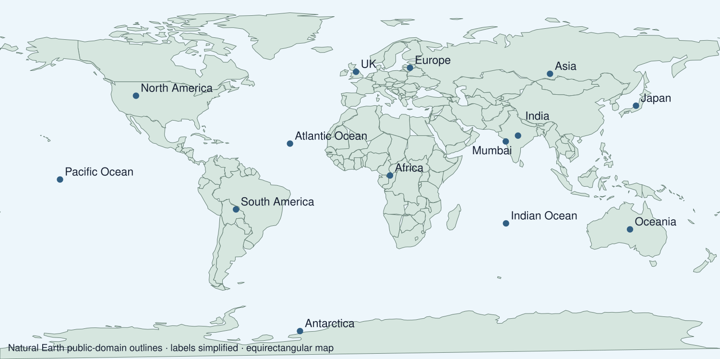
A detail I noticed and what it helps me explain
________________________________________________________________________
________________________________________________________________________
________________________________________________________________________
________________________________________________________________________

Shared investigation
1. Sort descriptions of land use, settlement growth and urbanisation.
2. Use practice data to test what a claim actually measures.
Work with a partner or adult, or use your own table. One person suggests; the other checks the evidence. Swap after one turn. Passing is allowed.

Move or match the cards
Cards to use
More jobs attract residents
A street has eight shops
Share living in urban areas rises

Possible labels: Land-use observation / Possible growth explanation / Urbanisation
Our explanation
________________________________________________________________________
________________________________________________________________________
________________________________________________________________________
Support: Use the glossary and one chunk of evidence. Plan the claim and supporting detail before explaining.
Further challenge: Evaluate why a single land-use tally cannot prove urbanisation over time.

Supported independent task
Complete this route only. Explain settlement and urbanisation.
1. Explain how work, transport and services can contribute to settlement growth.
2. Use a diagram and the labelled practice data.
3. Distinguish urban growth from a rising national urban share.
Support: Use the glossary and one chunk of evidence. Plan the claim and supporting detail before explaining. Complete the organiser one space at a time. A place may grow because ___. This can lead to ___. Urbanisation specifically means ___.
My choice or example
________________________________________________________________________
________________________________________________________________________
A detail from the card story or object
________________________________________________________________________
________________________________________________________________________
My reason
________________________________________________________________________
________________________________________________________________________
My check or next step
________________________________________________________________________
________________________________________________________________________
An adult may read or scribe your exact response. They should not choose the answer.

Standard independent task
Complete this route only. Explain settlement and urbanisation.
1. Explain how work, transport and services can contribute to settlement growth.
2. Use a diagram and the labelled practice data.
3. Distinguish urban growth from a rising national urban share.
Support: A place may grow because ___. This can lead to ___. Urbanisation specifically means ___.
My choice or example
________________________________________________________________________
________________________________________________________________________
A detail from the card story or object
________________________________________________________________________
________________________________________________________________________
My reason
________________________________________________________________________
________________________________________________________________________
My check or next step
________________________________________________________________________
________________________________________________________________________
Check the required evidence and revise one detail.

Stretch independent task
Complete this route only. Explain settlement and urbanisation.
1. Explain how work, transport and services can contribute to settlement growth.
2. Use a diagram and the labelled practice data.
3. Distinguish urban growth from a rising national urban share.
4. Evaluate why a single land-use tally cannot prove urbanisation over time.
Support: Choose the evidence independently. Use the frame only if it helps.
My choice or example
________________________________________________________________________
________________________________________________________________________
A detail from the card story or object
________________________________________________________________________
________________________________________________________________________
My reason
________________________________________________________________________
________________________________________________________________________
My check or next step
________________________________________________________________________
________________________________________________________________________
Evaluate why a single land-use tally cannot prove urbanisation over time.

Exit ticket
Choose a response mode. You may give your answers privately to an adult.

Is adding buildings alone enough to prove national urbanisation
My response
________________________________________________________________________
________________________________________________________________________
________________________________________________________________________

What further evidence would show population change
My response
________________________________________________________________________
________________________________________________________________________
________________________________________________________________________
Support: A place may grow because ___. This can lead to ___. Urbanisation specifically means ___.
Further challenge: Evaluate why a single land-use tally cannot prove urbanisation over time.
One thing I changed or want to check
________________________________________________________________________
________________________________________________________________________

