Comparing places through online evidence
Learning goal: Compare the local area with a contrasting place using online evidence.

Words to use
Word | Meaning
settlement | A place where people live
urbanisation | Growth in the share of people living in urban places
land use | What land is used for
GIS | Mapping information in separate data layers

Remember
Why compare maps at similar scales? It reduces misleading differences caused by showing unequal areas or detail.
Can one street represent a whole town without qualification? No. State the sampled area and limits.

How to show your learning
Create a comparison using online maps of both named places.
Using comparable areas, ___ shows ___ whereas ___. The source is useful for ___ but ___.

Evidence matters
Fictional cases are teaching examples. Historical, geographical and religious claims use the named sources. A model video demonstrates a method.
You can respond by speaking, pointing, drawing, typing or writing. A fictional personal example is welcome.
Sources: OpenStreetMap Middlesbrough; OpenStreetMap Helmsley

Arrival choices
Previous lesson reminder:
Start with 1 and 2. Try 3 and 4 when ready. Reading and exact scribing are available.

1 Why is a bar chart suitable for land use categories
Support: Use the reminder strip or talk it through with an adult.
My response
________________________________________________________________________

2 Which meaning fits settlement
Support: Choose: A place where people live OR Growth in the share of people living in urban places.
My response
________________________________________________________________________

3 Why compare maps at similar scales
Support: Use the model evidence anchor D or read one relevant card together.
My response
________________________________________________________________________

4 Can one street represent a whole town without qualification
Support: Give a reason when ready.
My response
________________________________________________________________________
Stretch: use a precise example or explain which detail supports your answer.

Evidence cards
Read, point or listen. Keep the source label with any detail you use.

A Local reference points
The Middlesbrough railway station and the Transporter Bridge are reference points on our digital map. Toggle layers to examine their positions. Town Hall lies beyond this map’s southern boundary.
Source: OpenStreetMap place references; approximate labelled coordinates
Limit: These points alone cannot show population density or prove why development happened.

B Reasons places grow
Work, transport and services can attract people and businesses. A growing town may need more homes and infrastructure. Population growth can also occur within existing settlements.
Source: Authored geographical explanation
Limit: A reason is a hypothesis until tested against evidence for a particular place.

C Practice land-use sample
Fictional practice tally: shops 8, homes 12, public services 4, green spaces 6. This is training data only. Replace it with your dated observations for the fieldwork enquiry.
Source: Authored classroom case
Limit: This example does not describe every person or place.

D Contrasting reference place
Compare a small centre such as Helmsley with central Middlesbrough at comparable map scales. Record the area, source and date used.
Source: OpenStreetMap linked views
Limit: One sampled street does not represent a whole settlement.

Visual resource
Use this visual with the evidence cards and enquiry questions.
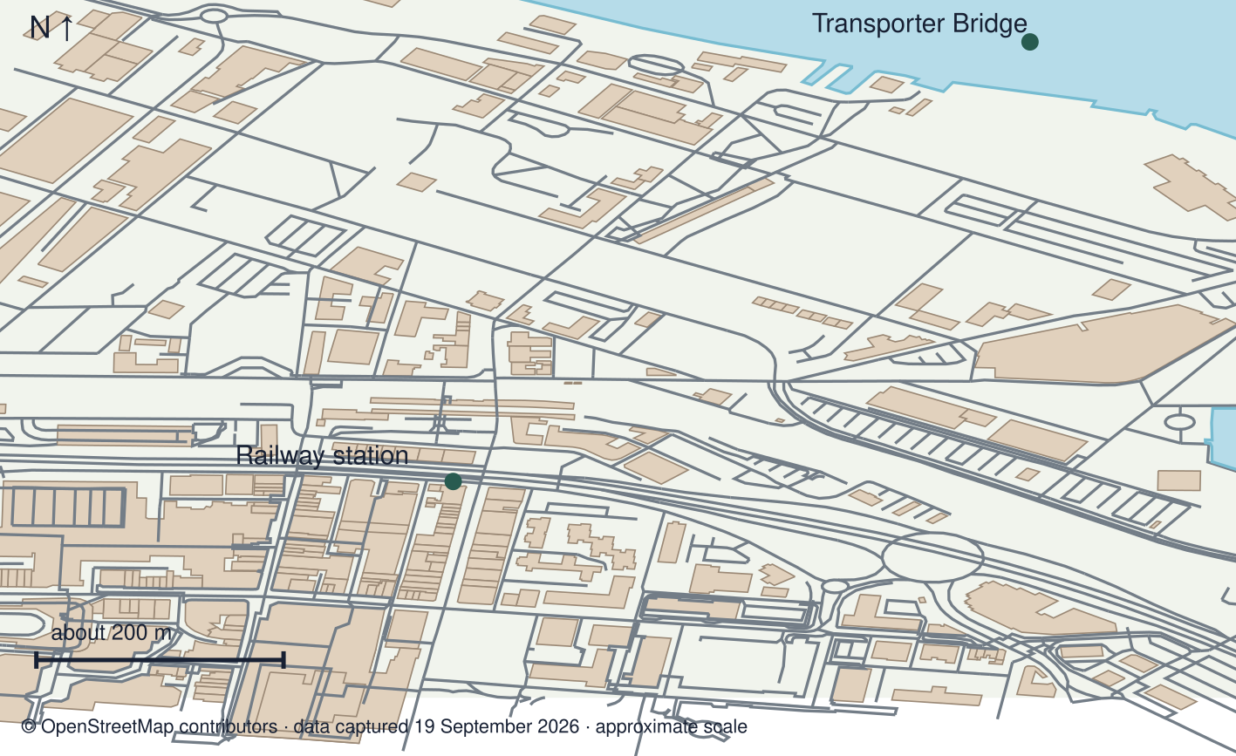
A detail I noticed and what it helps me explain
________________________________________________________________________
________________________________________________________________________
________________________________________________________________________
________________________________________________________________________

Shared investigation
1. Compare Middlesbrough and Helmsley at similar map scales.
2. Check creator, date, coverage and the question each source can answer.
Work with a partner or adult, or use your own table. One person suggests; the other checks the evidence. Swap after one turn. Passing is allowed.
Use the evidence cards and any visual sheet. Follow the two shared steps above, then record one decision.
Our explanation
________________________________________________________________________
________________________________________________________________________
________________________________________________________________________
Support: Use the glossary and one chunk of evidence. Plan the claim and supporting detail before explaining.
Further challenge: Explain how choosing different map extents could change the contrast.

Supported independent task
Complete this route only. Compare the local area with a contrasting place using online evidence.
1. Create a comparison using online maps of both named places.
2. Support two contrasts with comparable evidence.
3. Evaluate one source’s usefulness and a limitation, recording access date and scale.
Support: Use the glossary and one chunk of evidence. Plan the claim and supporting detail before explaining. Complete the organiser one space at a time. Using comparable areas, ___ shows ___ whereas ___. The source is useful for ___ but ___.
Evidence from the first example
________________________________________________________________________
________________________________________________________________________
Evidence from the second example
________________________________________________________________________
________________________________________________________________________
One similarity
________________________________________________________________________
________________________________________________________________________
One difference or change
________________________________________________________________________
________________________________________________________________________
An adult may read or scribe your exact response. They should not choose the answer.

Standard independent task
Complete this route only. Compare the local area with a contrasting place using online evidence.
1. Create a comparison using online maps of both named places.
2. Support two contrasts with comparable evidence.
3. Evaluate one source’s usefulness and a limitation, recording access date and scale.
Support: Using comparable areas, ___ shows ___ whereas ___. The source is useful for ___ but ___.
Evidence from the first example
________________________________________________________________________
________________________________________________________________________
Evidence from the second example
________________________________________________________________________
________________________________________________________________________
One similarity
________________________________________________________________________
________________________________________________________________________
One difference or change
________________________________________________________________________
________________________________________________________________________
Check the required evidence and revise one detail.

Stretch independent task
Complete this route only. Compare the local area with a contrasting place using online evidence.
1. Create a comparison using online maps of both named places.
2. Support two contrasts with comparable evidence.
3. Evaluate one source’s usefulness and a limitation, recording access date and scale.
4. Explain how choosing different map extents could change the contrast.
Support: Choose the evidence independently. Use the frame only if it helps.
Evidence from the first example
________________________________________________________________________
________________________________________________________________________
Evidence from the second example
________________________________________________________________________
________________________________________________________________________
One similarity
________________________________________________________________________
________________________________________________________________________
One difference or change
________________________________________________________________________
________________________________________________________________________
Explain how choosing different map extents could change the contrast.

Exit ticket
Choose a response mode. You may give your answers privately to an adult.

Why compare maps at similar scales
My response
________________________________________________________________________
________________________________________________________________________
________________________________________________________________________

Can one street represent a whole town without qualification
My response
________________________________________________________________________
________________________________________________________________________
________________________________________________________________________
Support: Using comparable areas, ___ shows ___ whereas ___. The source is useful for ___ but ___.
Further challenge: Explain how choosing different map extents could change the contrast.
One thing I changed or want to check
________________________________________________________________________
________________________________________________________________________

