How a local place changes
Learning goal: Talk about how my local area has changed.

Words to use
Word | Meaning
past | A time before now
present | The time we are in now
change | Something that becomes different
continuity | Something that stays the same

Remember
What is continuity? Something that stays the same across the evidence being compared.
Can photographs alone always explain why a place changed? No. Another source may be needed for the reason.

How to show your learning
Annotate the two credited photographs.
In photo ___ I can see ___. In photo ___ ___. Both ___.

Evidence matters
Fictional cases are teaching examples. Historical, geographical and religious claims use the named sources. A model video demonstrates a method.
You can respond by speaking, pointing, drawing, typing or writing. A fictional personal example is welcome.

Arrival choices
Previous lesson reminder:
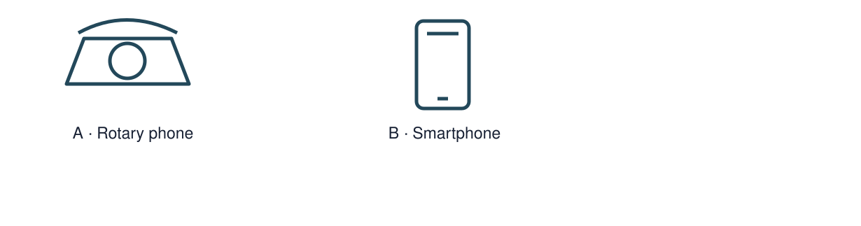
Start with 1 and 2. Try 3 and 4 when ready. Reading and exact scribing are available.

1 What information establishes the order
Support: Use the reminder strip or talk it through with an adult.
My response
________________________________________________________________________

2 Which meaning fits past
Support: Choose: A time before now OR The time we are in now.
My response
________________________________________________________________________

3 What is continuity
Support: Use the model evidence anchor C or read one relevant card together.
My response
________________________________________________________________________

4 Can photographs alone always explain why a place changed
Support: Give a reason when ready.
My response
________________________________________________________________________
Stretch: use a precise example or explain which detail supports your answer.

Evidence cards
Read, point or listen. Keep the source label with any detail you use.

A A fictional week
Monday: choose a club activity. Wednesday: practise the activity. Friday: share what was made. The words Monday, Wednesday and Friday supply the order.
Source: Authored classroom case
Limit: This example does not describe every person or place.

B Telephone comparison
A rotary telephone and a smartphone both support conversations over distance. A smartphone can also show a video call; a rotary dial selects numbers differently.
Source: Authored comparison of familiar objects
Limit: A newer object is not automatically better for every person or purpose.

C Photo enquiry
Use the paired local photographs supplied with this unit. Read the captions and dates. Point to one feature in each image before deciding what changed.
Source: See photograph captions and credits
Limit: A camera angle or season can make features appear different; a photograph alone may not explain why.

D Questions worth asking
Who used this object? When was this photo made? A dated catalogue entry can help with time; a user’s account can help with experience.
Source: Authored classroom case
Limit: This example does not describe every person or place.

Visual resource 1
Use this visual with the evidence cards and enquiry questions.
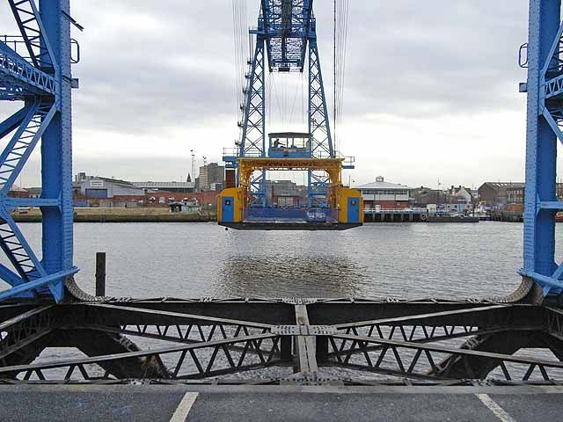
Source: 21 November 2008 · Oliver Dixon · CC BY-SA 2.0
The viewpoints differ. Compare visible details; do not infer rebuilding from the camera angle. These are historical photographs, not a live view.
A detail I noticed and what it helps me explain
________________________________________________________________________
________________________________________________________________________
________________________________________________________________________
________________________________________________________________________

Visual resource 2
Use this visual with the evidence cards and enquiry questions.
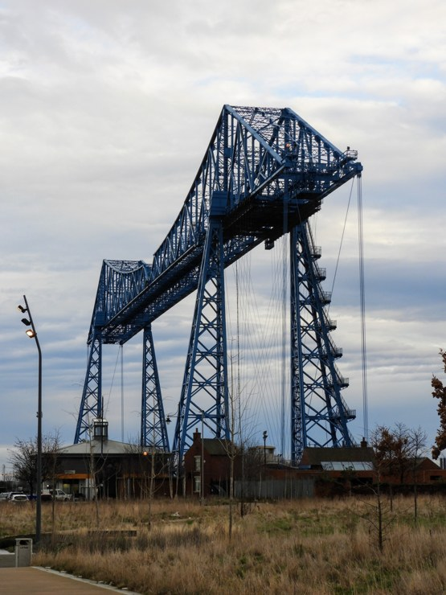
Source: 31 January 2020 · Reading Tom · CC BY 2.0
The viewpoints differ. Compare visible details; do not infer rebuilding from the camera angle. These are historical photographs, not a live view.
A detail I noticed and what it helps me explain
________________________________________________________________________
________________________________________________________________________
________________________________________________________________________
________________________________________________________________________

Shared investigation
1. Compare the local bridge photographs.
2. Mark one visible continuity and one visible change.
Work with a partner or adult, or use your own table. One person suggests; the other checks the evidence. Swap after one turn. Passing is allowed.
Use the evidence cards and any visual sheet. Follow the two shared steps above, then record one decision.
Our explanation
________________________________________________________________________
________________________________________________________________________
________________________________________________________________________
Support: Show two choices. Read one short instruction. Point, match or say a word, then add a reason when ready.
Further challenge: State a limitation caused by viewpoint and suggest another photo that would help.

Supported independent task
Complete this route only. Talk about how my local area has changed.
1. Annotate the two credited photographs.
2. Add one change and one continuity using arrows or numbered captions.
3. Record a careful spoken or written comparison.
Support: Show two choices. Read one short instruction. Point, match or say a word, then add a reason when ready. Complete the organiser one space at a time. In photo ___ I can see ___. In photo ___ ___. Both ___.
Evidence from the first example
________________________________________________________________________
________________________________________________________________________
Evidence from the second example
________________________________________________________________________
________________________________________________________________________
One similarity
________________________________________________________________________
________________________________________________________________________
One difference or change
________________________________________________________________________
________________________________________________________________________
An adult may read or scribe your exact response. They should not choose the answer.

Standard independent task
Complete this route only. Talk about how my local area has changed.
1. Annotate the two credited photographs.
2. Add one change and one continuity using arrows or numbered captions.
3. Record a careful spoken or written comparison.
Support: In photo ___ I can see ___. In photo ___ ___. Both ___.
Evidence from the first example
________________________________________________________________________
________________________________________________________________________
Evidence from the second example
________________________________________________________________________
________________________________________________________________________
One similarity
________________________________________________________________________
________________________________________________________________________
One difference or change
________________________________________________________________________
________________________________________________________________________
Check the required evidence and revise one detail.

Stretch independent task
Complete this route only. Talk about how my local area has changed.
1. Annotate the two credited photographs.
2. Add one change and one continuity using arrows or numbered captions.
3. Record a careful spoken or written comparison.
4. State a limitation caused by viewpoint and suggest another photo that would help.
Support: Choose the evidence independently. Use the frame only if it helps.
Evidence from the first example
________________________________________________________________________
________________________________________________________________________
Evidence from the second example
________________________________________________________________________
________________________________________________________________________
One similarity
________________________________________________________________________
________________________________________________________________________
One difference or change
________________________________________________________________________
________________________________________________________________________
State a limitation caused by viewpoint and suggest another photo that would help.

Exit ticket
Choose a response mode. You may give your answers privately to an adult.

What is continuity
My response
________________________________________________________________________
________________________________________________________________________
________________________________________________________________________

Can photographs alone always explain why a place changed
My response
________________________________________________________________________
________________________________________________________________________
________________________________________________________________________
Support: In photo ___ I can see ___. In photo ___ ___. Both ___.
Further challenge: State a limitation caused by viewpoint and suggest another photo that would help.
One thing I changed or want to check
________________________________________________________________________
________________________________________________________________________

