A question about the past
Learning goal: Ask a question about the past.

Words to use
Word | Meaning
past | A time before now
present | The time we are in now
change | Something that becomes different
continuity | Something that stays the same

Remember
What source could help date an old telephone? A dated manufacturer’s catalogue or museum record.
Would looking at the object tell us every user’s experience? No. A user account could help with that question.

How to show your learning
Write or record one who, what, where, when or why question.
My question is ___. I could use ___ because ___.

Evidence matters
Fictional cases are teaching examples. Historical, geographical and religious claims use the named sources. A model video demonstrates a method.
You can respond by speaking, pointing, drawing, typing or writing. A fictional personal example is welcome.

Arrival choices
Previous lesson reminder:
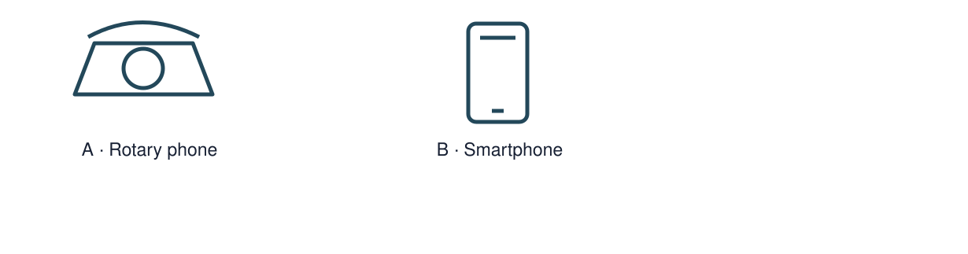
Start with 1 and 2. Try 3 and 4 when ready. Reading and exact scribing are available.

1 What is continuity
Support: Use the reminder strip or talk it through with an adult.
My response
________________________________________________________________________

2 Which meaning fits past
Support: Choose: A time before now OR The time we are in now.
My response
________________________________________________________________________

3 What source could help date an old telephone
Support: Use the model evidence anchor D or read one relevant card together.
My response
________________________________________________________________________

4 Would looking at the object tell us every user s experience
Support: Give a reason when ready.
My response
________________________________________________________________________
Stretch: use a precise example or explain which detail supports your answer.

Evidence cards
Read, point or listen. Keep the source label with any detail you use.

A A fictional week
Monday: choose a club activity. Wednesday: practise the activity. Friday: share what was made. The words Monday, Wednesday and Friday supply the order.
Source: Authored classroom case
Limit: This example does not describe every person or place.

B Telephone comparison
A rotary telephone and a smartphone both support conversations over distance. A smartphone can also show a video call; a rotary dial selects numbers differently.
Source: Authored comparison of familiar objects
Limit: A newer object is not automatically better for every person or purpose.

C Photo enquiry
Use the paired local photographs supplied with this unit. Read the captions and dates. Point to one feature in each image before deciding what changed.
Source: See photograph captions and credits
Limit: A camera angle or season can make features appear different; a photograph alone may not explain why.

D Questions worth asking
Who used this object? When was this photo made? A dated catalogue entry can help with time; a user’s account can help with experience.
Source: Authored classroom case
Limit: This example does not describe every person or place.

Visual resource
Use this visual with the evidence cards and enquiry questions.
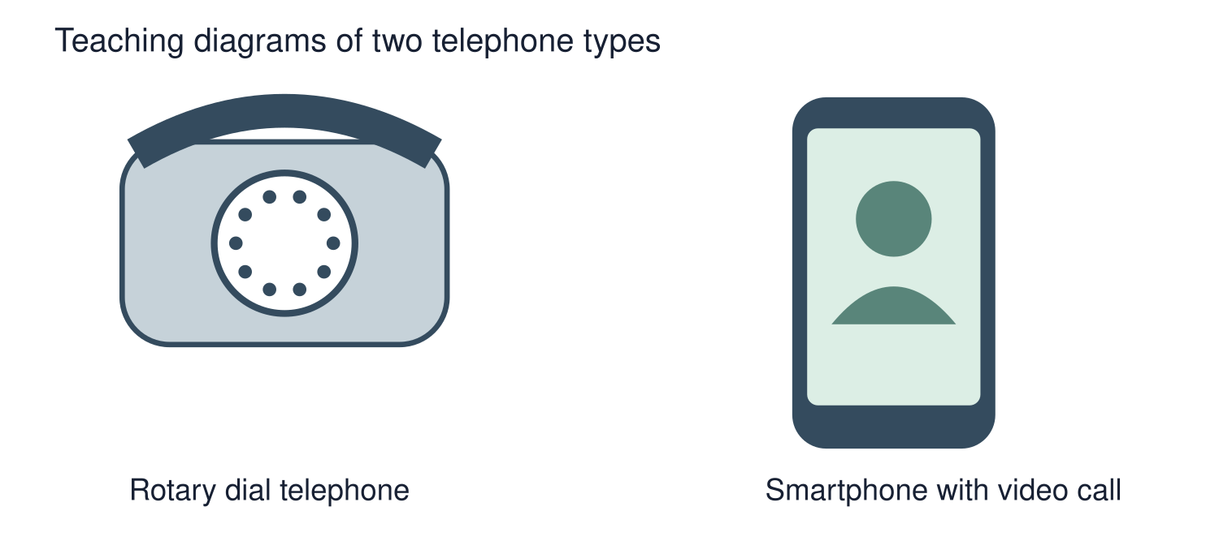
A detail I noticed and what it helps me explain
________________________________________________________________________
________________________________________________________________________
________________________________________________________________________
________________________________________________________________________

Shared investigation
1. Inspect the telephone as a mystery object.
2. Choose which questions can be answered by looking and which need another source.
Work with a partner or adult, or use your own table. One person suggests; the other checks the evidence. Swap after one turn. Passing is allowed.

Move or match the cards
Cards to use
How did a user feel about it?
When was this model made?
How many finger holes are visible?

Possible labels: Find another source / Look at the object
Our explanation
________________________________________________________________________
________________________________________________________________________
________________________________________________________________________
Support: Show two choices. Read one short instruction. Point, match or say a word, then add a reason when ready.
Further challenge: Compare two possible sources and identify what each might miss.

Supported independent task
Complete this route only. Ask a question about the past.
1. Write or record one who, what, where, when or why question.
2. Suggest a source that could help investigate it.
3. Explain why that source fits the question.
Support: Show two choices. Read one short instruction. Point, match or say a word, then add a reason when ready. Complete the organiser one space at a time. My question is ___. I could use ___ because ___.
Source label and origin
________________________________________________________________________
________________________________________________________________________
A detail I can point to
________________________________________________________________________
________________________________________________________________________
What this detail helps me explain
________________________________________________________________________
________________________________________________________________________
What I still need to check
________________________________________________________________________
________________________________________________________________________
An adult may read or scribe your exact response. They should not choose the answer.

Standard independent task
Complete this route only. Ask a question about the past.
1. Write or record one who, what, where, when or why question.
2. Suggest a source that could help investigate it.
3. Explain why that source fits the question.
Support: My question is ___. I could use ___ because ___.
Source label and origin
________________________________________________________________________
________________________________________________________________________
A detail I can point to
________________________________________________________________________
________________________________________________________________________
What this detail helps me explain
________________________________________________________________________
________________________________________________________________________
What I still need to check
________________________________________________________________________
________________________________________________________________________
Check the required evidence and revise one detail.

Stretch independent task
Complete this route only. Ask a question about the past.
1. Write or record one who, what, where, when or why question.
2. Suggest a source that could help investigate it.
3. Explain why that source fits the question.
4. Compare two possible sources and identify what each might miss.
Support: Choose the evidence independently. Use the frame only if it helps.
Source label and origin
________________________________________________________________________
________________________________________________________________________
A detail I can point to
________________________________________________________________________
________________________________________________________________________
What this detail helps me explain
________________________________________________________________________
________________________________________________________________________
What I still need to check
________________________________________________________________________
________________________________________________________________________
Compare two possible sources and identify what each might miss.

Exit ticket
Choose a response mode. You may give your answers privately to an adult.

What source could help date an old telephone
My response
________________________________________________________________________
________________________________________________________________________
________________________________________________________________________

Would looking at the object tell us every user s experience
My response
________________________________________________________________________
________________________________________________________________________
________________________________________________________________________
Support: My question is ___. I could use ___ because ___.
Further challenge: Compare two possible sources and identify what each might miss.
One thing I changed or want to check
________________________________________________________________________
________________________________________________________________________

