Then and now evidence record
Learning goal: Record then and now with photos and captions.

Words to use
Word | Meaning
past | A time before now
present | The time we are in now
change | Something that becomes different
continuity | Something that stays the same

Remember
What two comparisons should your final record include? A change and a continuity.
Why retain the source caption? It identifies the evidence and helps check dates and claims.

How to show your learning
Choose a dated pair of photographs or object images.
Then ___. Later ___. A change is ___. A continuity is ___.

Evidence matters
Fictional cases are teaching examples. Historical, geographical and religious claims use the named sources. A model video demonstrates a method.
You can respond by speaking, pointing, drawing, typing or writing. A fictional personal example is welcome.

Arrival choices
Previous lesson reminder:
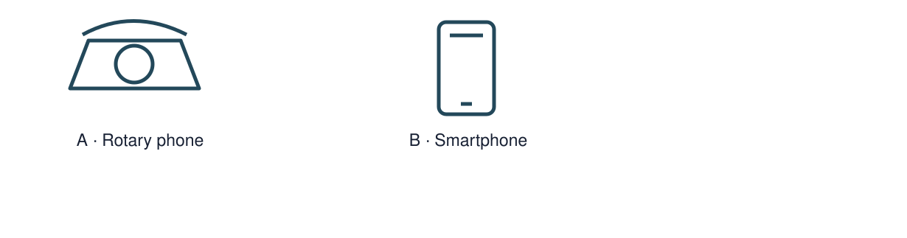
Start with 1 and 2. Try 3 and 4 when ready. Reading and exact scribing are available.

1 What source could help date an old telephone
Support: Use the reminder strip or talk it through with an adult.
My response
________________________________________________________________________

2 Which meaning fits past
Support: Choose: A time before now OR The time we are in now.
My response
________________________________________________________________________

3 What two comparisons should your final record include
Support: Use the model evidence anchor C or read one relevant card together.
My response
________________________________________________________________________

4 Why retain the source caption
Support: Give a reason when ready.
My response
________________________________________________________________________
Stretch: use a precise example or explain which detail supports your answer.

Evidence cards
Read, point or listen. Keep the source label with any detail you use.

A A fictional week
Monday: choose a club activity. Wednesday: practise the activity. Friday: share what was made. The words Monday, Wednesday and Friday supply the order.
Source: Authored classroom case
Limit: This example does not describe every person or place.

B Telephone comparison
A rotary telephone and a smartphone both support conversations over distance. A smartphone can also show a video call; a rotary dial selects numbers differently.
Source: Authored comparison of familiar objects
Limit: A newer object is not automatically better for every person or purpose.

C Photo enquiry
Use the paired local photographs supplied with this unit. Read the captions and dates. Point to one feature in each image before deciding what changed.
Source: See photograph captions and credits
Limit: A camera angle or season can make features appear different; a photograph alone may not explain why.

D Questions worth asking
Who used this object? When was this photo made? A dated catalogue entry can help with time; a user’s account can help with experience.
Source: Authored classroom case
Limit: This example does not describe every person or place.

Visual resource 1
Use this visual with the evidence cards and enquiry questions.
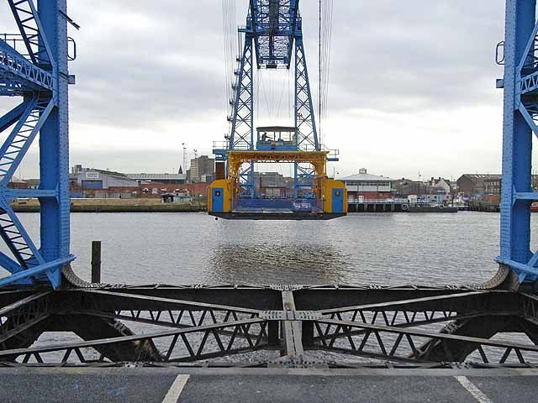
Source: 21 November 2008 · Oliver Dixon · CC BY-SA 2.0
The viewpoints differ. Compare visible details; do not infer rebuilding from the camera angle. These are historical photographs, not a live view.
A detail I noticed and what it helps me explain
________________________________________________________________________
________________________________________________________________________
________________________________________________________________________
________________________________________________________________________

Visual resource 2
Use this visual with the evidence cards and enquiry questions.
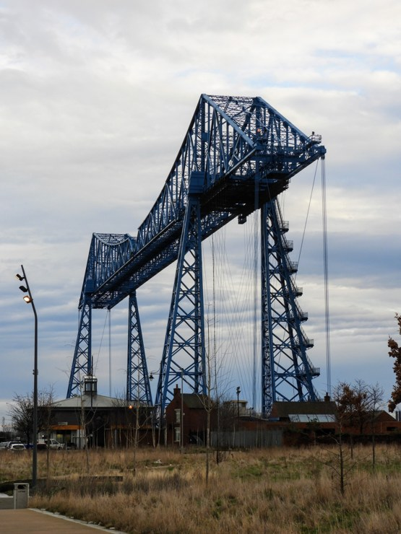
Source: 31 January 2020 · Reading Tom · CC BY 2.0
The viewpoints differ. Compare visible details; do not infer rebuilding from the camera angle. These are historical photographs, not a live view.
A detail I noticed and what it helps me explain
________________________________________________________________________
________________________________________________________________________
________________________________________________________________________
________________________________________________________________________

Shared investigation
1. Review a practice caption for evidence and accuracy.
2. Identify the difference between a change and a reason for it.
Work with a partner or adult, or use your own table. One person suggests; the other checks the evidence. Swap after one turn. Passing is allowed.
Use the evidence cards and any visual sheet. Follow the two shared steps above, then record one decision.
Our explanation
________________________________________________________________________
________________________________________________________________________
________________________________________________________________________
Support: Show two choices. Read one short instruction. Point, match or say a word, then add a reason when ready.
Further challenge: Add an enquiry question about a reason that the images do not establish.

Supported independent task
Complete this route only. Record then and now with photos and captions.
1. Choose a dated pair of photographs or object images.
2. Create a short then-and-now record with captions.
3. Explain one change and one continuity, and name the source.
Support: Show two choices. Read one short instruction. Point, match or say a word, then add a reason when ready. Complete the organiser one space at a time. Then ___. Later ___. A change is ___. A continuity is ___.
My answer to the assessment enquiry
________________________________________________________________________
________________________________________________________________________
My evidence and source
________________________________________________________________________
________________________________________________________________________
My explanation or comparison
________________________________________________________________________
________________________________________________________________________
My conclusion and what the evidence does not show
________________________________________________________________________
________________________________________________________________________
An adult may read or scribe your exact response. They should not choose the answer.

Standard independent task
Complete this route only. Record then and now with photos and captions.
1. Choose a dated pair of photographs or object images.
2. Create a short then-and-now record with captions.
3. Explain one change and one continuity, and name the source.
Support: Then ___. Later ___. A change is ___. A continuity is ___.
My answer to the assessment enquiry
________________________________________________________________________
________________________________________________________________________
My evidence and source
________________________________________________________________________
________________________________________________________________________
My explanation or comparison
________________________________________________________________________
________________________________________________________________________
My conclusion and what the evidence does not show
________________________________________________________________________
________________________________________________________________________
Check the required evidence and revise one detail.

Stretch independent task
Complete this route only. Record then and now with photos and captions.
1. Choose a dated pair of photographs or object images.
2. Create a short then-and-now record with captions.
3. Explain one change and one continuity, and name the source.
4. Add an enquiry question about a reason that the images do not establish.
Support: Choose the evidence independently. Use the frame only if it helps.
My answer to the assessment enquiry
________________________________________________________________________
________________________________________________________________________
My evidence and source
________________________________________________________________________
________________________________________________________________________
My explanation or comparison
________________________________________________________________________
________________________________________________________________________
My conclusion and what the evidence does not show
________________________________________________________________________
________________________________________________________________________
Add an enquiry question about a reason that the images do not establish.

Exit ticket
Choose a response mode. You may give your answers privately to an adult.

What two comparisons should your final record include
My response
________________________________________________________________________
________________________________________________________________________
________________________________________________________________________

Why retain the source caption
My response
________________________________________________________________________
________________________________________________________________________
________________________________________________________________________
Support: Then ___. Later ___. A change is ___. A continuity is ___.
Further challenge: Add an enquiry question about a reason that the images do not establish.
One thing I changed or want to check
________________________________________________________________________
________________________________________________________________________

