Our class caring action
Learning goal: Take part in a class caring action.

Words to use
Word | Meaning
fairness | Giving people a fair chance and meeting needs
care | Acting to help with a need
right | A basic entitlement held by people
responsibility | Something we should take care to do

Remember
What is evidence that you took part? A dated observation, the created item or an exact recorded account of your contribution.
Can a plan alone prove the action happened? No. Retain evidence of what was actually done.

How to show your learning
Carry out one agreed contribution: make a label, check its readability or organise an accessible resource option.
My role was ___. I did ___. The feedback or observation was ___.

Evidence matters
Fictional cases are teaching examples. Historical, geographical and religious claims use the named sources. A model video demonstrates a method.
You can respond by speaking, pointing, drawing, typing or writing. A fictional personal example is welcome.
Sources: Luke 10 in the King James Version; Nobel Prize Malala facts

Arrival choices
Previous lesson reminder:
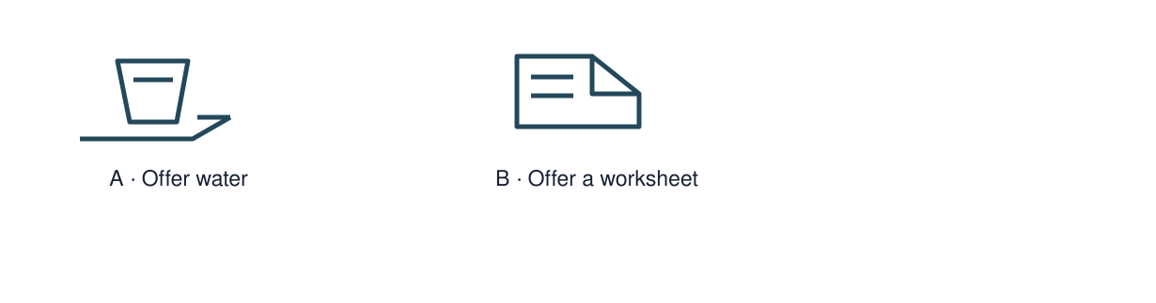
Start with 1 and 2. Try 3 and 4 when ready. Reading and exact scribing are available.

1 What does Malala campaign for
Support: Use the reminder strip or talk it through with an adult.
My response
________________________________________________________________________

2 Which meaning fits fairness
Support: Choose: Giving people a fair chance and meeting needs OR Acting to help with a need.
My response
________________________________________________________________________

3 What is evidence that you took part
Support: Use the model evidence anchor C or read one relevant card together.
My response
________________________________________________________________________

4 Can a plan alone prove the action happened
Support: Give a reason when ready.
My response
________________________________________________________________________
Stretch: use a precise example or explain which detail supports your answer.

Evidence cards
Read, point or listen. Keep the source label with any detail you use.

A The Good Samaritan
Easy-read retelling of the Christian parable in Luke 10: A traveller needs help. Two people pass by. A Samaritan stops, cares for him and arranges more help. The story asks what it means to be a neighbour.
Source: Authored retelling of Luke 10:25–37
Limit: A religious story teaches an idea; this retelling is not a quotation or a historical record.

B A fair turn
Fictional case: three pupils share one tablet. Jo needs text read aloud. The group can agree turns and switch on speech support. Equal dignity does not always mean identical support.
Source: Authored classroom case
Limit: This example does not describe every person or place.

C A caring action
Fictional case: a new student cannot find the reading resources. A clear shelf label and a choice of formats could help. Ask what is useful before deciding.
Source: Authored classroom case
Limit: This example does not describe every person or place.

M Malala Yousafzai
Malala campaigns for children’s education, especially girls’ education. She shared the 2014 Nobel Peace Prize with Kailash Satyarthi.
Source: Nobel Prize, Malala Yousafzai facts
Limit: An award recognises work; it does not prove that unequal access to education has ended.

Shared investigation
1. Choose one manageable class action, such as clearer resource labels.
2. Agree the need, roles and how to notice an effect.
Work with a partner or adult, or use your own table. One person suggests; the other checks the evidence. Swap after one turn. Passing is allowed.
Use the evidence cards and any visual sheet. Follow the two shared steps above, then record one decision.
Our explanation
________________________________________________________________________
________________________________________________________________________
________________________________________________________________________
Support: Show two choices. Read one short instruction. Point, match or say a word, then add a reason when ready.
Further challenge: Explain a change you would make after feedback and why.

Supported independent task
Complete this route only. Take part in a class caring action.
1. Carry out one agreed contribution: make a label, check its readability or organise an accessible resource option.
2. Record what you actually did.
3. Ask for feedback and reflect on its effect.
Support: Show two choices. Read one short instruction. Point, match or say a word, then add a reason when ready. Complete the organiser one space at a time. My role was ___. I did ___. The feedback or observation was ___.
Question or need
________________________________________________________________________
________________________________________________________________________
What I actually did and where
________________________________________________________________________
________________________________________________________________________
Observation count or feedback
________________________________________________________________________
________________________________________________________________________
What this evidence shows and one limit
________________________________________________________________________
________________________________________________________________________
An adult may read or scribe your exact response. They should not choose the answer.

Standard independent task
Complete this route only. Take part in a class caring action.
1. Carry out one agreed contribution: make a label, check its readability or organise an accessible resource option.
2. Record what you actually did.
3. Ask for feedback and reflect on its effect.
Support: My role was ___. I did ___. The feedback or observation was ___.
Question or need
________________________________________________________________________
________________________________________________________________________
What I actually did and where
________________________________________________________________________
________________________________________________________________________
Observation count or feedback
________________________________________________________________________
________________________________________________________________________
What this evidence shows and one limit
________________________________________________________________________
________________________________________________________________________
Check the required evidence and revise one detail.

Stretch independent task
Complete this route only. Take part in a class caring action.
1. Carry out one agreed contribution: make a label, check its readability or organise an accessible resource option.
2. Record what you actually did.
3. Ask for feedback and reflect on its effect.
4. Explain a change you would make after feedback and why.
Support: Choose the evidence independently. Use the frame only if it helps.
Question or need
________________________________________________________________________
________________________________________________________________________
What I actually did and where
________________________________________________________________________
________________________________________________________________________
Observation count or feedback
________________________________________________________________________
________________________________________________________________________
What this evidence shows and one limit
________________________________________________________________________
________________________________________________________________________
Explain a change you would make after feedback and why.

Exit ticket
Choose a response mode. You may give your answers privately to an adult.

What is evidence that you took part
My response
________________________________________________________________________
________________________________________________________________________
________________________________________________________________________

Can a plan alone prove the action happened
My response
________________________________________________________________________
________________________________________________________________________
________________________________________________________________________
Support: My role was ___. I did ___. The feedback or observation was ___.
Further challenge: Explain a change you would make after feedback and why.
One thing I changed or want to check
________________________________________________________________________
________________________________________________________________________

