Worldviews and responses to change
Learning goal: Compare how different communities respond to change with an RE link.

Words to use
Word | Meaning
climate | Weather patterns over a long period
hazard | A process or event with potential to cause harm
effect | A consequence
response | An action taken because of a situation

Remember
Can different stated values lead to caring actions? Yes. The accounts give different motivations for actions intended to reduce heat harm.
Do these fictional accounts describe all faith or non-religious groups? No. They are authored examples, not representative findings.

How to show your learning
Complete a grid comparing the faith group and non-religious residents’ group.
Both ___. Account 1 gives ___ as a reason; account 2 gives ___.

Evidence matters
Fictional cases are teaching examples. Historical, geographical and religious claims use the named sources. A model video demonstrates a method.
You can respond by speaking, pointing, drawing, typing or writing. A fictional personal example is welcome.
Sources: NASA Causes of climate change

Arrival choices
Previous lesson reminder:
Start with 1 and 2. Try 3 and 4 when ready. Reading and exact scribing are available.

1 What happens when fossil fuels are burned
Support: Use the reminder strip or talk it through with an adult.
My response
________________________________________________________________________

2 Which meaning fits climate
Support: Choose: Weather patterns over a long period OR A process or event with potential to cause harm.
My response
________________________________________________________________________

3 Can different stated values lead to caring actions
Support: Use the model evidence anchor D or read one relevant card together.
My response
________________________________________________________________________

4 Do these fictional accounts describe all faith or non religious groups
Support: Give a reason when ready.
My response
________________________________________________________________________
Stretch: use a precise example or explain which detail supports your answer.

Evidence cards
Read, point or listen. Keep the source label with any detail you use.

A Zones and events
Broad temperature zones relate to latitude. Near the equator is generally warmer; high latitudes are generally colder. Local climate also depends on altitude and other factors. Earthquakes relate mainly to plate boundaries, not climate zones.
Source: Authored map explanation
Limit: Broad bands simplify climate; they are not a detailed climate classification.

B Human influence
Burning fossil fuels adds carbon dioxide. Greenhouse gases slow heat loss to space. Human activity is the main cause of recent global warming.
Source: NASA Causes of climate change
Limit: One local hot or cold day does not establish the global trend.

C Two responses
Reducing fossil-fuel use tackles a cause of warming. Shade, water access and cooler buildings can reduce harm during heat. These responses do different jobs.
Source: Authored examples based on climate mechanisms
Limit: Their suitability depends on the place and the needs of people there.

D Community accounts
Fictional account 1: a faith group explains caring for creation as its reason for planting shade trees. Fictional account 2: a non-religious residents’ group gives human wellbeing as its reason for a cool-room project.
Source: Two authored teaching accounts with explicitly stated values
Limit: These are not reports of real organisations and do not represent every religious or non-religious person.

Visual resource
Use this visual with the evidence cards and enquiry questions.
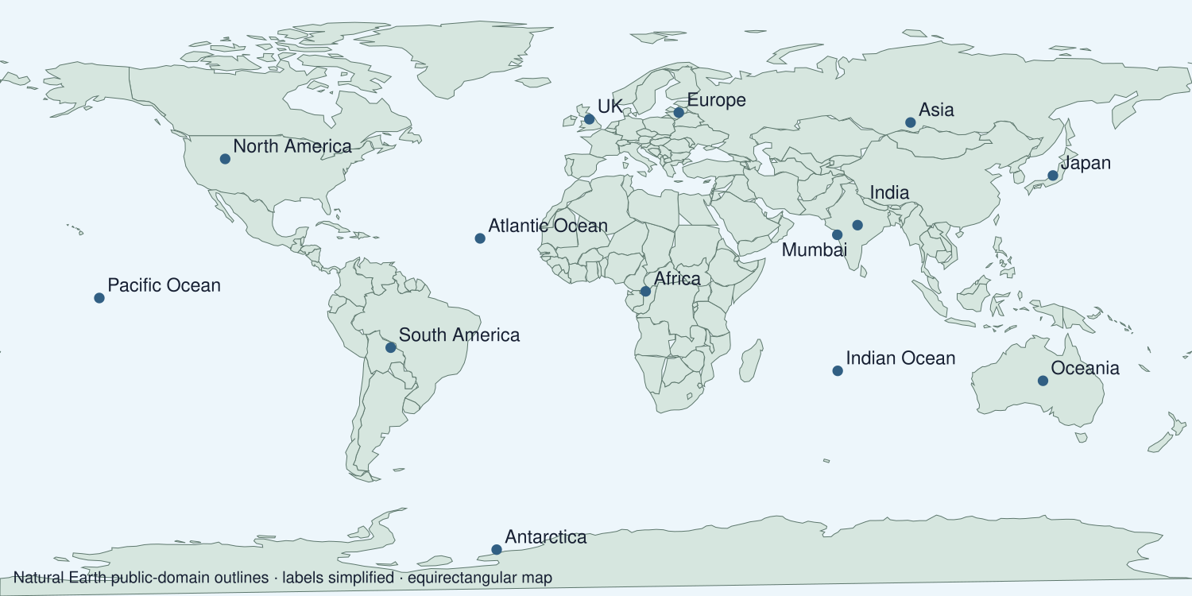
A detail I noticed and what it helps me explain
________________________________________________________________________
________________________________________________________________________
________________________________________________________________________
________________________________________________________________________

Shared investigation
1. Read the two fictional community accounts and their stated values.
2. Compare action and motivation separately.
Work with a partner or adult, or use your own table. One person suggests; the other checks the evidence. Swap after one turn. Passing is allowed.
Use the evidence cards and any visual sheet. Follow the two shared steps above, then record one decision.
Our explanation
________________________________________________________________________
________________________________________________________________________
________________________________________________________________________
Support: Read one evidence card together. Highlight a useful detail. Rehearse with: Both ___. Account 1 gives ___ as a reason; account 2 gives ___.
Further challenge: Explain what additional evidence would be needed about a real community’s impact.

Supported independent task
Complete this route only. Compare how different communities respond to change with an RE link.
1. Complete a grid comparing the faith group and non-religious residents’ group.
2. Explain one similarity and one difference using their stated values.
3. Avoid generalising either account to everyone in a community.
Support: Read one evidence card together. Highlight a useful detail. Rehearse with: Both ___. Account 1 gives ___ as a reason; account 2 gives ___. Complete the organiser one space at a time. Both ___. Account 1 gives ___ as a reason; account 2 gives ___.
Evidence from the first example
________________________________________________________________________
________________________________________________________________________
Evidence from the second example
________________________________________________________________________
________________________________________________________________________
One similarity
________________________________________________________________________
________________________________________________________________________
One difference or change
________________________________________________________________________
________________________________________________________________________
An adult may read or scribe your exact response. They should not choose the answer.

Standard independent task
Complete this route only. Compare how different communities respond to change with an RE link.
1. Complete a grid comparing the faith group and non-religious residents’ group.
2. Explain one similarity and one difference using their stated values.
3. Avoid generalising either account to everyone in a community.
Support: Both ___. Account 1 gives ___ as a reason; account 2 gives ___.
Evidence from the first example
________________________________________________________________________
________________________________________________________________________
Evidence from the second example
________________________________________________________________________
________________________________________________________________________
One similarity
________________________________________________________________________
________________________________________________________________________
One difference or change
________________________________________________________________________
________________________________________________________________________
Check the required evidence and revise one detail.

Stretch independent task
Complete this route only. Compare how different communities respond to change with an RE link.
1. Complete a grid comparing the faith group and non-religious residents’ group.
2. Explain one similarity and one difference using their stated values.
3. Avoid generalising either account to everyone in a community.
4. Explain what additional evidence would be needed about a real community’s impact.
Support: Choose the evidence independently. Use the frame only if it helps.
Evidence from the first example
________________________________________________________________________
________________________________________________________________________
Evidence from the second example
________________________________________________________________________
________________________________________________________________________
One similarity
________________________________________________________________________
________________________________________________________________________
One difference or change
________________________________________________________________________
________________________________________________________________________
Explain what additional evidence would be needed about a real community’s impact.

Exit ticket
Choose a response mode. You may give your answers privately to an adult.

Can different stated values lead to caring actions
My response
________________________________________________________________________
________________________________________________________________________
________________________________________________________________________

Do these fictional accounts describe all faith or non religious groups
My response
________________________________________________________________________
________________________________________________________________________
________________________________________________________________________
Support: Both ___. Account 1 gives ___ as a reason; account 2 gives ___.
Further challenge: Explain what additional evidence would be needed about a real community’s impact.
One thing I changed or want to check
________________________________________________________________________
________________________________________________________________________

